The Holy Way Presbyterian Church

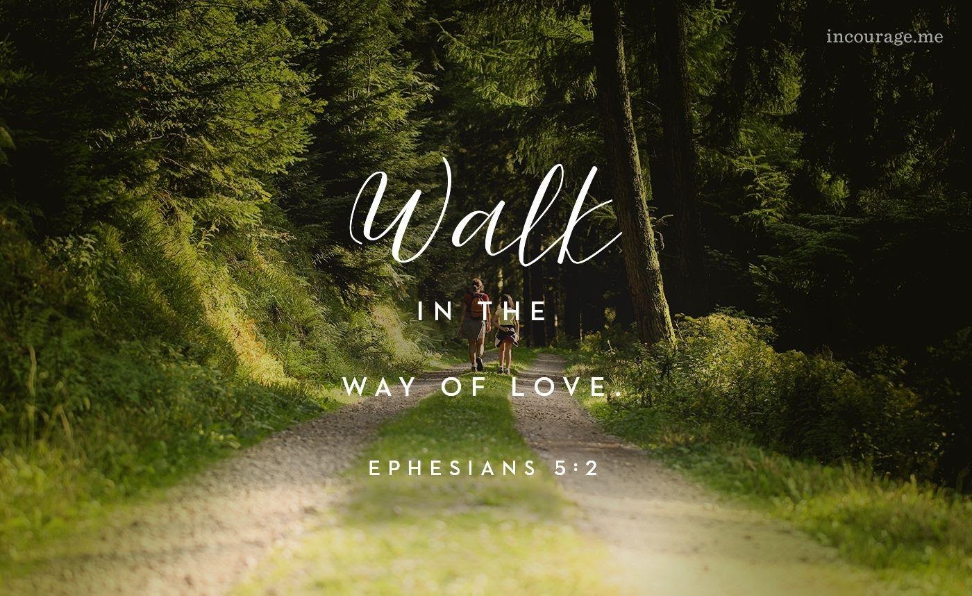

Tucson, Arizona

August 8, 2021 9:30 a.m.
Living In Community...

Words of Meditation - Let us not live like those who do not have Christ in their hearts...chasing every idol and thing of this world. Let us instead Give thanks to the one who made us and Praise the Lord above for the gifts he has given us individually, and the gift of eternal life in Jesus Christ the Son.

Welcome to Worship Rev. Tina Salvaneschi
Opening Prayer
Release Children to Sunday School - Miss Kathy
Introit: Eternal Father, Strong to Save (Hymn #8, V3)
Ryan Phillips, Choir Director

Hymn: Hope Of The World (Hymn #734, V. 1, 2, 3, 5) Ryan Phillips, Choir Director

Call to Worship: Lay Leader, Don Kimball

O Magnify the Lord with me, and let us exalt God’s name together.
We sought the Lord, and God answered us.
God delivered us from all our fears.
O taste and see that the Lord is good!
Happy are those who take refuge in God.

People: Amen

Birthdays and Anniversaries Alfonso Valenzuela
Celebrations, Joys and Concerns Rev. Tina Salvaneschi
The People of the Congregation Share

...The Lord’s Prayer
People: Our Father, who art in heaven, hallowed be thy name. Thy kingdom come, thy will be done on earth as it is in heaven. Give us this day our daily bread, and forgive us our debts as we forgive our debtors. And lead us not into temptation, but deliver us from evil, for thine is the kingdom and the power and the glory forever. Amen

Anthem: The Painters Hand Ryan Phillips, Choir Director
Invitation for Tithes and Offering: Rev. Tina Salvaneschi
Prayer

Offertory Music: Dr. Astrid Chan
(offering baskets available at all four exits as you leave)

Scripture Reading: Lay Leader, Don Kimball
Ephesians 5:1-9
1 Follow God’s example, therefore, as dearly loved children 2 and walk in the way of love, just as Christ loved us and gave himself up for us as a fragrant offering and sacrifice to God.

3 But among you there must not be even a hint of sexual immorality, or of any kind of impurity, or of greed, because these are improper for God’s holy people. 4 Nor should there be obscenity, foolish talk or coarse joking, which are out of place, but rather thanksgiving. 5 For of this you can be sure: No immoral, impure or greedy person—such a person is an idolater—has any inheritance in the kingdom of Christ and of God. 6 Let no one deceive you with empty words, for because of such things God’s wrath comes on those who are disobedient. 7 Therefore do not be partners with them.

8 For you were once darkness, but now you are light in the Lord. Live as children of light 9 (for the fruit of the light consists in all goodness, righteousness and truth)

Leader: This is the Word of the Lord. People: Thanks be to God.

Message: Walk in the Way of Love and Light Rev. Tina Salvaneschi

Sending Hymn: Guide Me Oh Thou Great Jehovah (Hymn #65)
Ryan Phillips, Choir Director

Children Share What they learned in Sunday School Miss Kathy

Benediction: 2 Corinthians 13:14 Rev. Tina Salvaneschi

Song: Let There Be Peace On Earth Ryan Phillips, Choir Director
Postlude: Dr. Astrid Chan

Stay Connected at The Holy Way

“Sermon Debrief Bible Study in person on Campus and Zoom” - Tuesday 10:00 a.m.
It’s Both! Come and meet live in the Conference Room at 10:00 a.m. or join on Zoom and we will conference you in on the big screen!
This is a great way to get to Fellowship, wrestle with questions about Sunday’s sermon, ponder the meaning of God’s Word, and discover how Scriptures can transform our lives today. This is led by Pastor Tina and is interactive! Come join the live class if you are able!

“Thoughtful Thursdays” - Thursday 10:00 a.m. Zoom
This is a great way to stay connected (especially for our snowbirds, and folks that can’t make it to in-person services!). We share about our lives, spend time talking, share joys, prayer requests…and anything else that comes up. Oh yes, laughter seems to happen too. This is group led, with Pastor Tina and for women AND men!

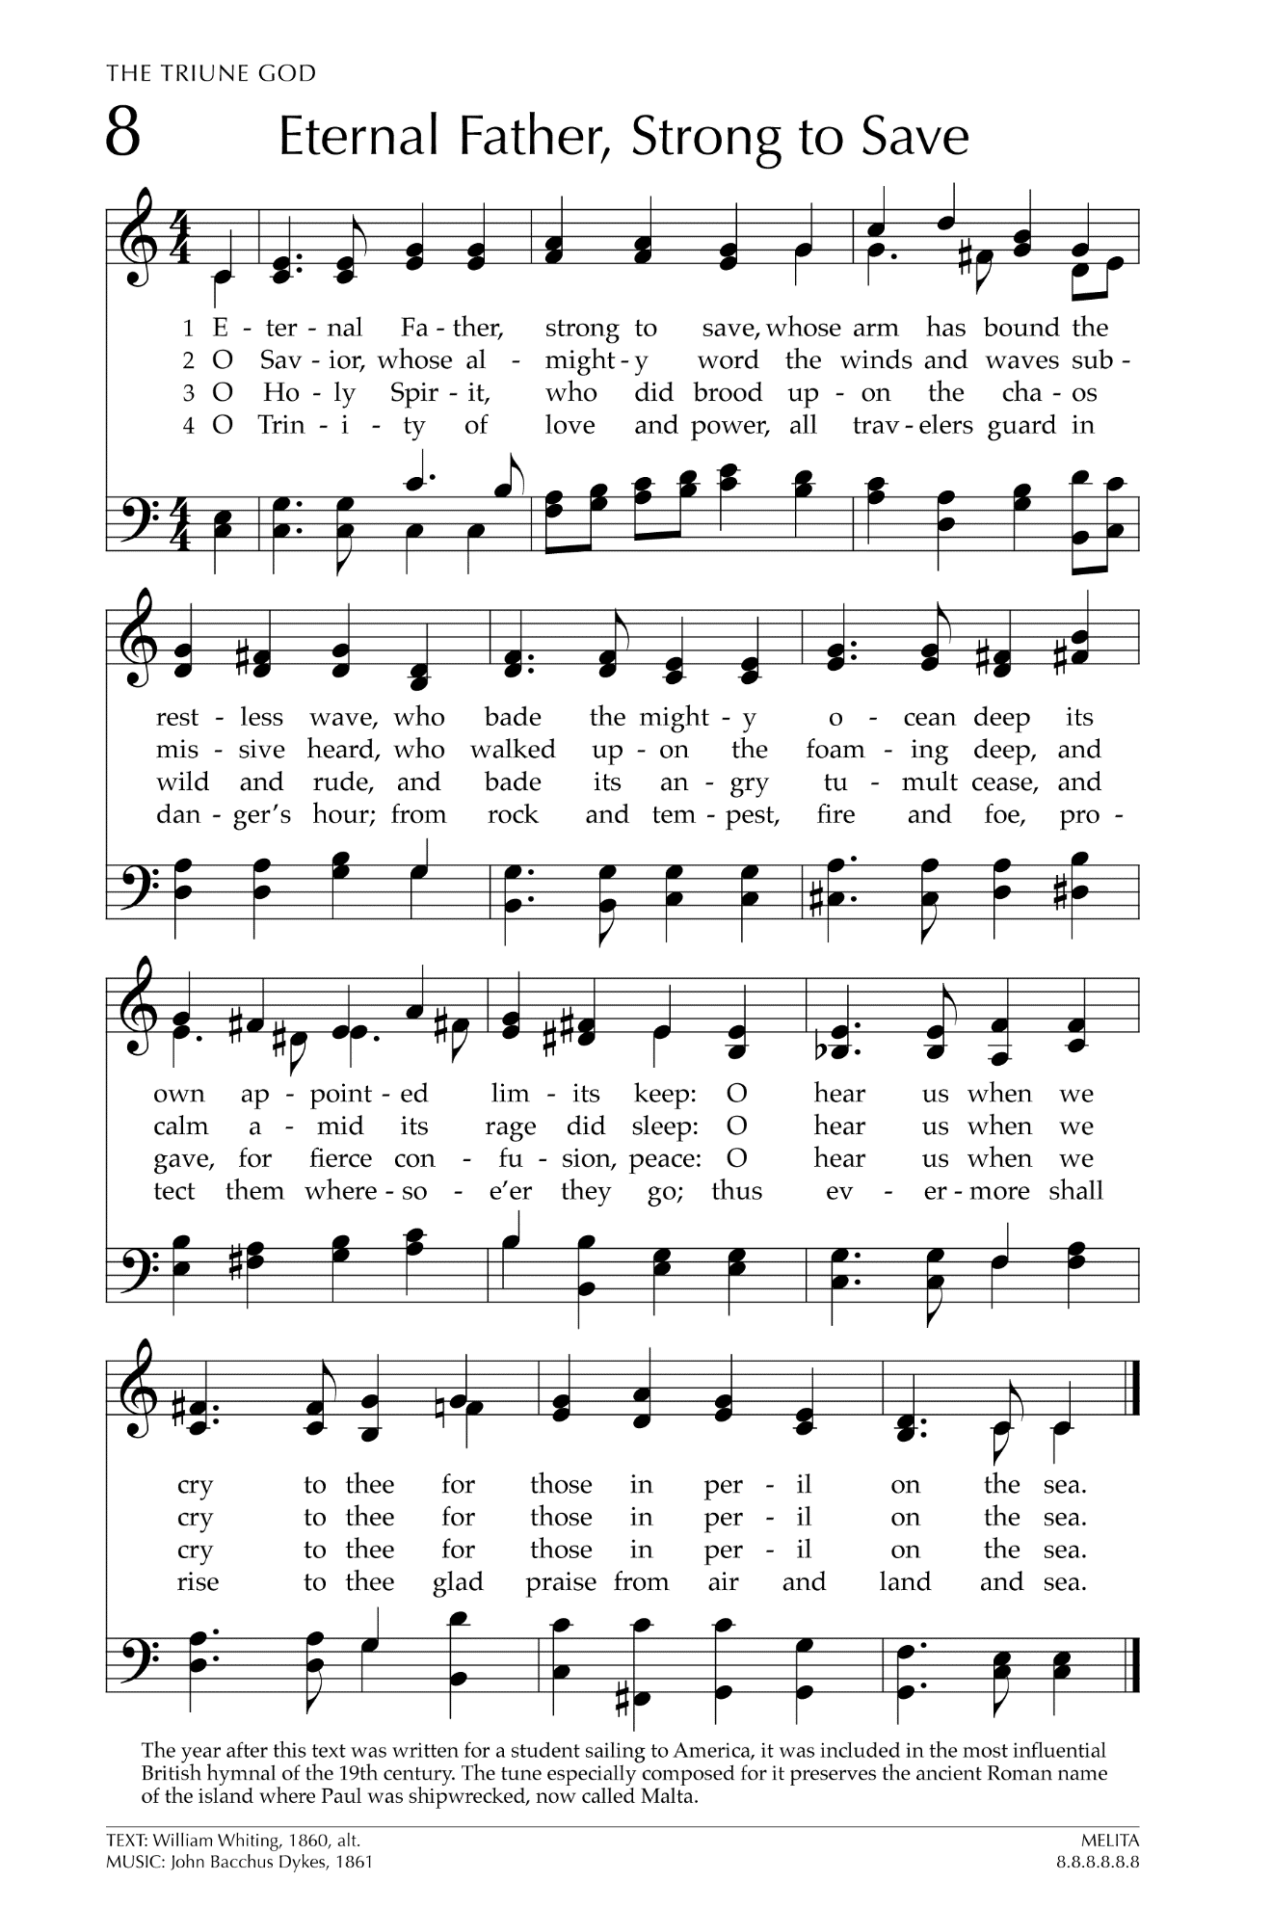
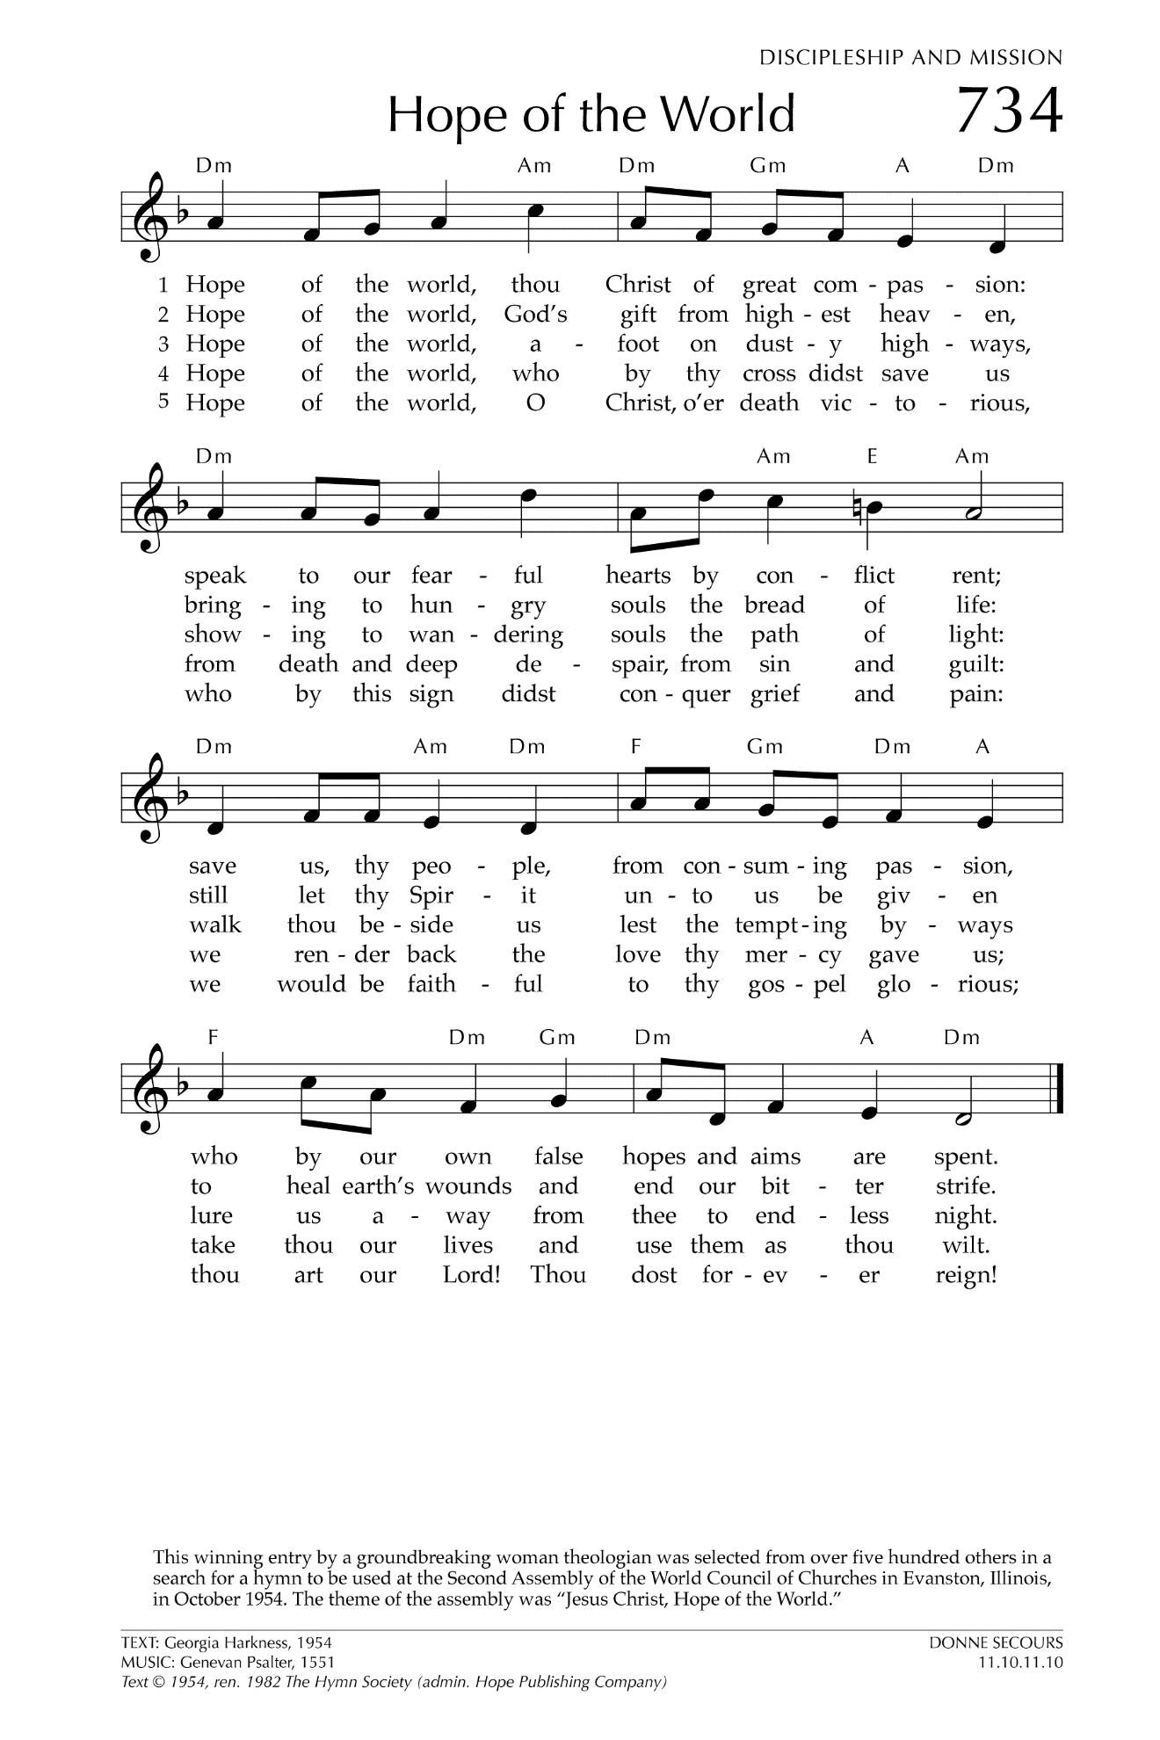
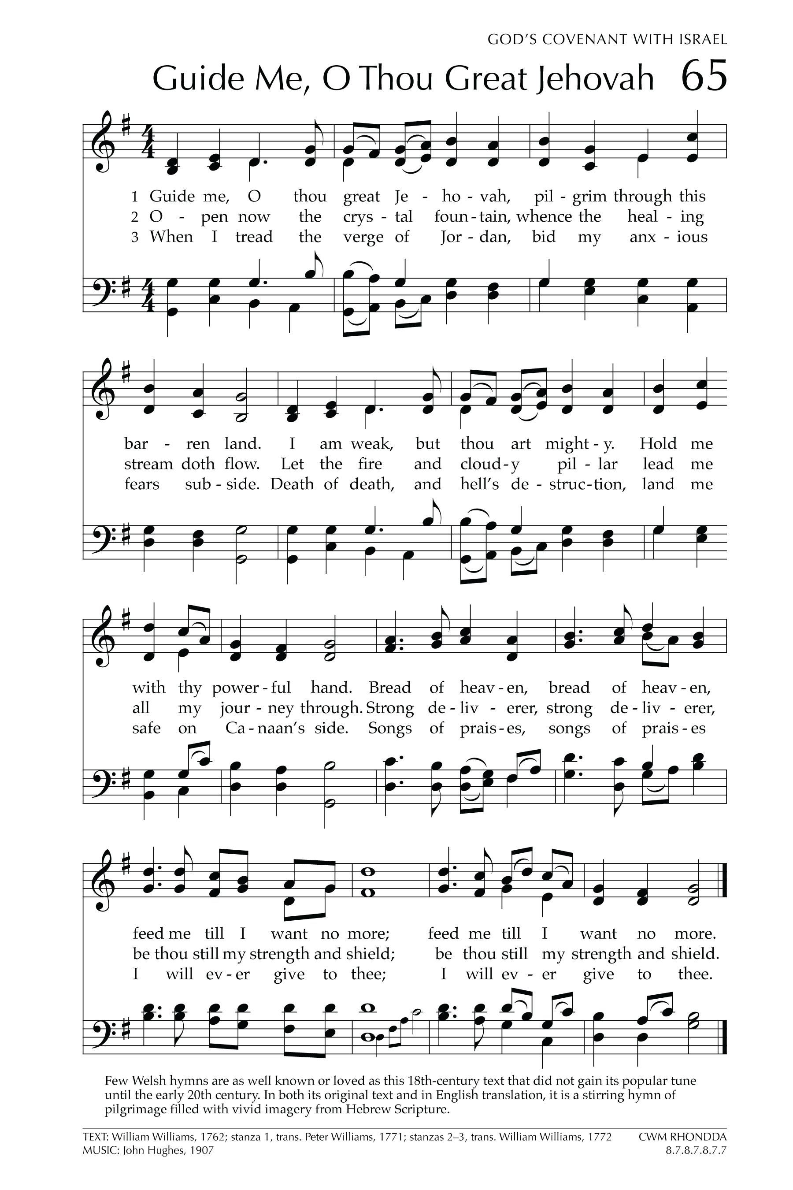

Let There Be Peace on Earth

Let there be peace on earth
And let it begin with me
Let there be peace on earth
The peace that was meant to be
With God as our Father
Christians all are we
Let us walk with each other
In perfect harmony.
Let peace begin with me
Let this be the moment now.
With every step I take
Let this be my solemn vow
To take each moment and live
Each moment in peace eternally
Let there be Peace on Earth
And let it begin with me!

