The Holy Way Presbyterian Church
Tucson, Arizona

June 20, 2021 9:30 a.m. Happy Father’s Day

Welcome to Worship Rev. Tina Salvaneschi
Opening Prayer

Introit: For The Beauty of The Earth (Hymn #14, V. 5)
Ryan Phillips, Director of Music

Hymn: Come, Labor On (Hymn #719) Ryan Phillips, Director of Music

Call to Worship: Lay Leader, Karl Allen
John 4:21-24

Listen to the words of Jesus:
“A new day is coming
—in fact, it’s already here—
when the importance will not be placed
on the time and place of worship
but on the truthful hearts of worshipers.
The Father is spirit,
and he is seeking followers
whose worship is sourced in truth
and deeply spiritual as well.
If you do not seek the Father,
then you do not worship.”

The time is coming
—indeed, it is already here—
when true worshippers will worship the Father
in spirit and in truth.
These are the worshippers the Father wants! People: Amen

Prayers for the People Rev. Tina Salvaneschi
& The Lord’s Prayer

Our Father, who art in heaven, hallowed be thy name. Thy kingdom come, thy will be done on earth as it is in heaven. Give us this day our daily bread, and forgive us our debts as we forgive our debtors. And lead us not into temptation, but deliver us from evil, for thine is the kingdom and the power and the glory forever. Amen

Anthem: You’re A Good, Good Father Ryan Phillips, Director of Music

Invitation for Tithes and Offering: Rev. Tina Salvaneschi

Offertory Music: Dr. Astrid Chan
(offering baskets available at all four exits as you leave)

Scripture Reading: Lay Leader, Karl Allen
2 Timothy 1:1-7, 13-14

Greetings from: 1 Paul, an apostle of Jesus Christ by the will of God, according to the promise of life, which is in Christ Jesus, 2 To Timothy, a beloved son: Grace, mercy, and peace from God the Father and Christ Jesus our Lord.
3 I thank God, whom I serve with a pure conscience, as my forefathers did, as without ceasing I remember you in my prayers night and day, 4 greatly desiring to see you, being mindful of your tears, that I may be filled with joy, 5 when I call to remembrance the genuine faith that is in you, which dwelt first in your grandmother Lois and your mother Eunice, and I am persuaded is in you also. 6 Therefore I remind you to stir up the gift of God which is in you through the laying on of my hands. 7 For God has not given us a spirit of fear, but of power and of love and of a sound mind.

13 Hold fast the pattern of sound words which you have heard from me, in faith and love which are in Christ Jesus. 14 That good thing, which was committed to you, keep by the Holy Spirit who dwells in us.

2 Timothy 3:14-17

14 But you must continue in the things which you have learned and been assured of, knowing from whom you have learned them, 15 and that from childhood you have known the Holy Scriptures, which are able to make you wise for salvation through faith which is in Christ Jesus.
16 All Scripture is given by inspiration of God, and is profitable for doctrine, for reproof, for correction, for [a]instruction in righteousness, 17 that the man of God may be complete, thoroughly equipped for every good work.

Leader: This is the Word of the Lord. People: Thanks be to God.

Message: Paul and Timothy: “A Father & Son”
Rev. Tina Salvaneschi

Rev. Tina Salvaneschi
Sending Hymn: Will You Come and Follow Me (Hymn #726) Ryan Phillips, Director of Music

Benediction: 2 Corinthians 13:14 Rev. Tina Salvaneschi

Song: Let There Be Peace on Earth Ryan Phillips, Director of Music

Postlude: Dr. Astrid Chan

What’s New At the Holy Way?

“Sermon Debrief Bible Study” - Tuesday 10:00 a.m. Zoom
Come dive deeper into Sunday’s sermon and study the history, context, signs and meaning of God’s Word and how the Scriptures can apply to our lives today. This is lead by Pastor Tina and is very interactive!

“Thoughtful Thursdays” - Thursday 10:00 a.m. Zoom
This is a great way to stay connected (especially for our snowbirds, and folks that can’t make it to in-person services!). We share about our lives, spend time talking, share joys, pray requests…and anything else that comes up. Oh yes, laughter seems to happen too. This is group lead, with Pastor Tina and for women AND men!

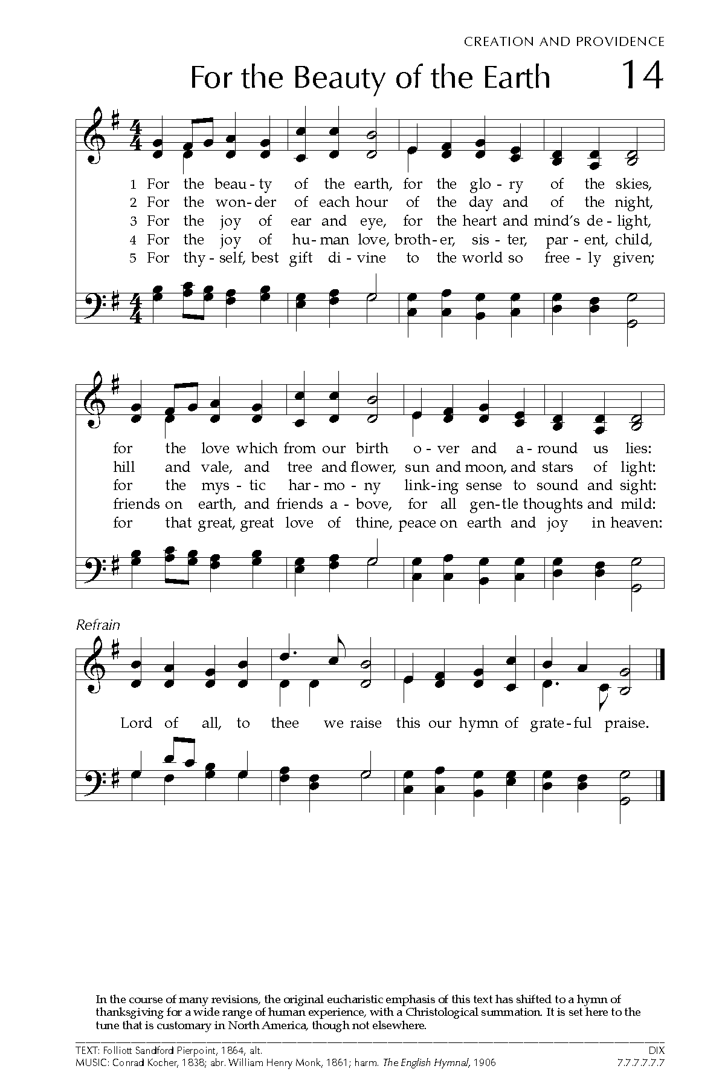
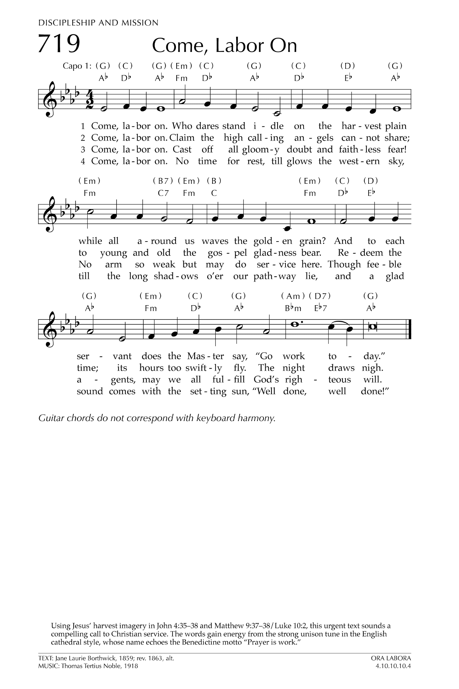
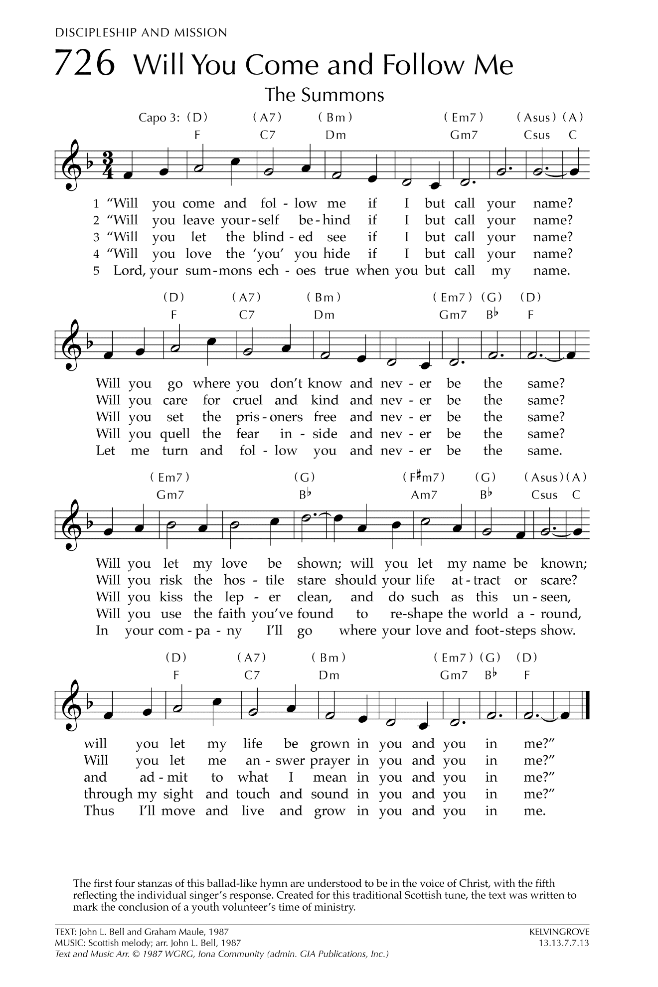

Let There Be Peace on Earth

Let there be peace on earth
And let it begin with me
Let there be peace on earth
The peace that was meant to be
With God as our Father
Christians all are we
Let us walk with each other
In perfect harmony.
Let peace begin with me
Let this be the moment now.
With every step I take
Let this be my solemn vow
To take each moment and live
Each moment in peace eternally
Let there be Peace on Earth
And let it begin with me!

