The Holy Way Presbyterian Church

Tucson, Arizona

December 19, 2021 9:30 a.m.
Fourth Sunday of Advent...

Welcome to Worship Rev. Tina Salvaneschi
Opening Prayer
Release Children to Sunday School - Miss Kathy
Introit: Watchman, Tell Us of the Night (Hymn #97, v. 1)
Ryan Phillips, Choir Director

Hymn: Soon and Very Soon (Hymn #384) Ryan Phillips, Choir Director

Lighting of Advent Candle: Esther and Bill Boals
Luke 19:39-45

39 Now Mary arose in those days and went into the hill country with haste, to a city of Judah, 40 and entered the house of Zacharias and greeted Elizabeth. 41 And it happened, when Elizabeth heard the greeting of Mary, that the babe leaped in her womb; and Elizabeth was filled with the Holy Spirit. 42 Then she spoke out with a loud voice and said, “Blessed are you among women, and blessed is the fruit of your womb! 43 But why is this granted to me, that the mother of my Lord should come to me? 44 For indeed, as soon as the voice of your greeting sounded in my ears, the babe leaped in my womb for joy. 45 Blessed is she who believed, for there will be a fulfillment of those things which were told her from the Lord.”

People: Amen

Esther and Bill Boals light the candles

Birthdays and Anniversaries Marianne Hamilton
If you want to participate in our tradition of celebrating your birthday or anniversary by giving money towards church building, renovation, improvement, sound systems, just waive your hand, or stand up and Pastor Tina will receive it in the plate!

Celebrations, Joys and Concerns Rev. Tina Salvaneschi
The People of the Congregation Share Joys and Concerns
Marianne will bring the microphone to you.

...The Lord’s Prayer
People: Our Father, who art in heaven, hallowed be thy name. Thy kingdom come, thy will be done on earth as it is in heaven. Give us this day our daily bread, and forgive us our debts as we forgive our debtors. And lead us not into temptation, but deliver us from evil, for thine is the kingdom and the power and the glory forever. Amen

Anthem: A Star will Soon Shine Chancel Choir
Watch and wait, O people of God;
this is no time for doubt and fear.
Let your faith be steadfast and strong.
Soon a sign will appear.
A star will soon shine o’er Bethlehem town.
The prophets have said a child will come down
from heaven above to bring God’s Love.
Let us prepare for the King.
A star will soon shine alone in the night.
The sky will be filled with glorious light,
and a song will be heard through all the world.
Let us prepare for the King.
Watch and wait, O people of Hope;
love will come down from heav’n on high.
Trust your faith. Be patient and know
God will send you a sign.
A star will soon shine to show us the way.
The darkness we’ve known will soon be replaced
by the light of God’s Son, the Promised One.
Let us prepare for the King.

Tithes and Offering: Prayer Rev. Tina Salvaneschi
(Option: Place you index card with a private prayer for Pastor)
(Option: write on index card a word or two what giving to God means to you place index cards in plate)

Offertory Music:

Doxology: (Hymn #606) Ryan Phillips, Choir Director
Praise God, from whom all blessings flow;
praise God all creatures here below;
praise God above, ye heavenly host;
praise Father, Son, and Holy Ghost. Amen.

Scripture Reading: Lay Leader, Joan Valenzuela
Matthew 1:11-25

11 Josiah begot Jeconiah and his brothers about the time they were carried away to Babylon.

12 And after they were brought to Babylon, Jeconiah begot Shealtiel, and Shealtiel begot Zerubbabel. 13 Zerubbabel begot Abiud, Abiud begot Eliakim, and Eliakim begot Azor. 14 Azor begot Zadok, Zadok begot Achim, and Achim begot Eliud. 15 Eliud begot Eleazar, Eleazar begot Matthan, and Matthan begot Jacob. 16 And Jacob begot Joseph the husband of Mary, of whom was born Jesus who is called Christ.

17 So all the generations from Abraham to David are fourteen generations, from David until the captivity in Babylon are fourteen generations, and from the captivity in Babylon until the Christ are fourteen generations.
Christ Born of Mary

18 Now the birth of Jesus Christ was as follows: After His mother Mary was betrothed to Joseph, before they came together, she was found with child of the Holy Spirit. 19 Then Joseph her husband, being a just man, and not wanting to make her a public example, was minded to put her away secretly. 20 But while he thought about these things, behold, an angel of the Lord appeared to him in a dream, saying, “Joseph, son of David, do not be afraid to take to you Mary your wife, for that which is [c]conceived in her is of the Holy Spirit. 21 And she will bring forth a Son, and you shall call His name Jesus, for He will save His people from their sins.”

22 So all this was done that it might be fulfilled which was spoken by the Lord through the prophet, saying: 23 “Behold, the virgin shall be with child, and bear a Son, and they shall call His name Immanuel,” which is translated, “God with us.”

24 Then Joseph, being aroused from sleep, did as the angel of the Lord commanded him and took to him his wife, 25 and did not know her till she had brought forth her firstborn Son. And he called His name Jesus.

Leader: This is the Word of the Lord.
People: Thanks be to God.

Message: “Adopted into A Family” Rev. Tina Salvaneschi

Sending Hymn: Savior of the Nations, Come (Hymn #102) Ryan Phillips, Choir Director

Benediction: 2 Corinthians 13:14 Rev. Tina Salvaneschi

Song: Let There Be Peace on Earth Ryan Phillips, Choir Director
Postlude: Dr. Astrid Chan

Stay Connected During the Week!

“Sermon Debrief Bible Study in person on Campus” - Tuesday 10:00 am! Vaccinated Only Please (no Zoom)
Come and meet live in the Sanctuary at 10:00 am.
This is a great way to get to Fellowship, wrestle with questions about Sunday’s sermon, ponder the meaning of God’s Word, and discover how Scriptures can transform our lives today. This is led by Pastor Tina and is interactive and often there are donuts! Come join the live class if you are able!
“Thoughtful Thursdays” - Thursdays 10:00 am Zoom Only
This is a great way to stay connected (especially for our snowbirds, and folks that can’t make it to in-person services!). We share about our lives, spend time talking, share joys, pray requests…and anything else that comes up. Oh yes, laughter seems to happen too. This is group led, with Pastor Tina and for women AND men!
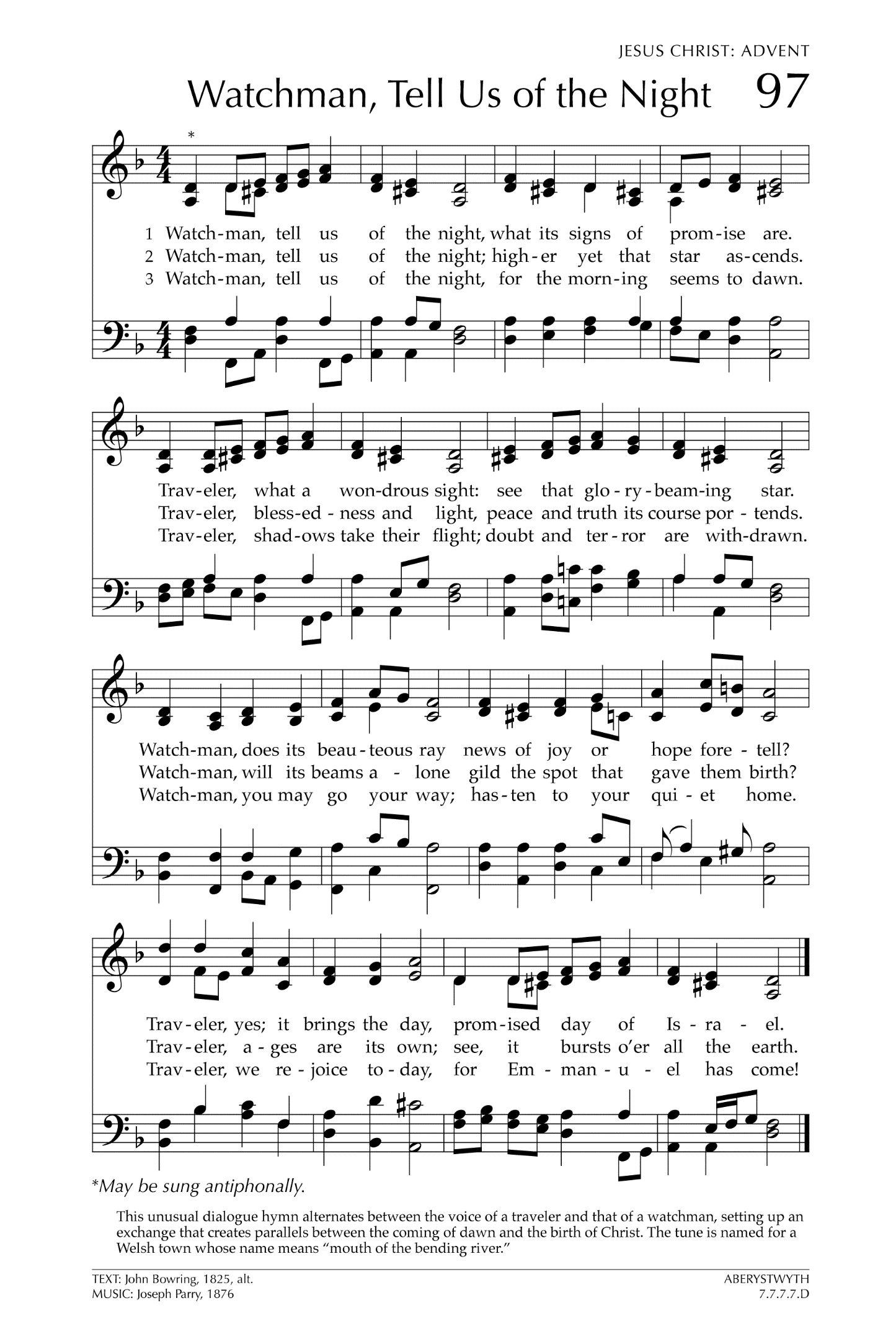
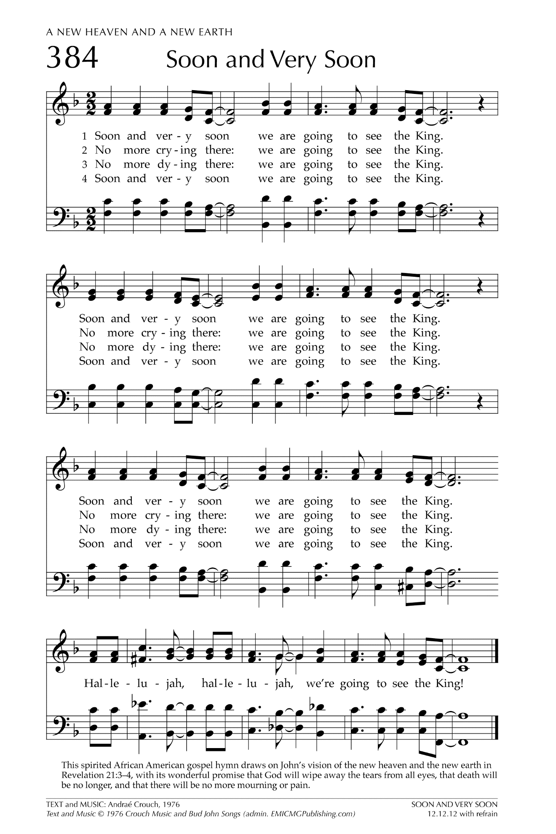
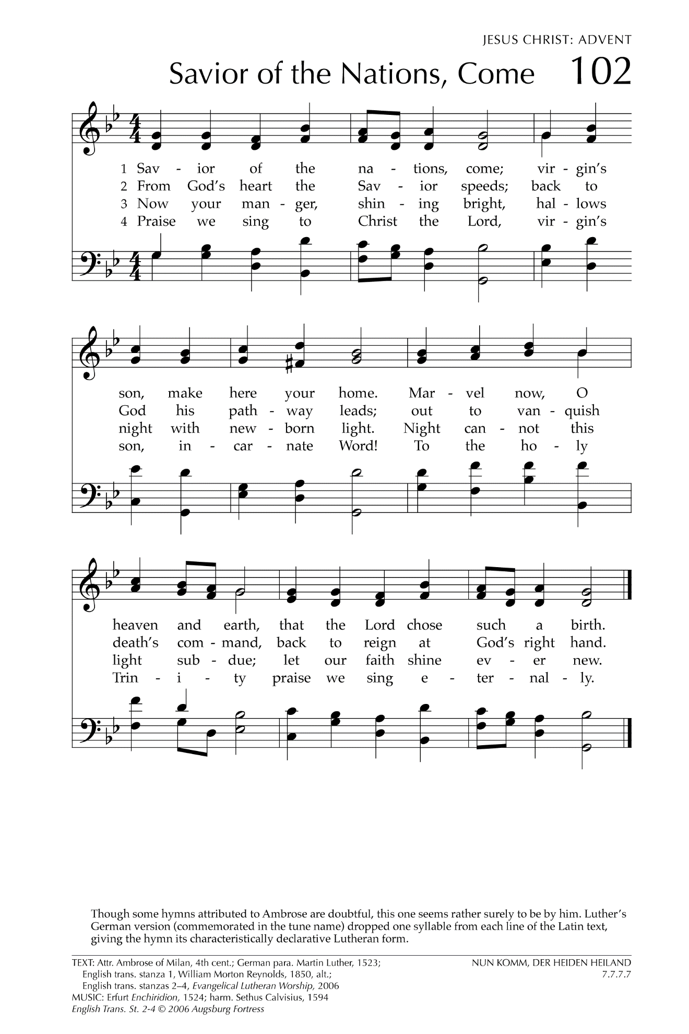

Let There Be Peace on Earth

Let there be peace on earth
And let it begin with me
Let there be peace on earth
The peace that was meant to be
With God as our Father
Christians all are we
Let us walk with each other
In perfect harmony.
Let peace begin with me
Let this be the moment now.
With every step I take
Let this be my solemn vow
To take each moment and live
Each moment in peace eternally
Let there be Peace on Earth
And let it begin with me!

