The Holy Way Presbyterian Church
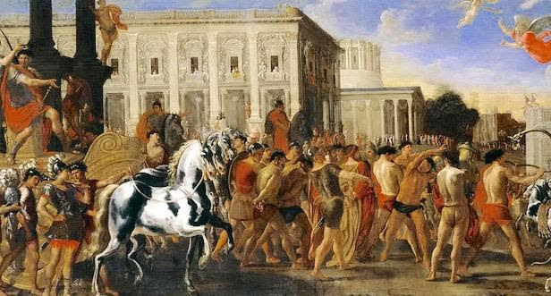

Tucson, Arizona

October 3, 2021 9:30 a.m.
Trusting In God Brings Comfort...

Words of Meditation - The Triumphal Entry of Constantine in Rome is a painting by Viviano Codazzi and Domenico Gargiulo. The fragrance of Christ among those who are perishing in an Ancient Roman Processional was quite a contrast. To one person it is a an aroma of death leading to death, and to another, it is an aroma of life, leading to life.

Welcome to Worship Rev. Tina Salvaneschi
Opening Prayer
Release Children to Sunday School - Miss Kathy
Introit: God, Who Stretched the Spangled Heavens (Hymn 24, V.4)
Ryan Phillips, Choir Director

Hymn: Open My Eyes, That I May See (Hymn #451) Ryan Phillips, Choir Director

Installation of New Members Rev. Tina Salvaneschi
William (Bill) and Esther Boals
Merlin and Peggy Hale
Janice Martin
Sheila Martin
Wayne McKee
Soren and Sheila Perry

Birthday’s and Anniversaries Alfonso Valenzuela
Celebrations, Joys and Concerns Rev. Tina Salvaneschi
The People of the Congregation Share Joys and Concerns

…The Lord’s Prayer
People: Our Father, who art in heaven, hallowed be thy name. Thy kingdom come, thy will be done on earth as it is in heaven. Give us this day our daily bread, and forgive us our debts as we forgive our debtors. And lead us not into temptation, but deliver us from evil, for thine is the kingdom and the power and the glory forever. Amen

Tithes and Offering: Prayer Rev. Tina Salvaneschi
(option: Place you index card with a private prayer for Pastor)
(option: write on index card a word or two what giving to God means to you and place index cards in plate)

Offertory Music: Come Share the Lord Chancel Choir
Dr. Astrid Chan

Scripture Reading: Lay Leader, Sherri Atleson
2 Corinthians 2:14-17

14 Now thanks be to God who always leads us in triumph in Christ, and through us diffuses the fragrance of His knowledge in every place. 15 For we are to God the fragrance of Christ among those who are being saved and among those who are perishing. 16 To the one we are the aroma of death leading to death, and to the other the aroma of life leading to life. And who is sufficient for these things? 17 For we are not, as so many, peddling the word of God; but as of sincerity, but as from God, we speak in the sight of God in Christ.

Leader: This is the Word of the Lord. People: Thanks be to God.

Message: “The Aroma of Christ” Rev. Tina Salvaneschi

Communion Hymn: Here in This Place (Hymn #401, V. 3)
Ryan Phillips, Choir Director
Communion: Words of Institution Rev. Tina Salvaneschi

(We are serving Communion by Intinction this morning with Covid Safety in mind. Ushers will welcome you forward on the sides of Sanctuary. Pastor and servers have bread and juice in front then please return to your seat down the center aisle. For those unable to come forward, we will serve you at your seat. Please be mindful of social distancing, and enjoy this time as we experience Communion together… (Gluten free is also available)

Sending Hymn: Oh Lord My God, How Great Thou Art (Hymn #625, V. 1,2,4)
Ryan Phillips, Choir Director

Benediction: 2 Corinthians 13:14 Rev. Tina Salvaneschi

Song: Let There Be Peace On Earth Ryan Phillips, Choir Director
Postlude: Dr. Astrid Chan

Stay Connected at The Holy Way
“Sermon Debrief Bible Study in person on Campus and Zoom” - Tuesday 10:00 a.m.
It’s Both! Come and meet live in the Conference Room at 10:00 a.m. or join on Zoom and we will conference you in on the big screen!
This is a great way to get to Fellowship, wrestle with questions about Sunday’s sermon, ponder the meaning of God’s Word, and discover how Scriptures can transform our lives today. This is led by Pastor Tina and is interactive! Come join the live class if you are able!

“Thoughtful Thursdays” - Thursday 10:00 a.m. Zoom Only
This is a great way to stay connected (especially for our snowbirds, and folks that can’t make it to in-person services!). We share about our lives, spend time talking, share joys, prayer requests…and anything else that comes up. Oh yes, laughter seems to happen too. This is group led, with Pastor Tina and for women AND men!

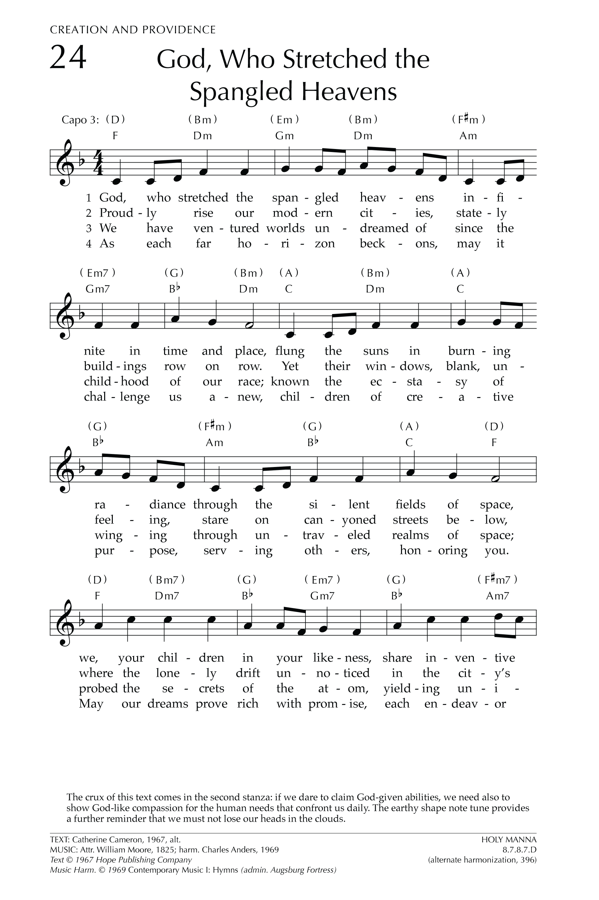
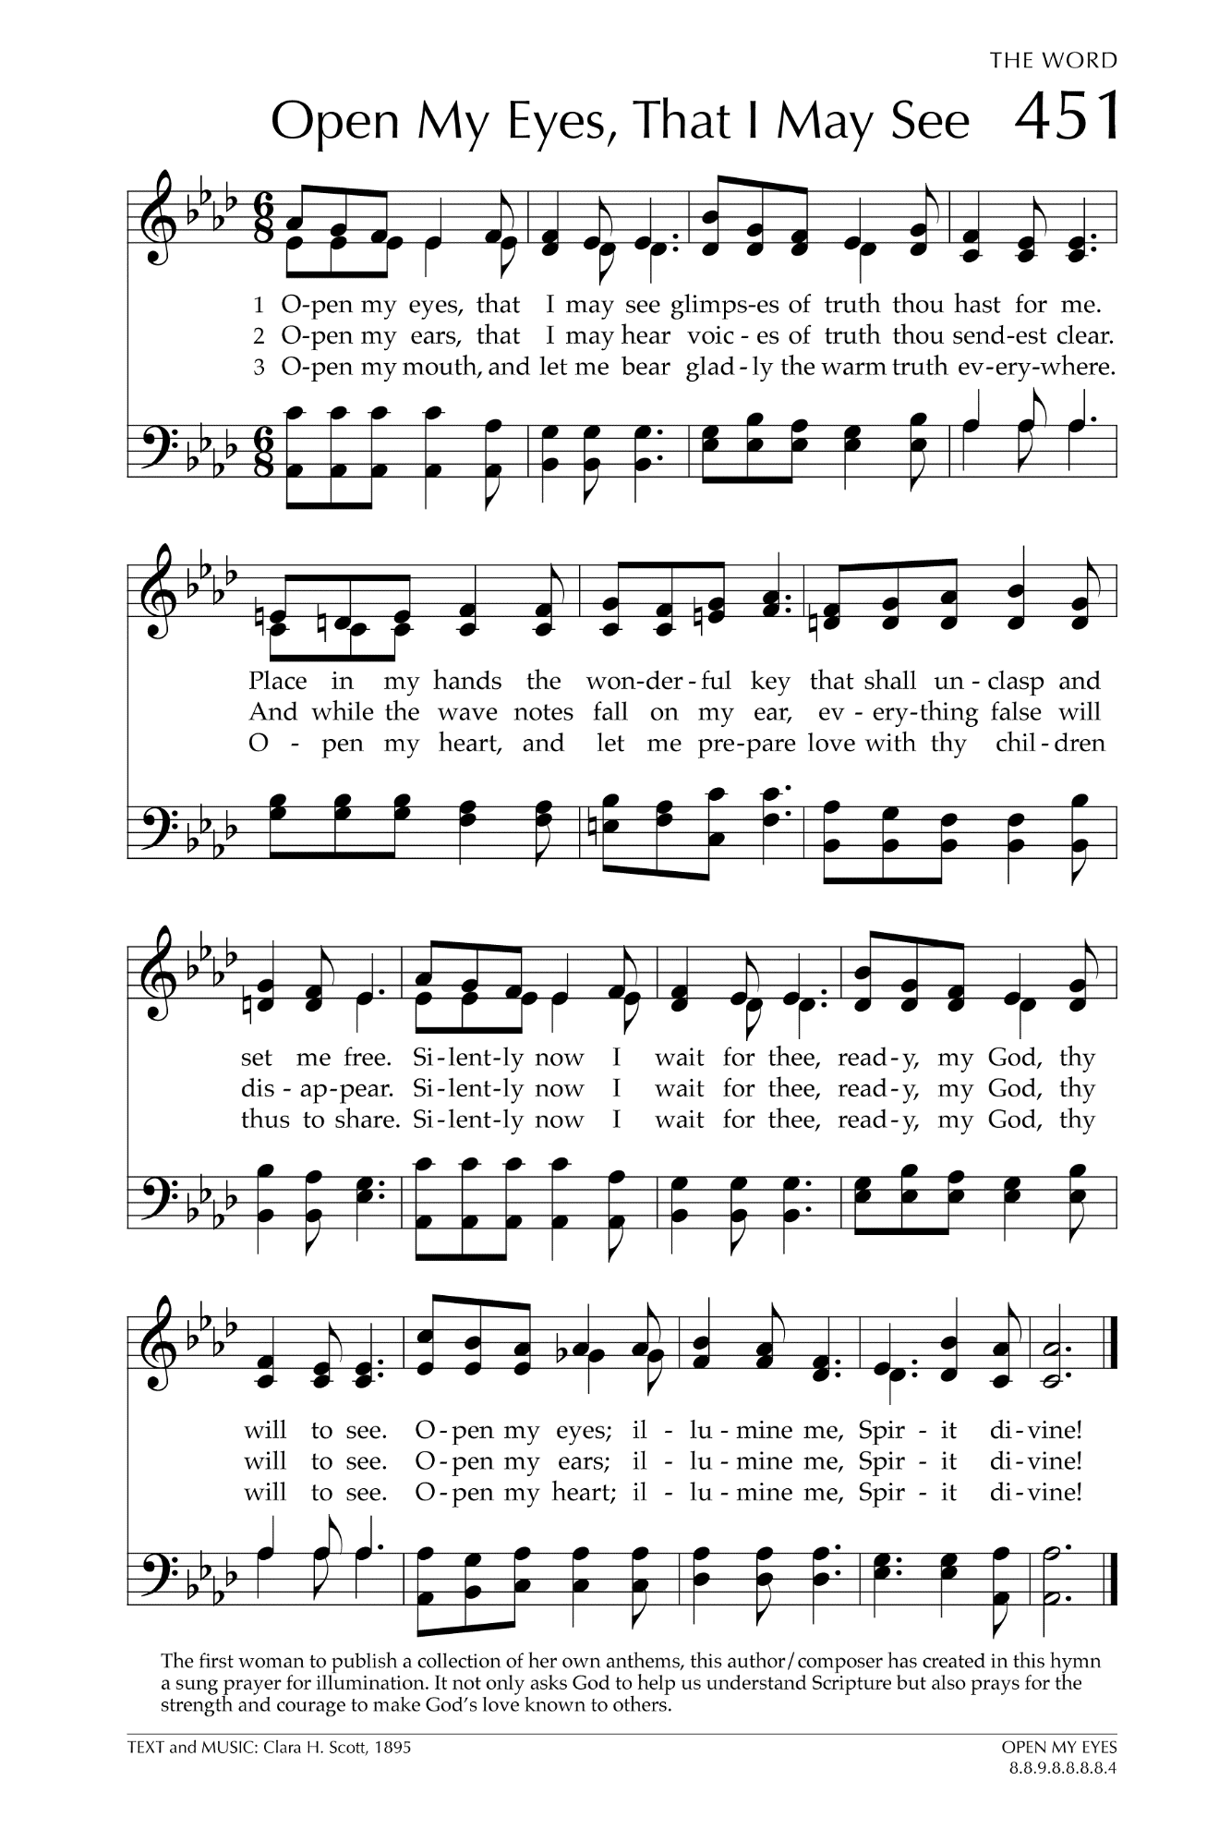
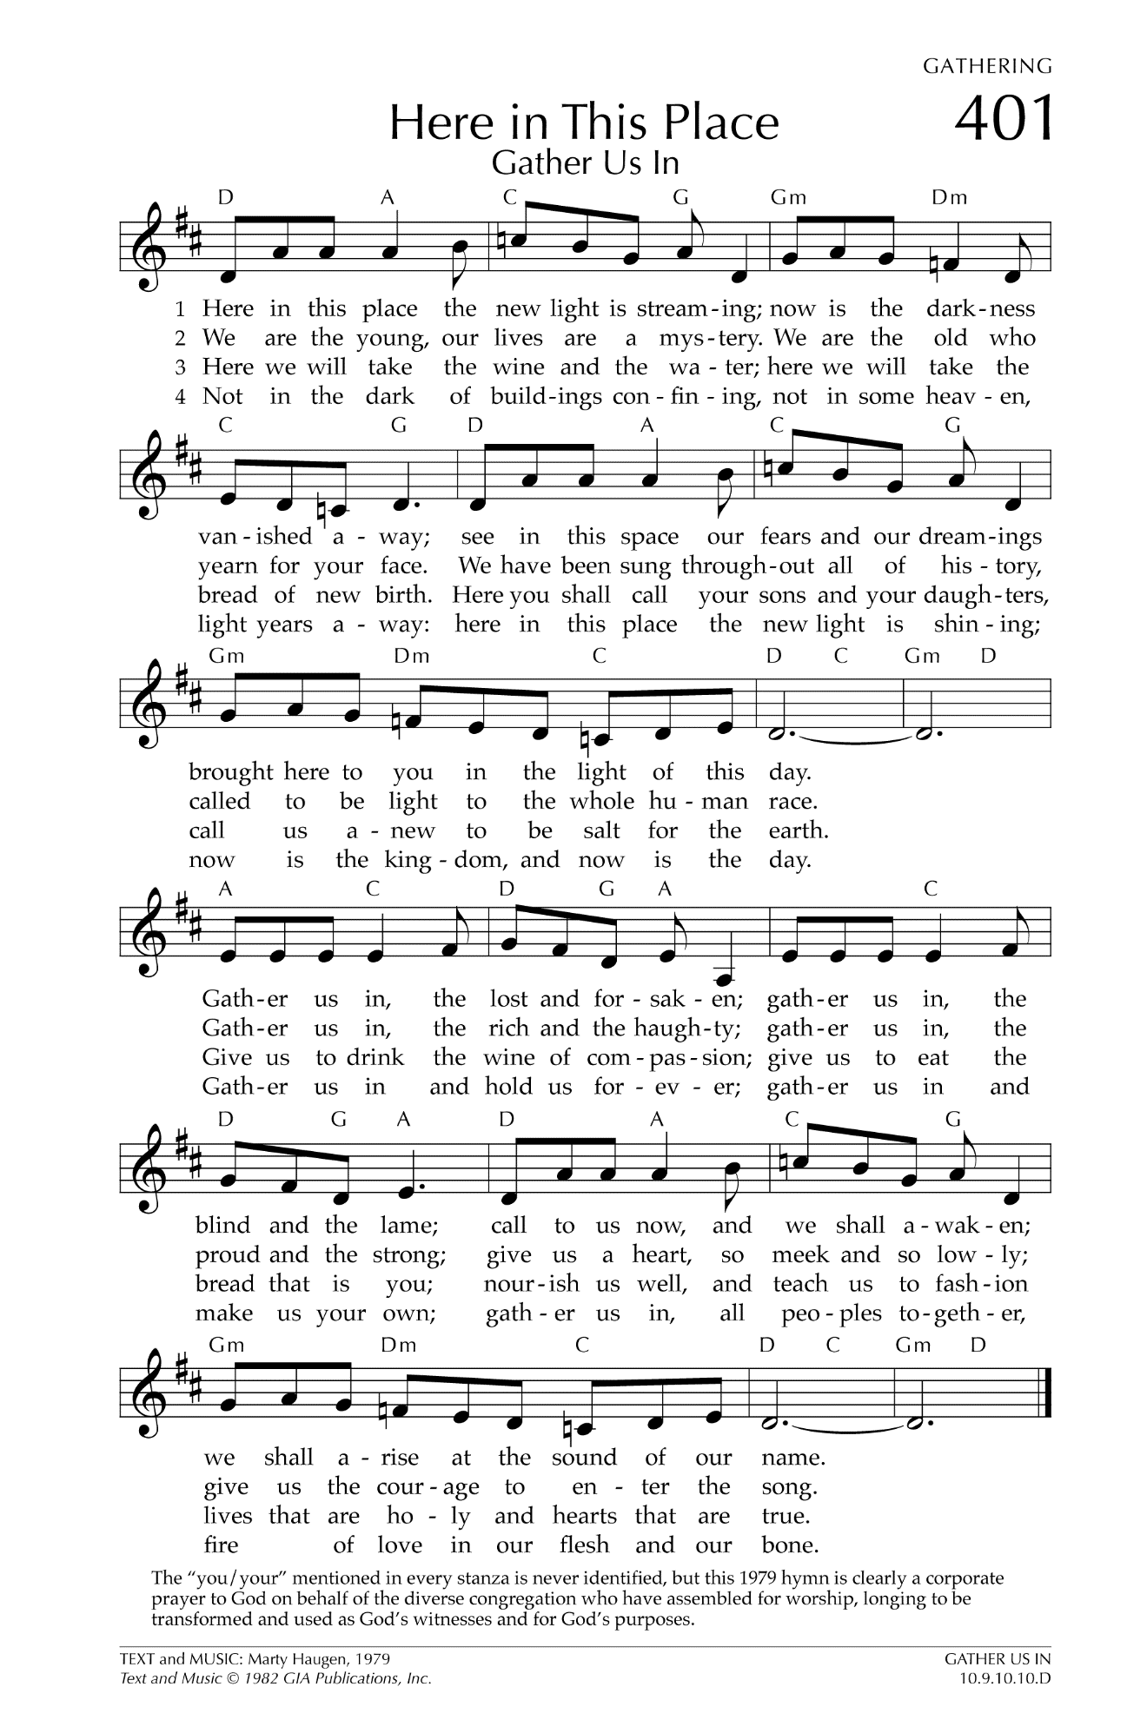
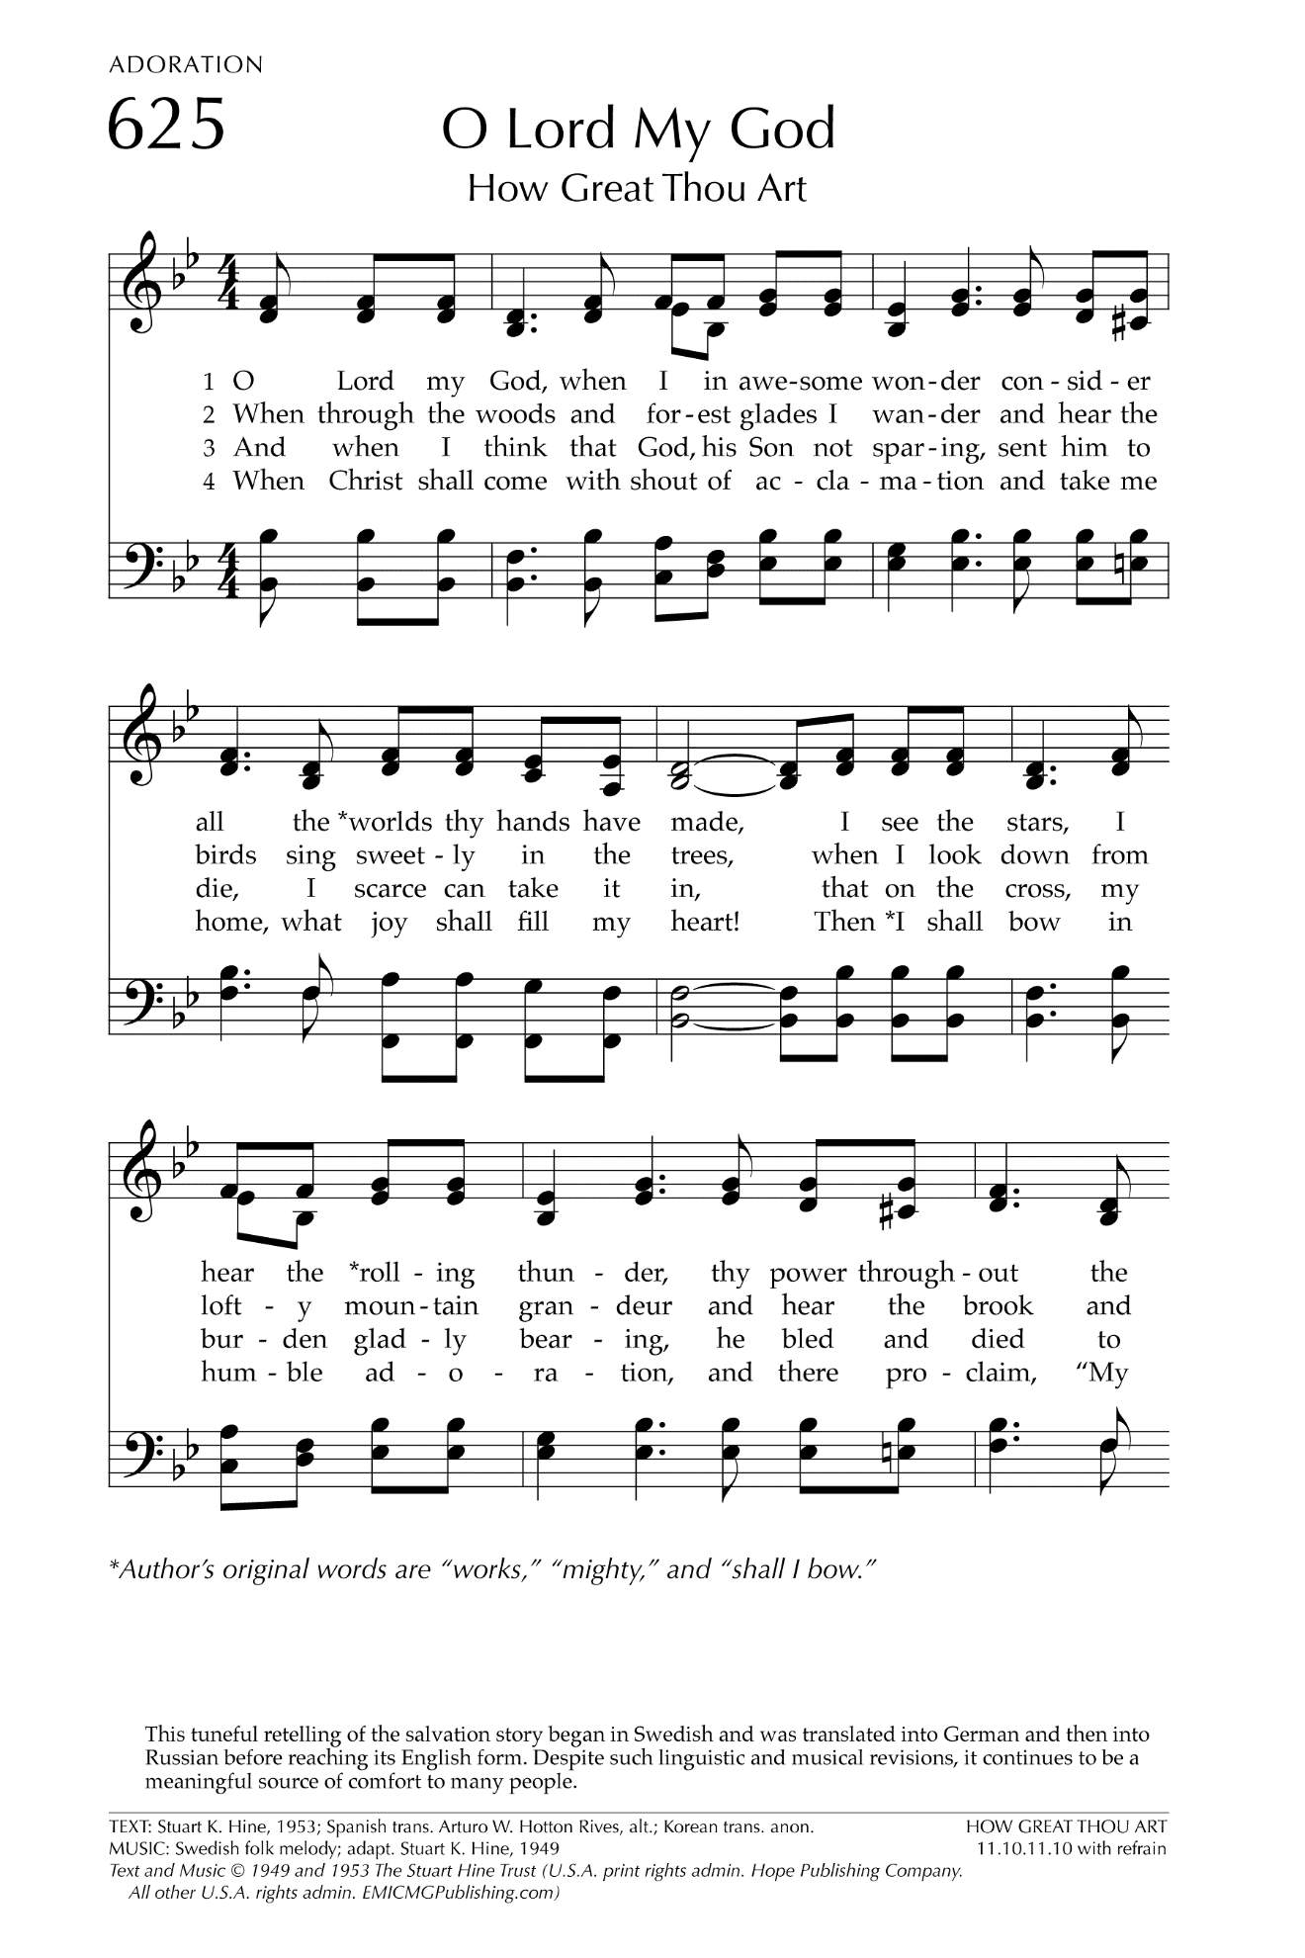

Let There Be Peace on Earth

Let there be peace on earth
And let it begin with me
Let there be peace on earth
The peace that was meant to be
With God as our Father
Christians all are we
Let us walk with each other
In perfect harmony.
Let peace begin with me
Let this be the moment now.
With every step I take
Let this be my solemn vow
To take each moment and live
Each moment in peace eternally
Let there be Peace on Earth
And let it begin with me!

