The Holy Way Presbyterian Church
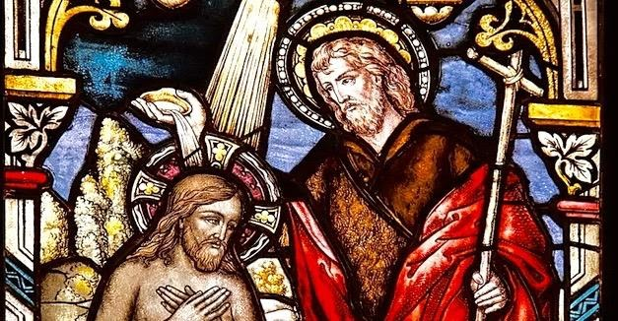

Tucson, Arizona

December 5, 2021 9:30 a.m.
Second Sunday of Advent...

Welcome to Worship Rev. Tina Salvaneschi
Opening Prayer
Release Children to Sunday School - Miss Kathy
Introit: Lift Up Your Heads You Mighty Gates (Hymn #93, v. 2)
Ryan Phillips, Choir Director

Hymn: Wild and Lone the Prophet’s Voice (Hymn #163) Ryan Phillips, Choir Director

Lighting of Advent Candle: Soren & Sheila Perry

We believe in God,
creator and lover of the earth,
origin and destiny of us all.
We believe in Jesus the Christ—
God coming to earth in the fragile promise
of a baby yet unborn—
who emerges as the herald of hope,
God's laughter in the face of despair.
Plunged into death and hell,
he broke captives free,
and is leading the way
to the land of promise
where justice and peace will flourish.

We believe in the Holy Spirit,
who implants the seed of truth,
and empowers us through Christ
to confront and transform
all that is corrupt, degraded and deceitful.

We believe in the coming reign of God.
Announced by John the Baptist,
where one day, all will be
robed in righteousness,
and gathered into the joyous fulfillment
of God's desire.

For one day that glorious day will come, so
we continue to pray...saying,
Come, Lord Jesus...Come!

People: Amen

The Perry’s light the candles together.

Birthdays and Anniversaries Stephen Levine
If you want to participate in our tradition of celebrating your birthday or anniversary by giving money towards church building, renovation, improvements & sound systems, just waive your hand, or stand up and Pastor Tina will receive it in the plate!

Celebrations, Joys and Concerns Rev. Tina Salvaneschi
The People of the Congregation Share Joys and Concerns

...The Lord’s Prayer
People: Our Father, who art in heaven, hallowed be thy name. Thy kingdom come, thy will be done on earth as it is in heaven. Give us this day our daily bread, and forgive us our debts as we forgive our debtors. And lead us not into temptation, but deliver us from evil, for thine is the kingdom and the power and the glory forever. Amen

Anthem: Come Share the Lord Chancel Choir
Tithes and Offering: Prayer Rev. Tina Salvaneschi
(Option: Place you index card with a private prayer for Pastor)
(Option: write on index card a word or two what giving to God means to you place index cards in plate)

Offertory Music: Dr. Astrid Chan

Doxology: (Hymn #606) Ryan Phillips, Choir Director
Praise God, from whom all blessings flow;
praise God all creatures here below;
praise God above, ye heavenly host;
praise Father, Son, and Holy Ghost. Amen.

Scripture Reading: Lay Leader, Jeannie Hollis
Matthew 3:1-11
1 In those days John the Baptist came preaching in the wilderness of Judea, 2 and saying, “Repent, for the kingdom of heaven is at hand!” 3 For this is he who was spoken of by the prophet Isaiah, saying:

“The voice of one crying in the wilderness:
‘Prepare the way of the Lord;
Make His paths straight.’ ”

4 Now John himself was clothed in camel’s hair, with a leather belt around his waist; and his food was locusts and wild honey. 5 Then Jerusalem, all Judea, and all the region around the Jordan went out to him 6 and were baptized by him in the Jordan, confessing their sins.

7 But when he saw many of the Pharisees and Sadducees coming to his baptism, he said to them, “Brood of vipers! Who warned you to flee from the wrath to come? 8 Therefore bear fruits worthy of repentance, 9 and do not think to say to yourselves, ‘We have Abraham as our father.’ For I say to you that God is able to raise up children to Abraham from these stones. 10 And even now the ax is laid to the root of the trees. Therefore every tree which does not bear good fruit is cut down and thrown into the fire. 11 I indeed baptize you with water unto repentance, but He who is coming after me is mightier than I, whose sandals I am not worthy to carry. He will baptize you with the Holy Spirit and fire.

Leader: This is the Word of the Lord.

People: Thanks be to God.

Message: “The Coming One” Rev. Tina Salvaneschi

Communion: Words of Institution Rev. Tina Salvaneschi
(Ushers will bring elements to your seats, we will partake together)

Communion Hymn: Come to the Table of Grace (Hymn #507) ( V. 1, 2)
Ryan Phillips, Choir Director
Sending Hymn: Together We Serve (Hymn #767) Ryan Phillips, Choir Director

Benediction: 2 Corinthians 13:14 Rev. Tina Salvaneschi

Song: Let There Be Peace on Earth Ryan Phillips, Choir Director

Postlude: Dr. Astrid Chan

Congregational Meeting will immediately follow the worship service.

Stay Connected During the Week!

“Sermon Debrief Bible Study in person on Campus” - Tuesday 10:00 am! Vaccinated Only Please (no Zoom)
Come and meet live in the Sanctuary at 10:00 am.
This is a great way to get to Fellowship, wrestle with questions about Sunday’s sermon, ponder the meaning of God’s Word, and discover how Scriptures can transform our lives today. This is led by Pastor Tina and is interactive and often there are donuts! Come join the live class if you are able!

“Thoughtful Thursdays” - Thursdays 10:00 am Zoom Only
This is a great way to stay connected (especially for our snowbirds, and folks that can’t make it to in-person services!). We share about our lives, spend time talking, share joys, pray requests…and anything else that comes up. Oh yes, laughter seems to happen too. This is group led, with Pastor Tina and for women AND men!

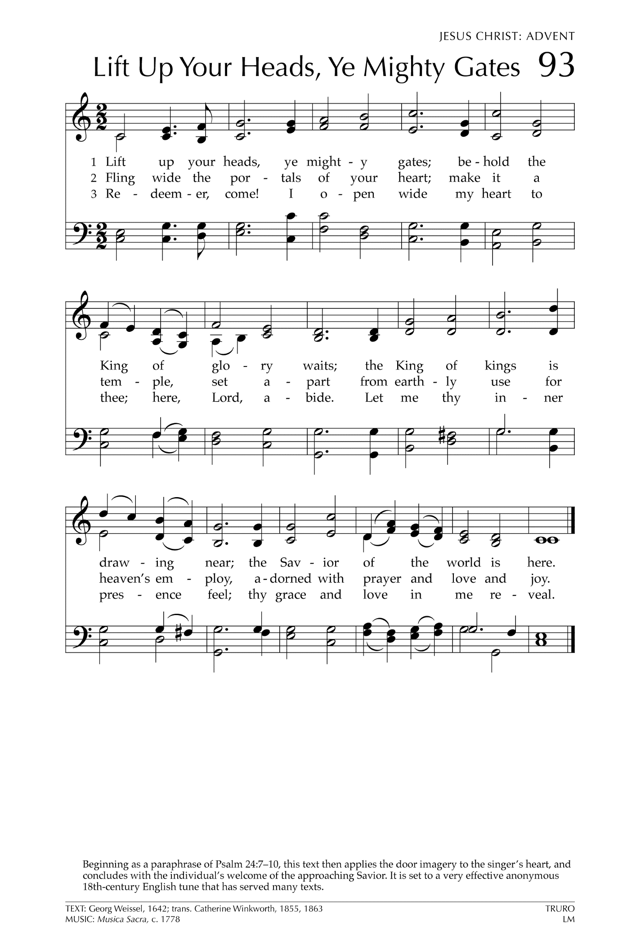
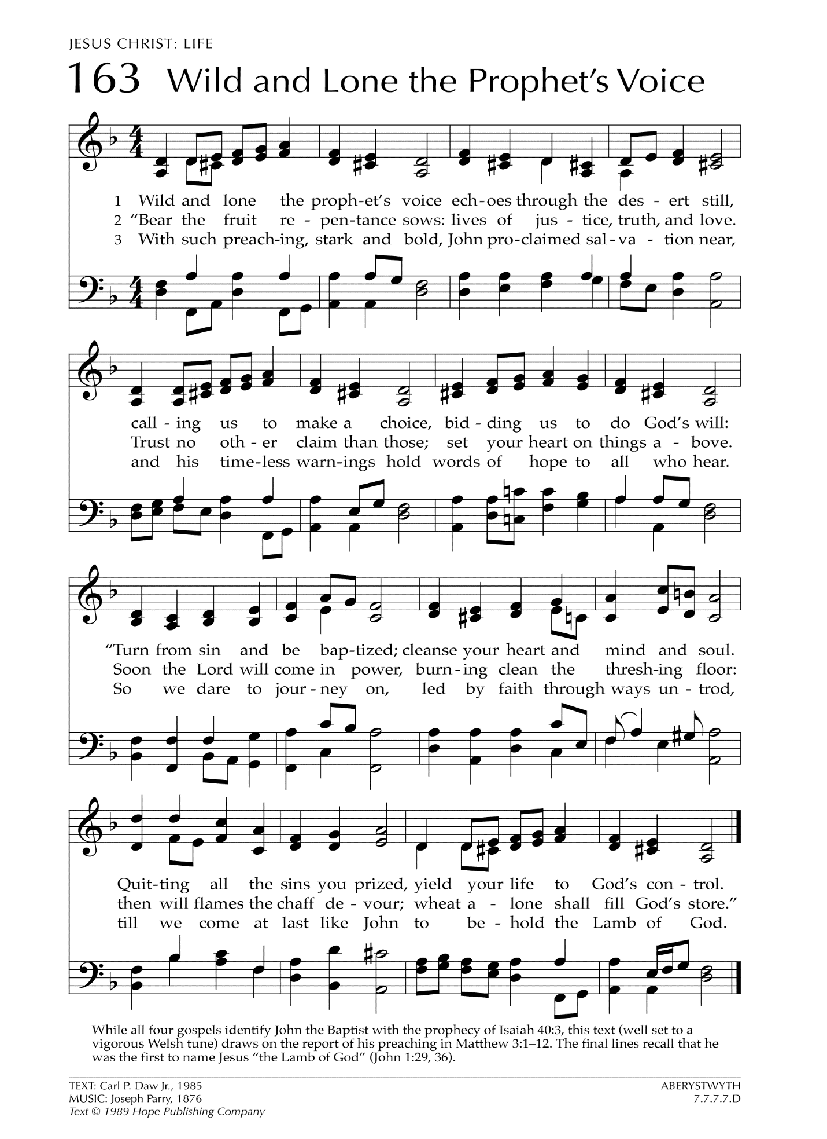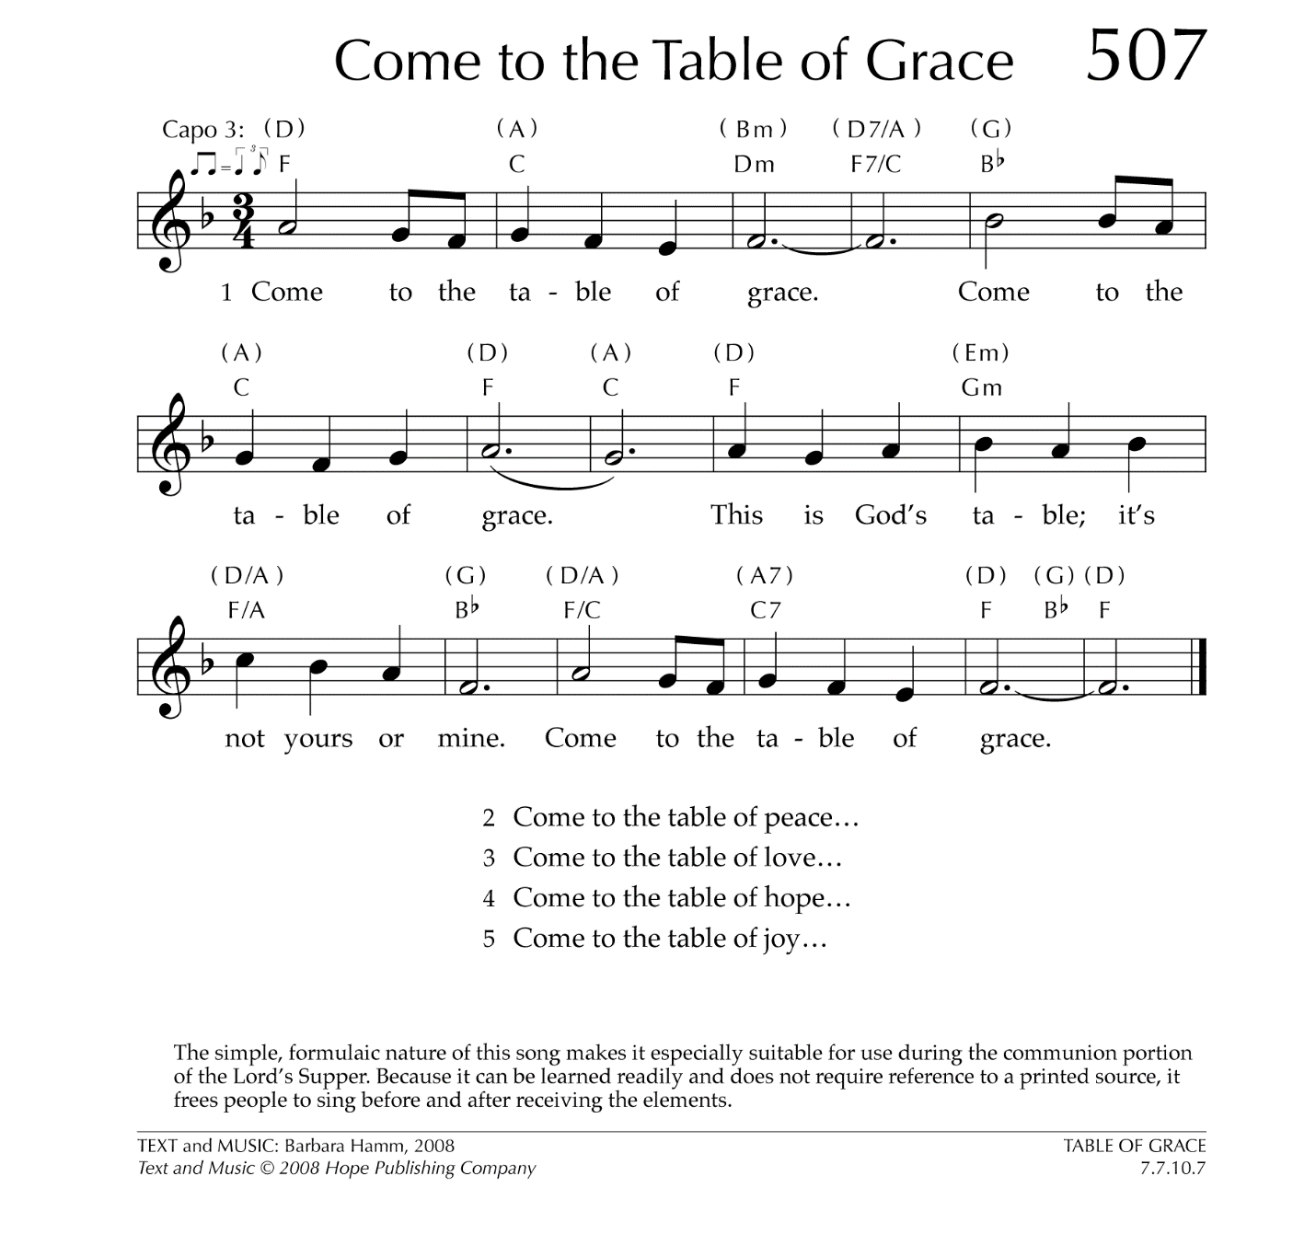

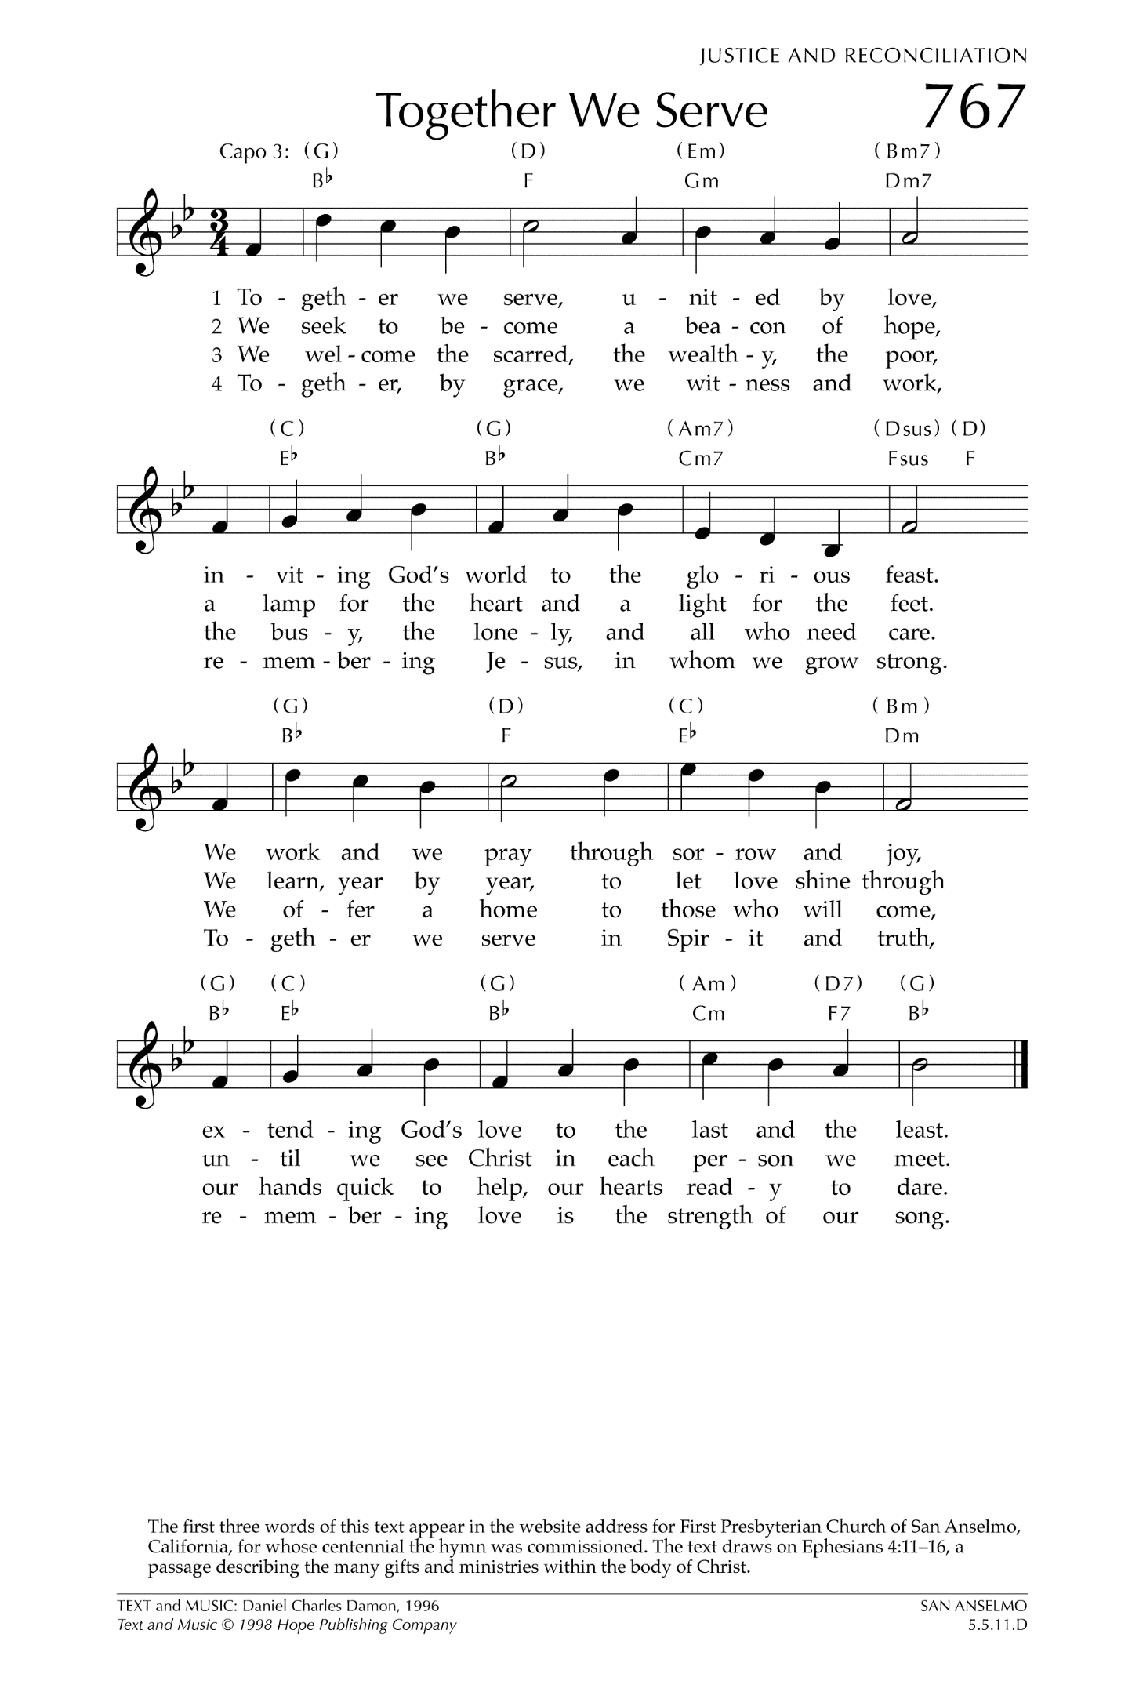

Let There Be Peace on Earth

Let there be peace on earth
And let it begin with me
Let there be peace on earth
The peace that was meant to be
With God as our Father
Christians all are we
Let us walk with each other
In perfect harmony.
Let peace begin with me
Let this be the moment now.
With every step I take
Let this be my solemn vow
To take each moment and live
Each moment in peace eternally
Let there be Peace on Earth
And let it begin with me!

