The Holy Way Presbyterian Church

Tucson, Arizona

October 10, 2021 9:30 a.m.
Trusting In God Brings Comfort...

Welcome to Worship Rev. Tina Salvaneschi
Opening Prayer
Release Children to Sunday School – Mr. Stephen
Introit: God of Grace and Glory (Hymn #307, V 1)
Ryan Phillips, Choir Director

Hymn: O Word of God Incarnate (Hymn #459) Ryan Phillips, Choir Director

Call to Worship: Lay Leader, Jeannie Hollis

Leader: Creator God,
we are so grateful for the creation which nourishes
and sustains all that lives.
Renew in us the sense of its value
that we may not squander its riches.
Or, that we bend it to our will that we find we have
destroyed it.

People: Bless the Lord, my soul
and bless God’s holy name.
Bless the Lord, my soul,
who leads us into life.

Transforming God,
we cannot sow our seed with clenched fists.
Help us to open our hands, and let go of grasping,
that we too may scatter our seeds of justice, peace and joy
with hope and generosity
May the fruits of our harvest
be for the sharing of the earth
and for the blessing of Your love.

People: Bless the Lord, my soul
and bless God’s holy name.
Bless the Lord, my soul,
who leads us into life.

People: Amen

Birthdays and Anniversaries
Celebrations, Joys and Concerns Rev. Tina Salvaneschi
The People of the Congregation Share Joys and Concerns

...The Lord’s Prayer
People: Our Father, who art in heaven, hallowed be thy name. Thy kingdom come, thy will be done on earth as it is in heaven. Give us this day our daily bread, and forgive us our debts as we forgive our debtors. And lead us not into temptation, but deliver us from evil, for thine is the kingdom and the power and the glory forever. Amen

Anthem: Prayer of St. Francis Chancel Choir
Tithes and Offering: Prayer Rev. Tina Salvaneschi
(Option: Place you index card with a private prayer for Pastor)
(Option: write on index card a word or two what giving to God means to you place index cards in plate)

Offertory Music: What Wonderous Love is This Dr. Astrid Chan Judy Montrose

Scripture Reading: Lay Leader, Jeannie Hollis
2 Corinthians 9:6-12

6 But this I say: He who sows sparingly will also reap sparingly, and he who sows bountifully will also reap bountifully. 7 So let each one give as he purposes in his heart, not grudgingly or of necessity; for God loves a cheerful giver. 8 And God is able to make all grace abound toward you, that you, always having all sufficiency in all things, may have an abundance for every good work. 9 As it is written:

“He has dispersed abroad; He has given to the poor; His righteousness endures forever.”

10 Now may He who supplies seed to the sower, and bread for food, supply and multiply the seed you have sown and increase the fruits of your righteousness, 11 while you are enriched in everything for all liberality, which causes thanksgiving through us to God. 12 For the administration of this service not only supplies the needs of the saints, but also is abounding through many thanksgivings to God.
Leader: This is the Word of the Lord. People: Thanks be to God.

Message: “A Generous Heart” Rev. Tina Salvaneschi

Sending Hymn: Come, Thou Fount of Every Blessing (Hymn #475)
Ryan Phillips, Choir Director

Benediction: 2 Corinthians 13:14 Rev. Tina Salvaneschi

Song: Let There Be Peace On Earth Ryan Phillips, Choir Director
Postlude: Dr. Astrid Chan

Stay Connected at The Holy Way
“Sermon Debrief Bible Study in person on Campus and Zoom” - Tuesday 10:00 a.m.
It’s Both! Come and meet live in the Conference Room at 10:00 a.m. or join on Zoom and we will conference you in on the big screen!
This is a great way to get to Fellowship, wrestle with questions about Sunday’s sermon, ponder the meaning of God’s Word, and discover how Scriptures can transform our lives today. This is led by Pastor Tina and is interactive! Come join the live class if you are able!

“Thoughtful Thursdays” - Thursday 10:00 a.m. Zoom Only
This is a great way to stay connected (especially for our snowbirds, and folks that can’t make it to in-person services!). We share about our lives, spend time talking, share joys, prayer requests…and anything else that comes up. Oh yes, laughter seems to happen too. This is group led, with Pastor Tina and for women AND men!

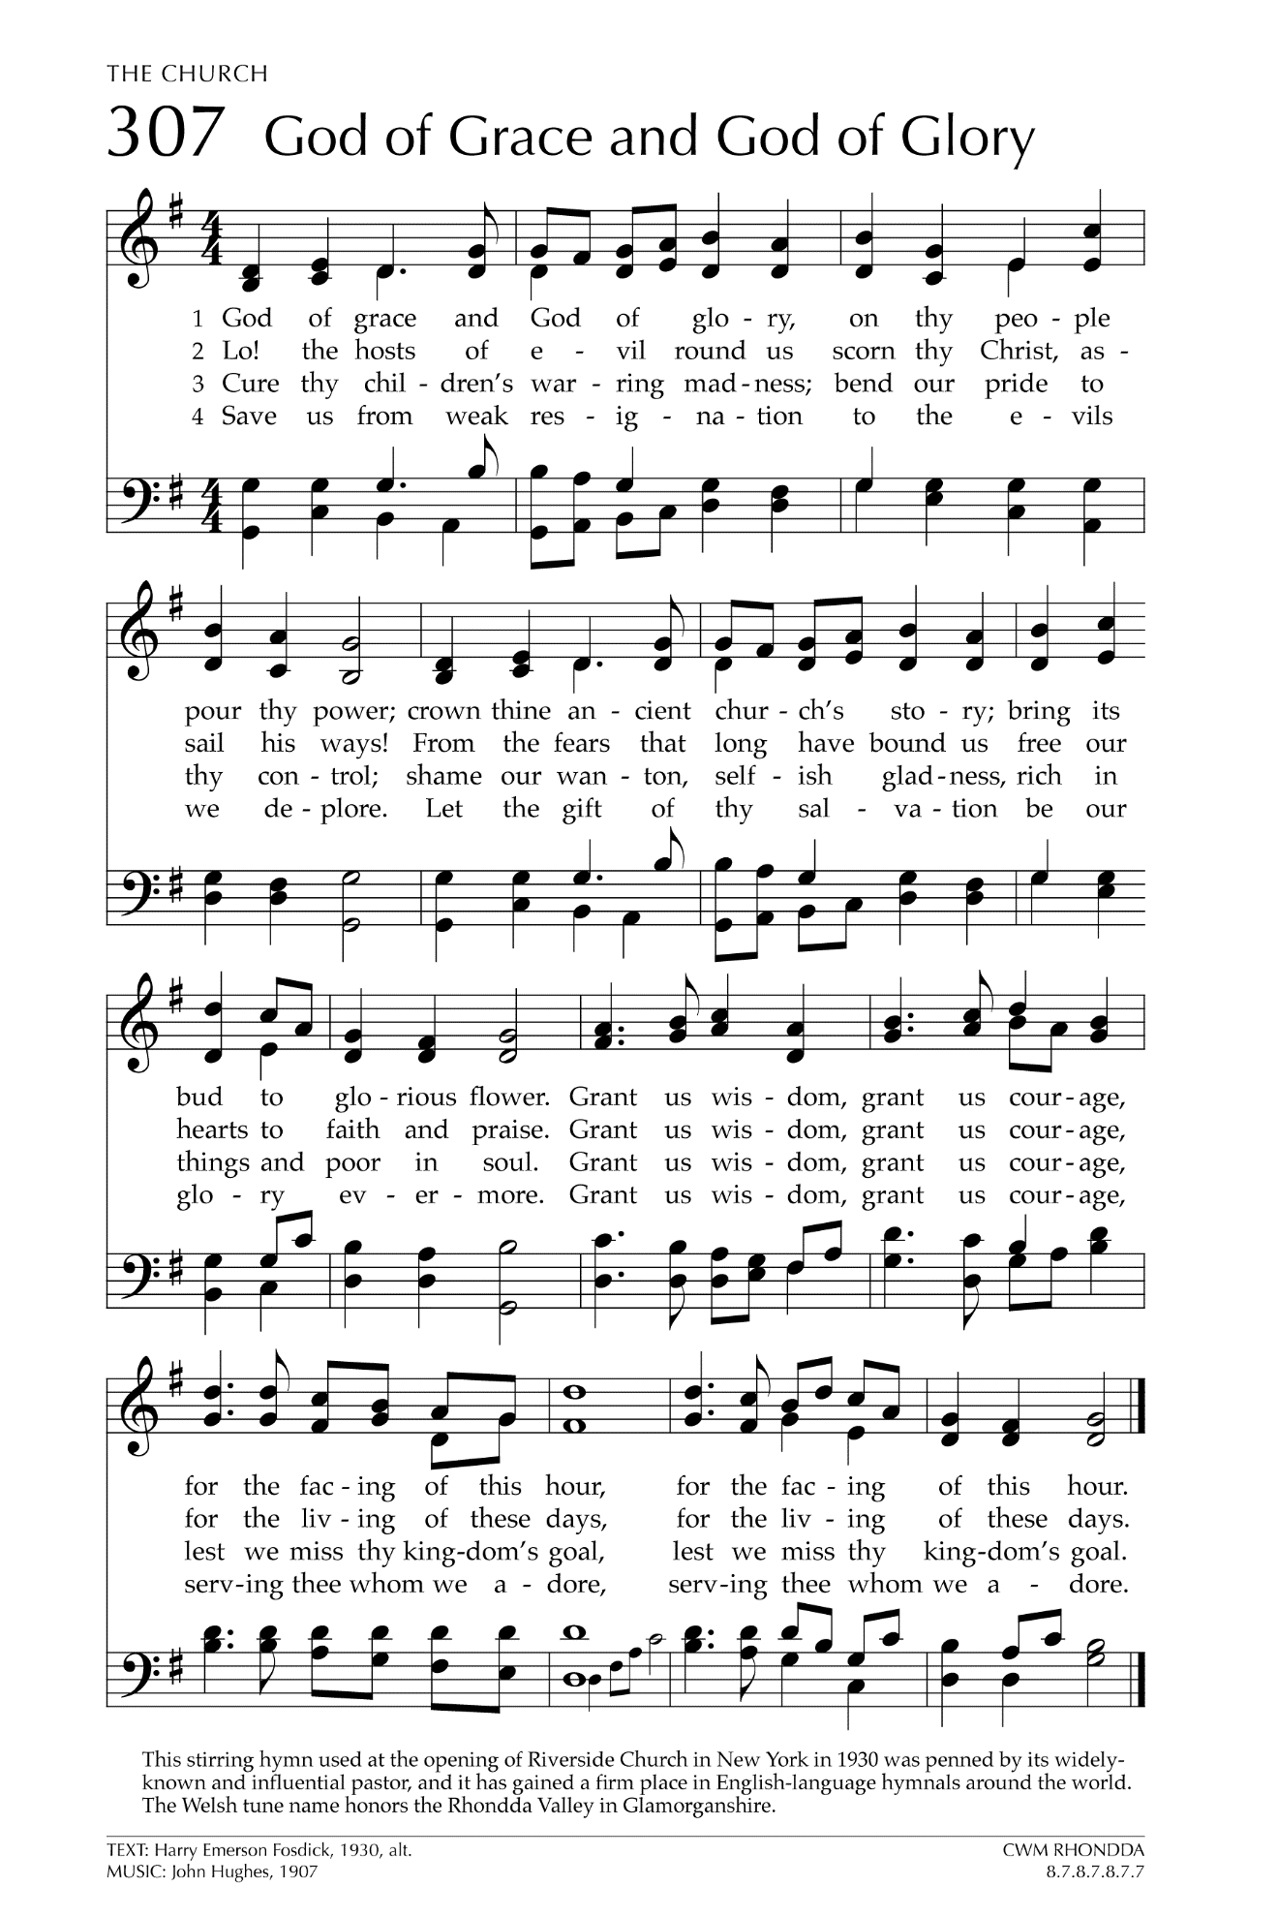
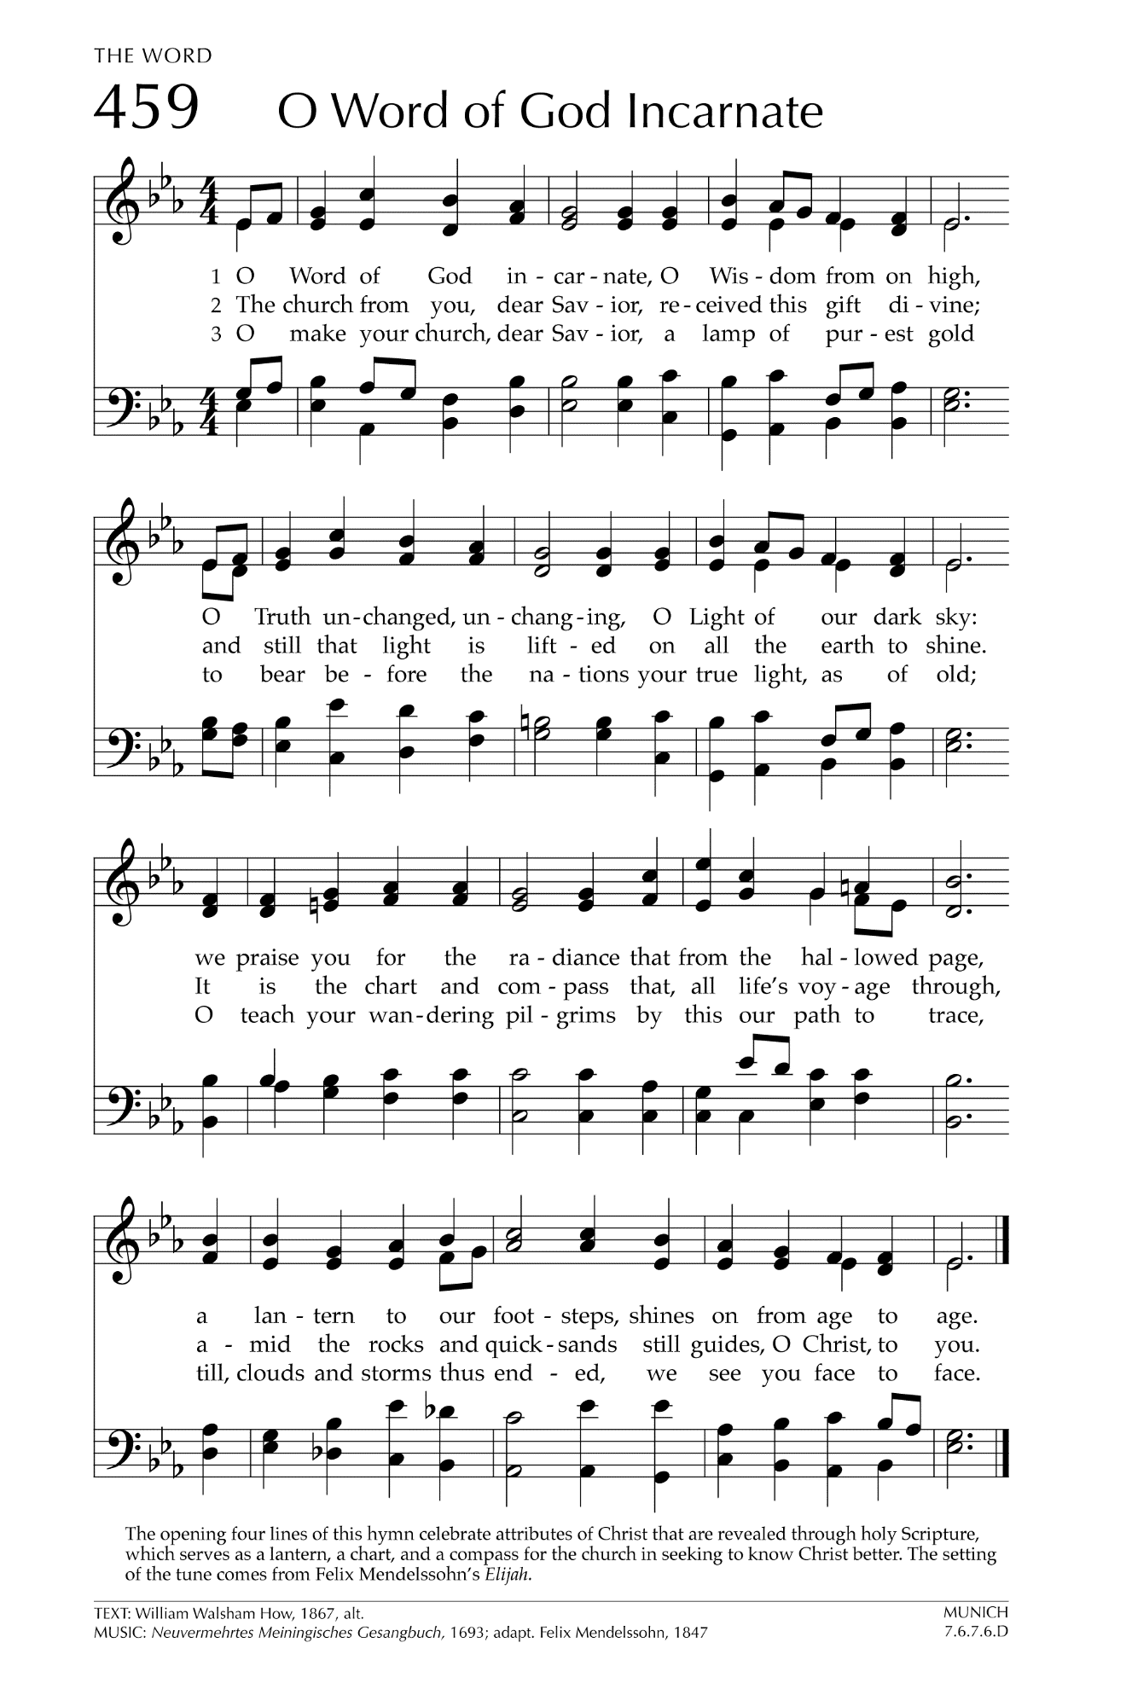
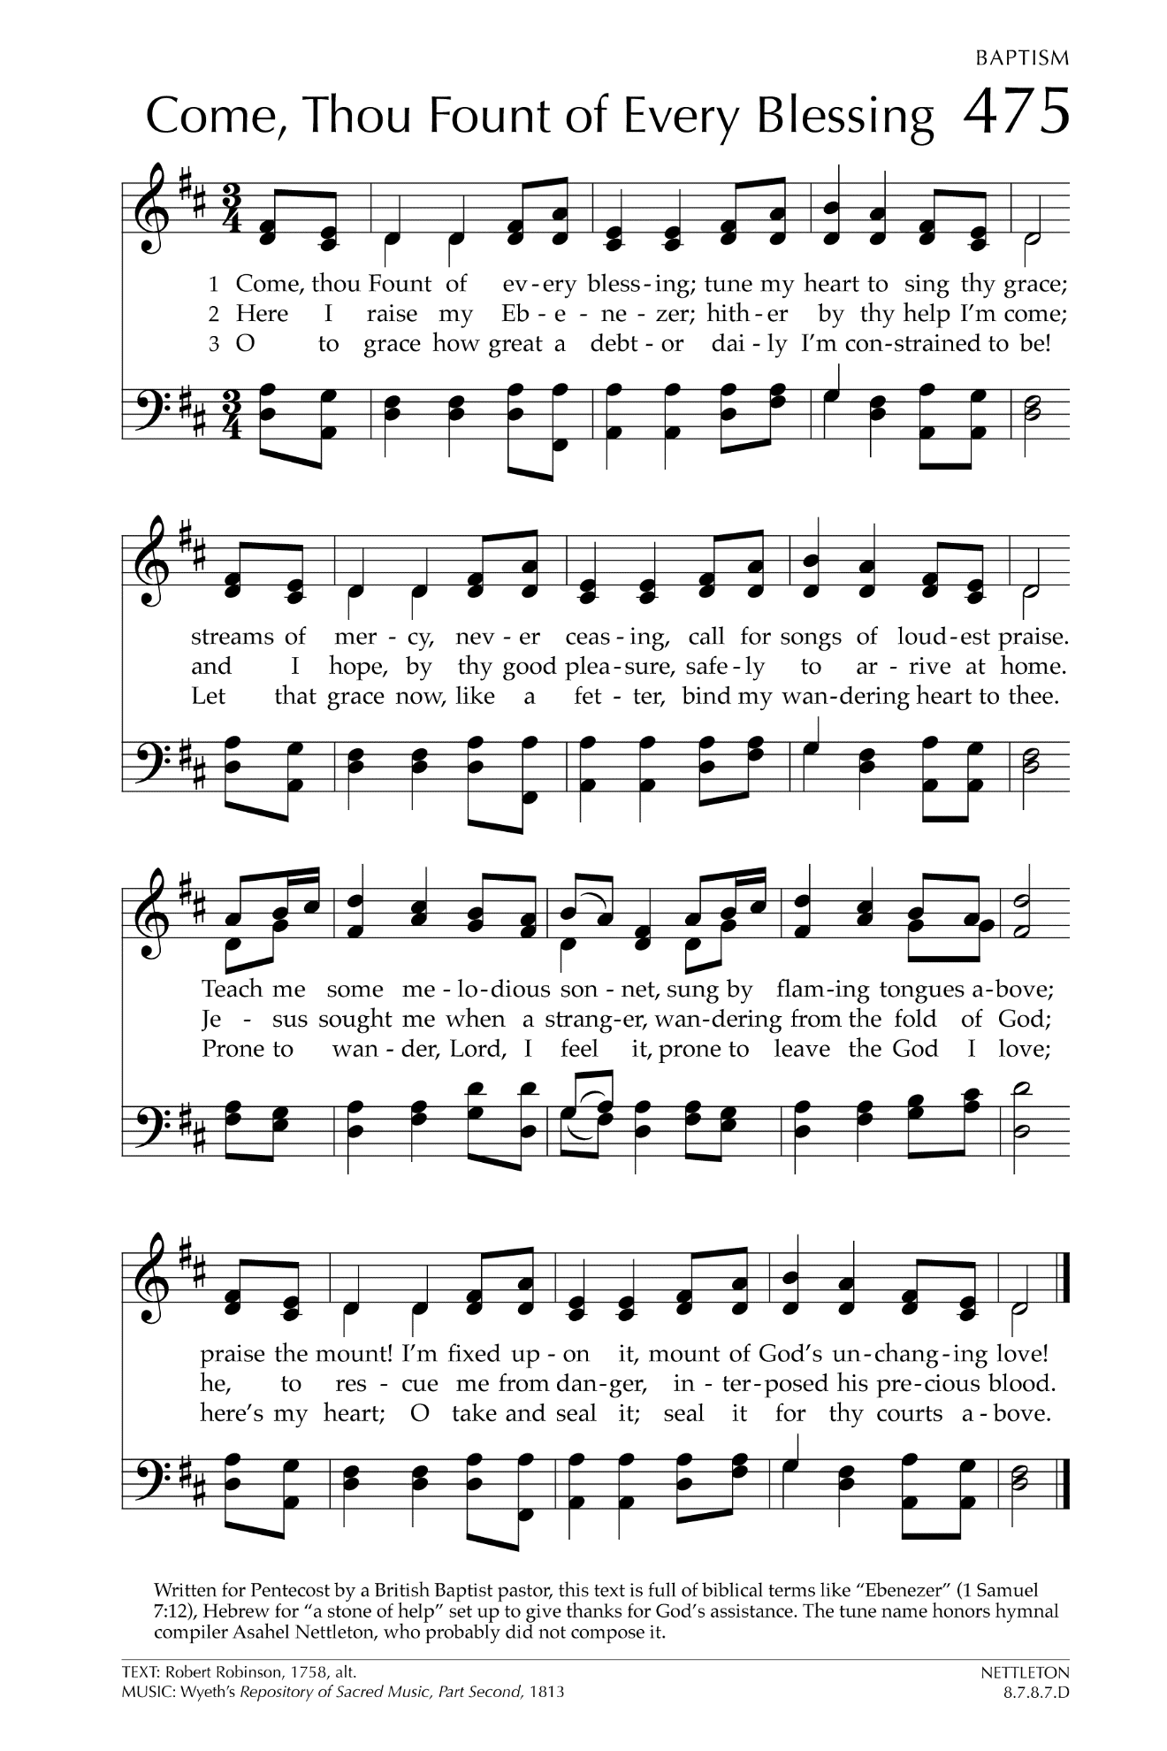

Let There Be Peace on Earth

Let there be peace on earth
And let it begin with me
Let there be peace on earth
The peace that was meant to be
With God as our Father
Christians all are we
Let us walk with each other
In perfect harmony.
Let peace begin with me
Let this be the moment now.
With every step I take
Let this be my solemn vow
To take each moment and live
Each moment in peace eternally
Let there be Peace on Earth
And let it begin with me!

