The Holy Way Presbyterian Church
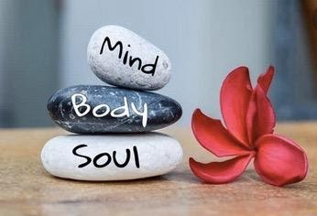

Tucson, Arizona

January 31, 2022 9:30 a.m.
Finding Balanced Living Series...

Welcome to Worship: Rev. Tina Salvaneschi
Opening Prayer
Children are Released to Sunday School

Hymn: Majesty (See attached, 2 X) Congregation
Cindy Johnston

Brief Special Congregational Meeting:

Call Meeting to Order Pastor Tina
Opening Prayer
Action Item: Seeking Approval for member Mary Marsch as Elder to fill recent vacancy on Session due to Returning Elder resignation who has stepped down with too much on her plate. Nominating Committee
recommends and Session has Approved Member Mary Marsch for
congregation approval.
Meeting Adjourned Pastor Tina

Birthdays and Anniversaries Stephen Levine
Sing Happy Birthday/Versary Cindy Johnston

If you want to participate in our tradition of celebrating your birthday or anniversary by giving money towards church building, renovations, improvements, sound systems, just waive your hand, or stand up and Pastor Tina will receive it in the basket!

Celebrations, Joys and Concerns Rev. Tina Salvaneschi
The People of the Congregation Share Joys and Concerns

...The Lord’s Prayer
People: Our Father, who art in heaven, hallowed be thy name. Thy kingdom come, thy will be done on earth as it is in heaven. Give us this day our daily bread, and forgive us our debts as we forgive our debtors. And lead us not into temptation, but deliver us from evil, for thine is the kingdom and the power and the glory forever. Amen

Installation of Elder: Welcome Candidate, Mary Marsch
(Pastor Tina Lay on Hands)
Rev. Tina Salvaneschi
Tithes and Offering: Prayer Rev. Tina Salvaneschi
(Option: Place you index card with a private prayer for Pastor)
(Option: write on index card a word or two what giving to God means to you place index cards in plate)

Anthem: When Peace Like a River
(It Is Well With My Soul) (Hymn 840, V. 1,2, 4) Congregation
Cindy Johnston

Doxology: (Hymn #606) Congregation
Praise God, from whom all blessings flow;
praise Him all creatures here below;
praise Him above, ye heavenly host;
praise Father, Son, and Holy Ghost. Amen.

Scripture Reading: Lay Leader Barbara Armbruster
Leviticus 14:33-48 (Reading)

33 And the Lord spoke to Moses and Aaron, saying: 34 “When you have come into the land of Canaan, which I give you as a possession, and I put the leprous plague in a house in the land of your possession, 35 and he who owns the house comes and tells the priest, saying, ‘It seems to me that there is some plague in the house,’ 36 then the priest shall command that they empty the house, before the priest goes into it to examine the plague, that all that is in the house may not be made unclean; and afterward the priest shall go in to examine the house.

44 then the priest shall come and look; and indeed if the plague has spread in the house, it is an active leprosy in the house. It is unclean. 47 And he who lies down in the house shall wash his clothes, and he who eats in the house shall wash his clothes.

48 “But if the priest comes in and examines it, and indeed the plague has not spread in the house after the house was plastered, then the priest shall pronounce the house clean, because the plague is healed.

Leader: This is the Word of the Lord.
People: Thanks be to God.

Message: “Balancing Spiritual & Physical Health”
Rev. Tina Salvaneschi

Sending Hymn: Open My Eyes, That I May See (Hymn 451) Congregation
Cindy Johnston

Benediction: 2 Corinthians 13:14 Rev. Tina Salvaneschi

Song: Let There Be Peace On Earth Congregation

Postlude: Astrid Chan

Stay Connected During the Week!

“Sermon Debrief Bible Study in person on Campus” - Tuesday 10:00 a.m.! Vaccinated Only Please (no Zoom)
Come and meet live in the Sanctuary at 10:00 a.m.
This is a great way to get to Fellowship, wrestle with questions about Sunday’s sermon, ponder the meaning of God’s Word, and discover how Scriptures can transform our lives today. This is led by Pastor Tina and is interactive and often there are donuts! Come join the live class if you are able!

“Thoughtful Thursdays” - Thursdays 10:00 a.m. Zoom Only
This is a great way to stay connected (especially for our snowbirds, and folks that can’t make it to in-person services!). We share about our lives, spend time talking, share joys, pray requests…and anything else that comes up. Oh yes, laughter seems to happen too. This is group lead, with Pastor Tina and for women AND men!
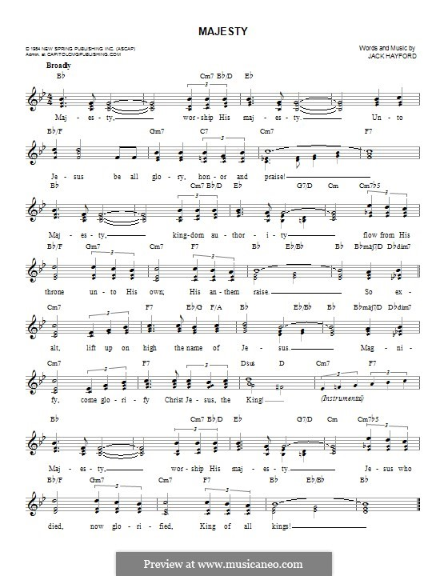

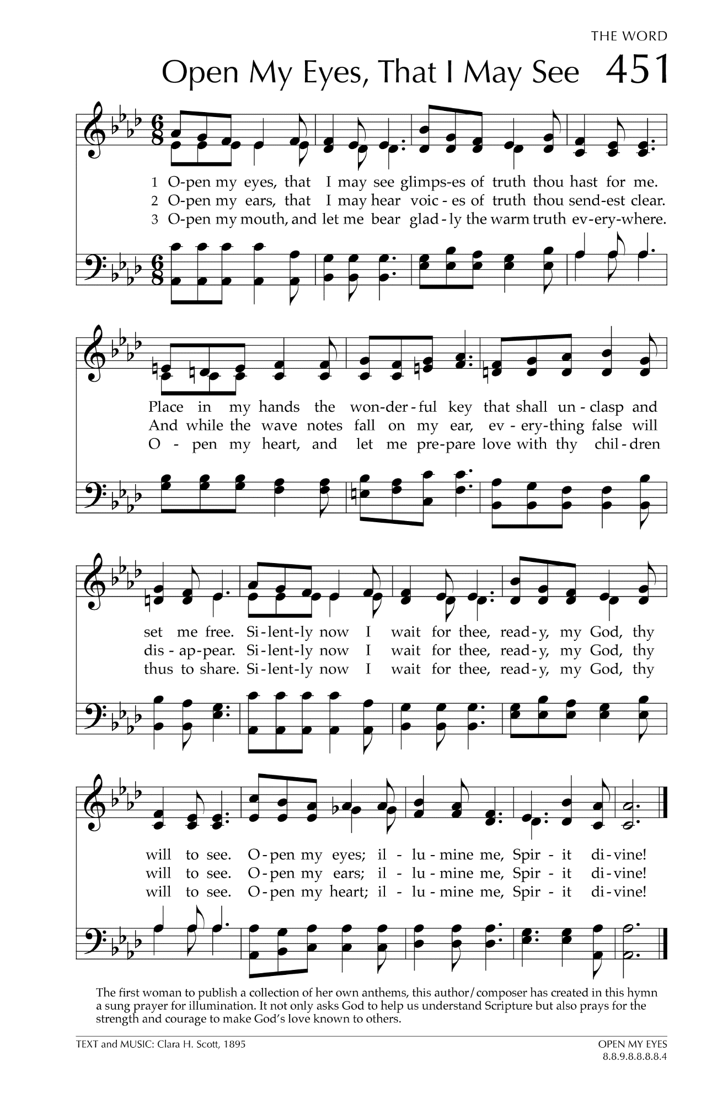

Let There Be Peace on Earth

Let there be peace on earth
And let it begin with me
Let there be peace on earth
The peace that was meant to be
With God as our Father
Christians all are we
Let us walk with each other
In perfect harmony.
Let peace begin with me
Let this be the moment now.
With every step I take
Let this be my solemn vow
To take each moment and live
Each moment in peace eternally
Let there be Peace on Earth
And let it begin with me!

