The Holy Way Presbyterian Church

Tucson, Arizona

September 19, 2021 9:30 a.m.
Living In Community...

Words of Meditation - When we look around and see people suffering many conclude that suffering brings despair, heartache and devastation. In some cases, this might be true. However, today we are going to look at the unexpected benefits of Christian Suffering that can bring strength, comfort, the ministry of forgiveness, and repentance that brings comfort.

Welcome to Worship Rev. Tina Salvaneschi
Opening Prayer
Release Children to Sunday School - Miss Kathy
Introit: God, Who Stretched the Spangled Heavens (Hymn #24, V 2)
Ryan Phillips, Choir Director

Hymn: O’ Save Me, God, And Hear my Cry (Hymn #812) Ryan Phillips, Choir Director

Call to Worship: Lay Leader, Sheri Attleson
Psalm 139:1, 13-18

1 O Lord, You have searched me and known me.
13 For You formed my inward parts;
You covered me in my mother’s womb.
14 I will praise You, for I am fearfully and wonderfully made;
Marvelous are Your works,
And that my soul knows very well.
15 My frame was not hidden from You,
When I was made in secret,
And skillfully wrought in the lowest parts of the earth.
16 Your eyes saw my substance, being yet unformed.
And in Your book they all were written,
The days fashioned for me,
When as yet there were none of them.
17 How precious also are Your thoughts to me, O God!
How great is the sum of them!
18 If I should count them, they would be more in number than the sand;
When I awake, I am still with You.

Leader: The God who answers in a day of trouble is among us,

People: And behold, it is very good!

Leader: The God who lights a candle during the night is here,

People: And behold, it is very good! Hearts, rejoice! For peace has triumphed, and morning has broken eternal night!

People: Amen

Birthdays and Anniversaries Alfonso Valenzuela
Celebrations, Joys and Concerns Rev. Tina Salvaneschi
The People of the Congregation Share Joys and Concerns

...The Lord’s Prayer
People: Our Father, who art in heaven, hallowed be thy name. Thy kingdom come, thy will be done on earth as it is in heaven. Give us this day our daily bread, and forgive us our debts as we forgive our debtors. And lead us not into temptation, but deliver us from evil, for thine is the kingdom and the power and the glory forever. Amen

Anthem: Psalm 42, We Thy People, Praise Thee
Bell Ringers

Tithes and Offering: Prayer Rev. Tina Salvaneschi
(Option: Place you index card with a private prayer for Pastor)
(Option: write on index card a word or two what giving to God means to you place index cards in plate)

Offertory Music: Dr. Astrid Chan

Scripture Reading: Lay Leader, Sheri Attleson
2 Corinthians 1:3-7

3 Blessed be the God and Father of our Lord Jesus Christ, the Father of mercies and God of all comfort, 4 who comforts us in all our tribulation, that we may be able to comfort those who are in any trouble, with the comfort with which we ourselves are comforted by God. 5 For as the sufferings of Christ abound in us, so our consolation also abounds through Christ. 6 Now if we are afflicted, it is for your consolation and salvation, which is effective for enduring the same sufferings which we also suffer. Or if we are comforted, it is for your consolation and salvation. 7 And our hope for you is steadfast, because we know that as you are partakers of the sufferings, so also you will partake of the consolation.

Leader: This is the Word of the Lord. People: Thanks be to God.

Message: “Beneficial Suffering” Rev. Tina Salvaneschi

Sending Hymn: All Who Love and Serve Your City (Hymn #351)
Ryan Phillips, Choir Director

Benediction: 2 Corinthians 13:14 Rev. Tina Salvaneschi

Song: Let There Be Peace On Earth Ryan Phillips, Choir Director

Postlude: Dr. Astrid Chan

Stay Connected at The Holy Way
“Sermon Debrief Bible Study in person on Campus and Zoom” - Tuesday 10:00 a.m.
It’s Both! Come and meet live in the Conference Room at 10:00 a.m. or join on Zoom and we will conference you in on the big screen!
This is a great way to get to Fellowship, wrestle with questions about Sunday’s sermon, ponder the meaning of God’s Word, and discover how Scriptures can transform our lives today. This is led by Pastor Tina and is interactive! Come join the live class if you are able!

“Thoughtful Thursdays” - Thursday 10:00 a.m. Zoom Only
This is a great way to stay connected (especially for our snowbirds, and folks that can’t make it to in-person services!). We share about our lives, spend time talking, share joys, prayer requests…and anything else that comes up. Oh yes, laughter seems to happen too. This is group led, with Pastor Tina and for women AND men!

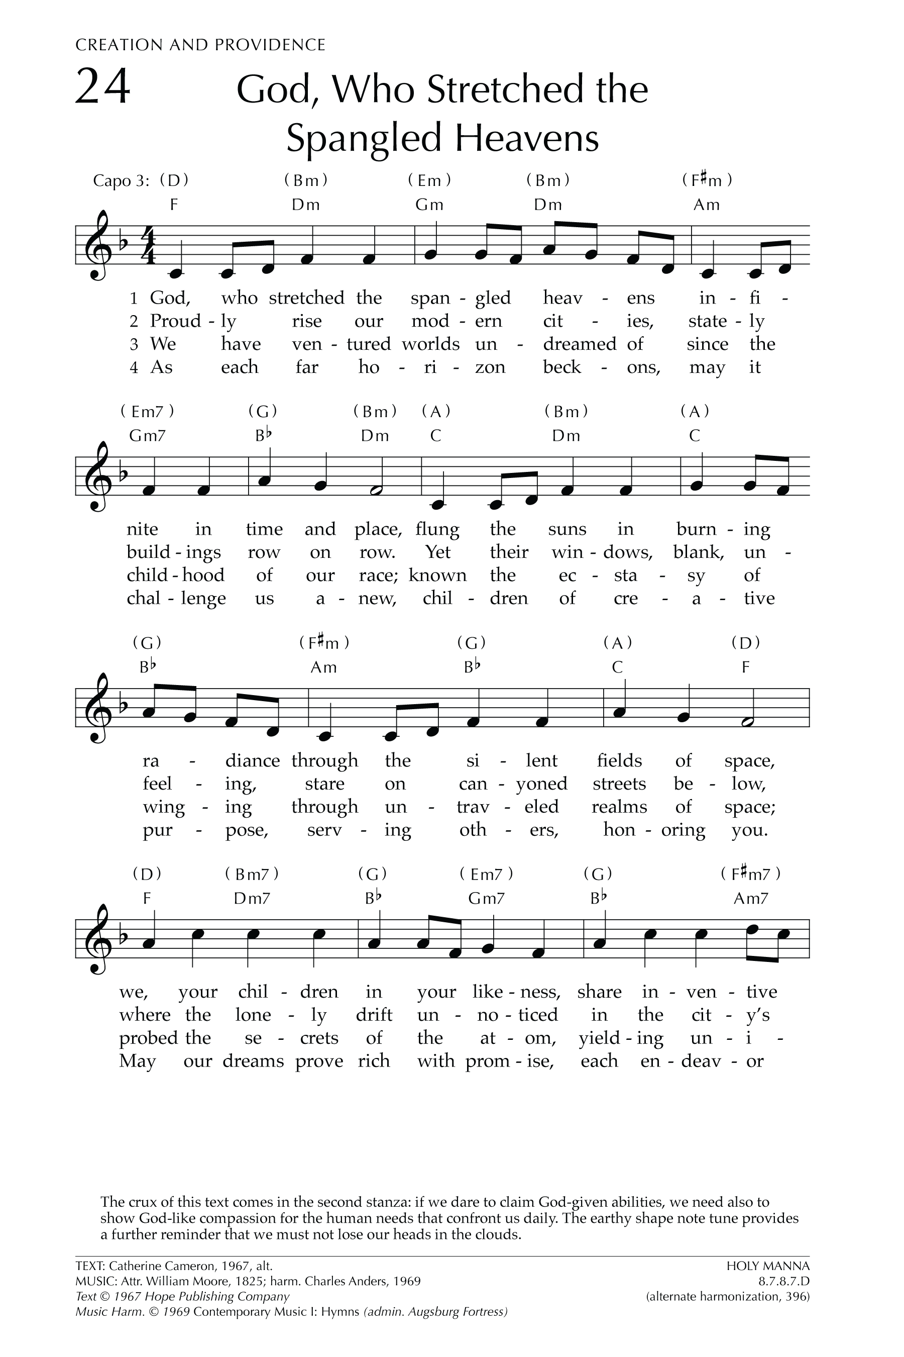
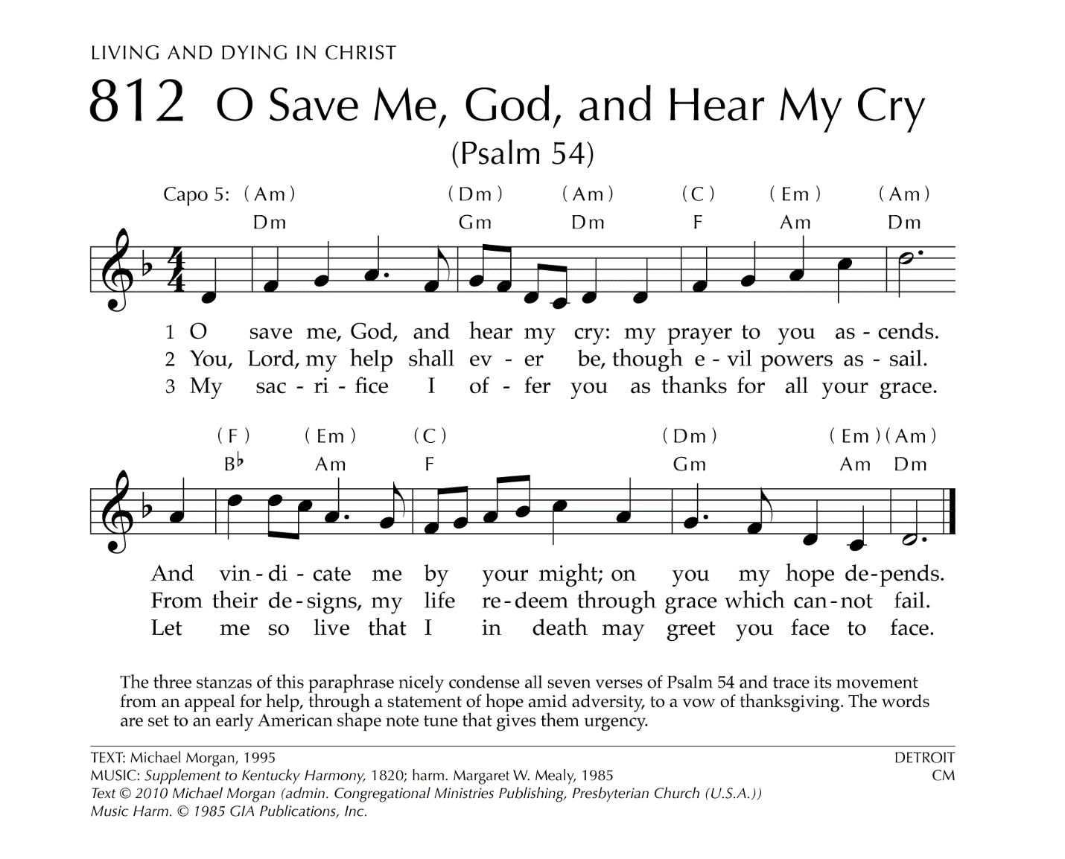

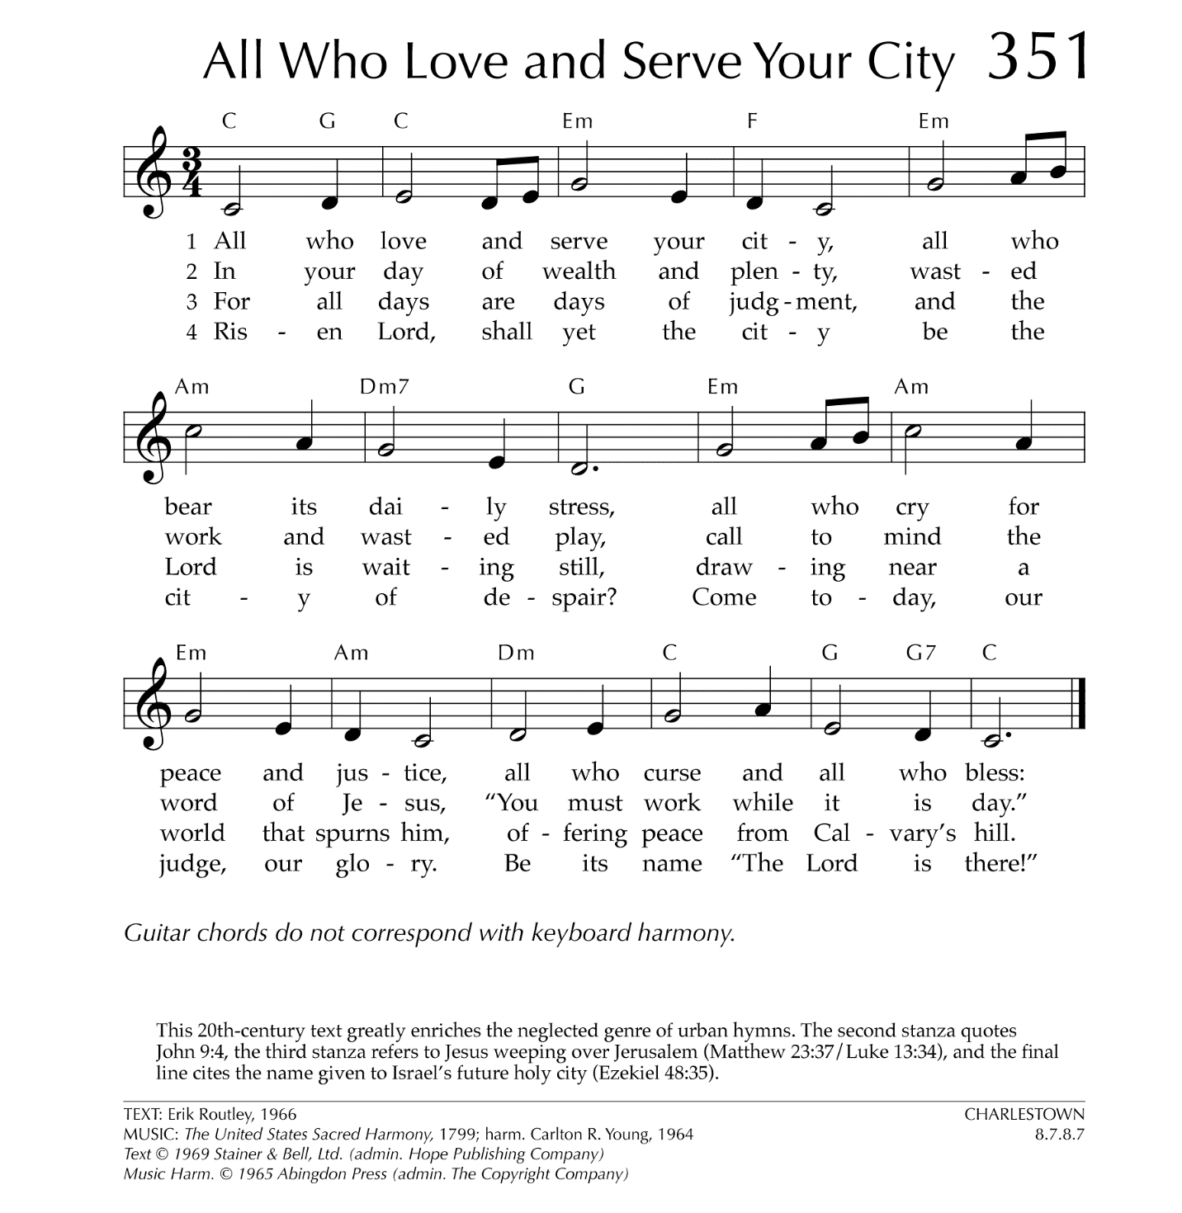

Let There Be Peace on Earth

Let there be peace on earth
And let it begin with me
Let there be peace on earth
The peace that was meant to be
With God as our Father
Christians all are we
Let us walk with each other
In perfect harmony.
Let peace begin with me
Let this be the moment now.
With every step I take
Let this be my solemn vow
To take each moment and live
Each moment in peace eternally
Let there be Peace on Earth
And let it begin with me!

