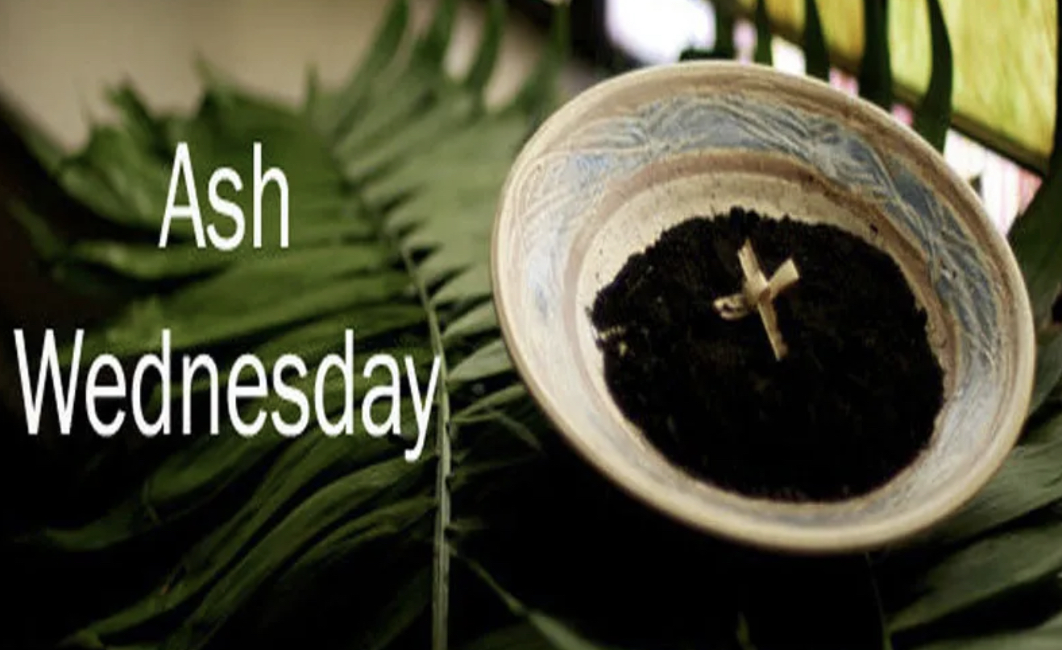
The Holy Way Presbyterian Church

4040 S. Bilbray Avenue
Tucson, Arizona 85746
(520) 965-2249

February 22, 2023, 4:00pm
Ash Wednesday Service

Mask wearing is optional
Please make the decision that is right for you.

Welcome to Worship: Elder Terry Saxton
Opening Prayer

Call To Worship: Bill Boals

Loving God, whose glory it is always to have mercy, be gracious to us who have gone astray from your ways, and bring us again with penitent hearts and steadfast faith to embrace and hold fast the unchangeable truth of your Word, Jesus Christ your Son.

Reader: O God the Father, Creator of heaven and earth
People: Have mercy on us.

Reader: O God, the Son, the Redeemer of the world
People: Have mercy on us.

Reader: O God, the Holy Spirit, Advocate and Guide,
People: Have mercy on us.

Reader: Holy, blessed and glorious Trinity, three persons and one God,
People: Have mercy on us.

People: Amen

Hymn: Change My Heart Oh God (Hymn 695) Congregation

Scripture Reading: Bill Boals

Genesis 3:19
In the sweat of your face you shall eat bread Till you return to the ground,
For out of it you were taken; For dust you are, And to dust you shall return.

Hebrews 12:1-2
Therefore we also, since we are surrounded by so great a cloud of witnesses, let us lay aside every weight, and the sin which so easily ensnares us, and let us run with endurance the race that is set before us, 2 looking unto Jesus, the author and finisher of our faith, who for the joy that was set before Him endured the cross, despising the shame, and has sat down at the right hand of the throne of God.

Leader: This is the Word of the Lord.
People: Thanks be to God.

Message: “Running a Good Race” Elder Terry Saxton

Invitation to Observe a Lenten Discipline: Elder Terry Saxton

Prayer of Confession: Bill Boals

leader & People: Almighty God, you have created us out of the dust of the earth. May these ashes be a sign of our mortality and penitence and a reminder that only by your gracious gift are we given everlasting life; through Jesus Christ our Savior. Amen

The Imposition of Ashes:
Sign Us with Ashes (Hymn 433) Astrid Chan

Sending Hymn: Be Thou My Vision (Hymn 450)
Congregation

Benediction: Ash Wednesday Blessing Elder Terry Saxton

Postlude: Be Thou My Vision (Reprise) Dr. Astrid Chan

This concludes Our Ash Wednesday Service. May you have a thoughtful beginning as you reflect on your Lenten journey~ In Christ Service, Pastor Tina

Stay Connected
“Sermon Debrief Bible Study”
Tuesday 10:00am! Come and meet live in the Ranch House at 10:00am.
This is a great way to get to Fellowship, wrestle with questions about Sunday’s sermon, ponder the meaning of God’s Word, and discover how Scriptures can transform our lives today. This is led by Pastor Tina and is interactive and often there are donuts! Come join the live class if you are able!

Change My Heart Oh God
Chorus
Change my heart oh God
Make it ever true
Change my heart oh God
May I be like You

Verse
You are the potter
I am the clay
Mold me and make me
This is what I pray

CCLI Song # 1565Eddie Espinosa © 1982 Mercy / Vineyard Publishing (Admin. by Integrity Music). For use solely with the SongSelect® Terms of Use. All rights reserved. www.ccli.com CCLI License # 20134359

Be Thou My Vision,

Verse 1
Be thou my vision, O Lord of my heart;
naught be all else to me, save that thou art;
thou my best thought, by day or by night,
waking or sleeping, thy presence my light.

Verse 2
Be thou my wisdom, and thou my true Word;
I ever with thee and thou with me, Lord;
thou my soul’s shelter, and thou my high tower;
raise thou me heavenward, O Power of my power.

Verse 3
Riches I heed not, nor vain, empty praise;
thou, mine inheritance, now and always;
thou and thou only, first in my heart,
High King of Heaven, my treasure thou art.

Verse 4
High King of Heaven, my victory won,
may I reach heaven’s joys, O bright heaven’s Sun!
Heart of my own heart, whatever befall,
still be my vision, O Ruler of all.

Sign Us With Ashes

Refrain: Sign us with ashes, merciful God,
children of dust, as to dust we return.
Sign us with ashes, merciful God.
Mark us and make us your own.

Verse 1 Surely, you alone can save us.
You pay our price with precious blood.
Reaching through your great compassion,
you lift up your people with love. (Refrain)

Verse 2 Surely, you alone uphold us.
You give us strength for all our needs.
Shielding with a father’s favor,
you bless us with pardon and peace. (Refrain)

Verse 3 Surely, you alone can heal us.
Yours is the will to make us whole.
Soothing with a mother’s kindness,
the contrite of heart, you console. (Refrain)

Verse 4 Surely, you alone can free us.
You break the bonds of guilt and sin.
Bracing, till we walk uprightly,
you bolster our hope once again. (Refrain)

Verse 5 Surely, you alone refine us.
You give us grace for lives made new,
forging, through your fire and radiance,
a sacrifice worthy for you. (Refrain)

Verse 6 Surely, you alone redeem us.
You fill our dust with holy breath.
Bursting from the grave in glory,
you rise from the ashes of death! (Refrain)

