The Holy Way Presbyterian Church

Tucson, Arizona

October 17, 2021 9:30 a.m.
Trusting In God Brings Comfort...

Meditation: Beginning up in the Andean foothills of the Amazon rainforest, Columbia, Caño Cristales is literally the ‘river that ran away from paradise’. It’s often regarded as the most beautiful river in the world, however this title can only be claimed seasonally when for a brief time it comes alive with colorful bottom-feeding algae. From late October to early November each year and when the later level is just right, vibrant patches of greens, blues, yellows, red and oranges brighten the water, making the Caño Cristales river look nothing short of a rainbow. This is the work of God in Creation!

Welcome to Worship Rev. Jennifer Soule Hill
Opening Prayer
Release Children to Sunday School - Miss Kathy
Introit: God of Grace and Glory (Hymn #307, V 2)
Ryan Phillips, Choir Director

Hymn: Oh God, In A Mysterious Way (Hymn #30) Ryan Phillips, Choir Director

Call to Worship: Lay Leader, Joan Valenzuela
Leader: God stretches out the heavens
and shapes the earth.
People: Come and give thanks!

Leader: God raises up the mountains
and pours water into the seas.
People: Come and give thanks!

Leader: God calls forth plants from the soil
and forms animals in infinite variety.
People: Come and give thanks!

Leader: God breathes upon us
and fills us with life.
People: Come lift your voices in praise!

Leader: God gives our lives meaning
through laughter and tears.
People: Come lift your voices in praise!

Leader: God touches our hearts
through family and friends.
People: Come lift your voices in praise!

Leader: God loves us and surrounds us
with love in abundance!
People: Come and worship!

People: Amen

Birthdays and Anniversaries
Celebrations, Joys and Concerns Rev. Jennifer Soule Hill The People of the Congregation Share Joys and Concerns

...The Lord’s Prayer
People: Our Father, who art in heaven, hallowed be thy name. Thy kingdom come, thy will be done on earth as it is in heaven. Give us this day our daily bread, and forgive us our debts as we forgive our debtors. And lead us not into temptation, but deliver us from evil, for thine is the kingdom and the power and the glory forever. Amen

Anthem: Everywhere I Go Ryan Phillips, Choir Director

Tithes and Offering: Prayer Rev. Jennifer Soule Hill
(Option: Place you index card with a private prayer for Pastor Tina)
(Option: write on index card a word or two what giving to God means to you place index cards in plate)

Offertory Music: Dr. Astrid Chan

Scripture Reading: Lay Leader, Joan Valenzuela

Leader: This is the Word of the Lord. People: Thanks be to God.

Message: Guest Speaker Rev. Jennifer Soule Hill

Sending Hymn: Immortal, Invisible, God only wise (Hymn #12)
Ryan Phillips, Choir Director

Benediction: 2 Corinthians 13:14 Rev. Jennifer Soule Hill

Song: Let There Be Peace On Earth Ryan Phillips, Choir Director
Postlude: Dr. Astrid Chan

Stay Connected at The Holy Way
“Sermon Debrief Bible Study in person on Campus and Zoom” - Tuesday 10:00 a.m.
It’s Both! Come and meet live in the Conference Room at 10:00 a.m. or join on Zoom and we will conference you in on the big screen!
This is a great way to get to Fellowship, wrestle with questions about Sunday’s sermon, ponder the meaning of God’s Word, and discover how Scriptures can transform our lives today. This is led by Pastor Tina and is interactive! Come join the live class if you are able!

“Thoughtful Thursdays” - Thursday 10:00 a.m. Zoom Only
This is a great way to stay connected (especially for our snowbirds, and folks that can’t make it to in-person services!). We share about our lives, spend time talking, share joys, prayer requests…and anything else that comes up. Oh yes, laughter seems to happen too. This is group led, with Pastor Tina and for women AND men!

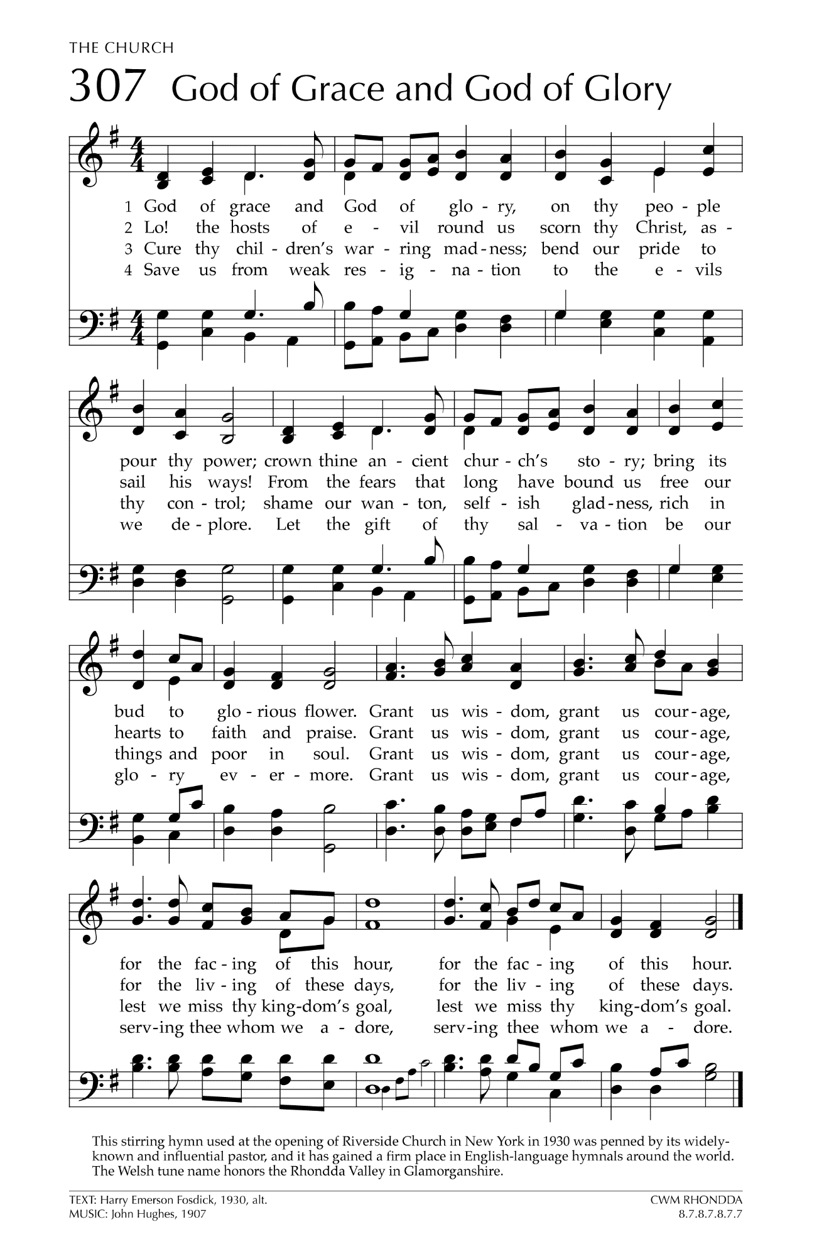
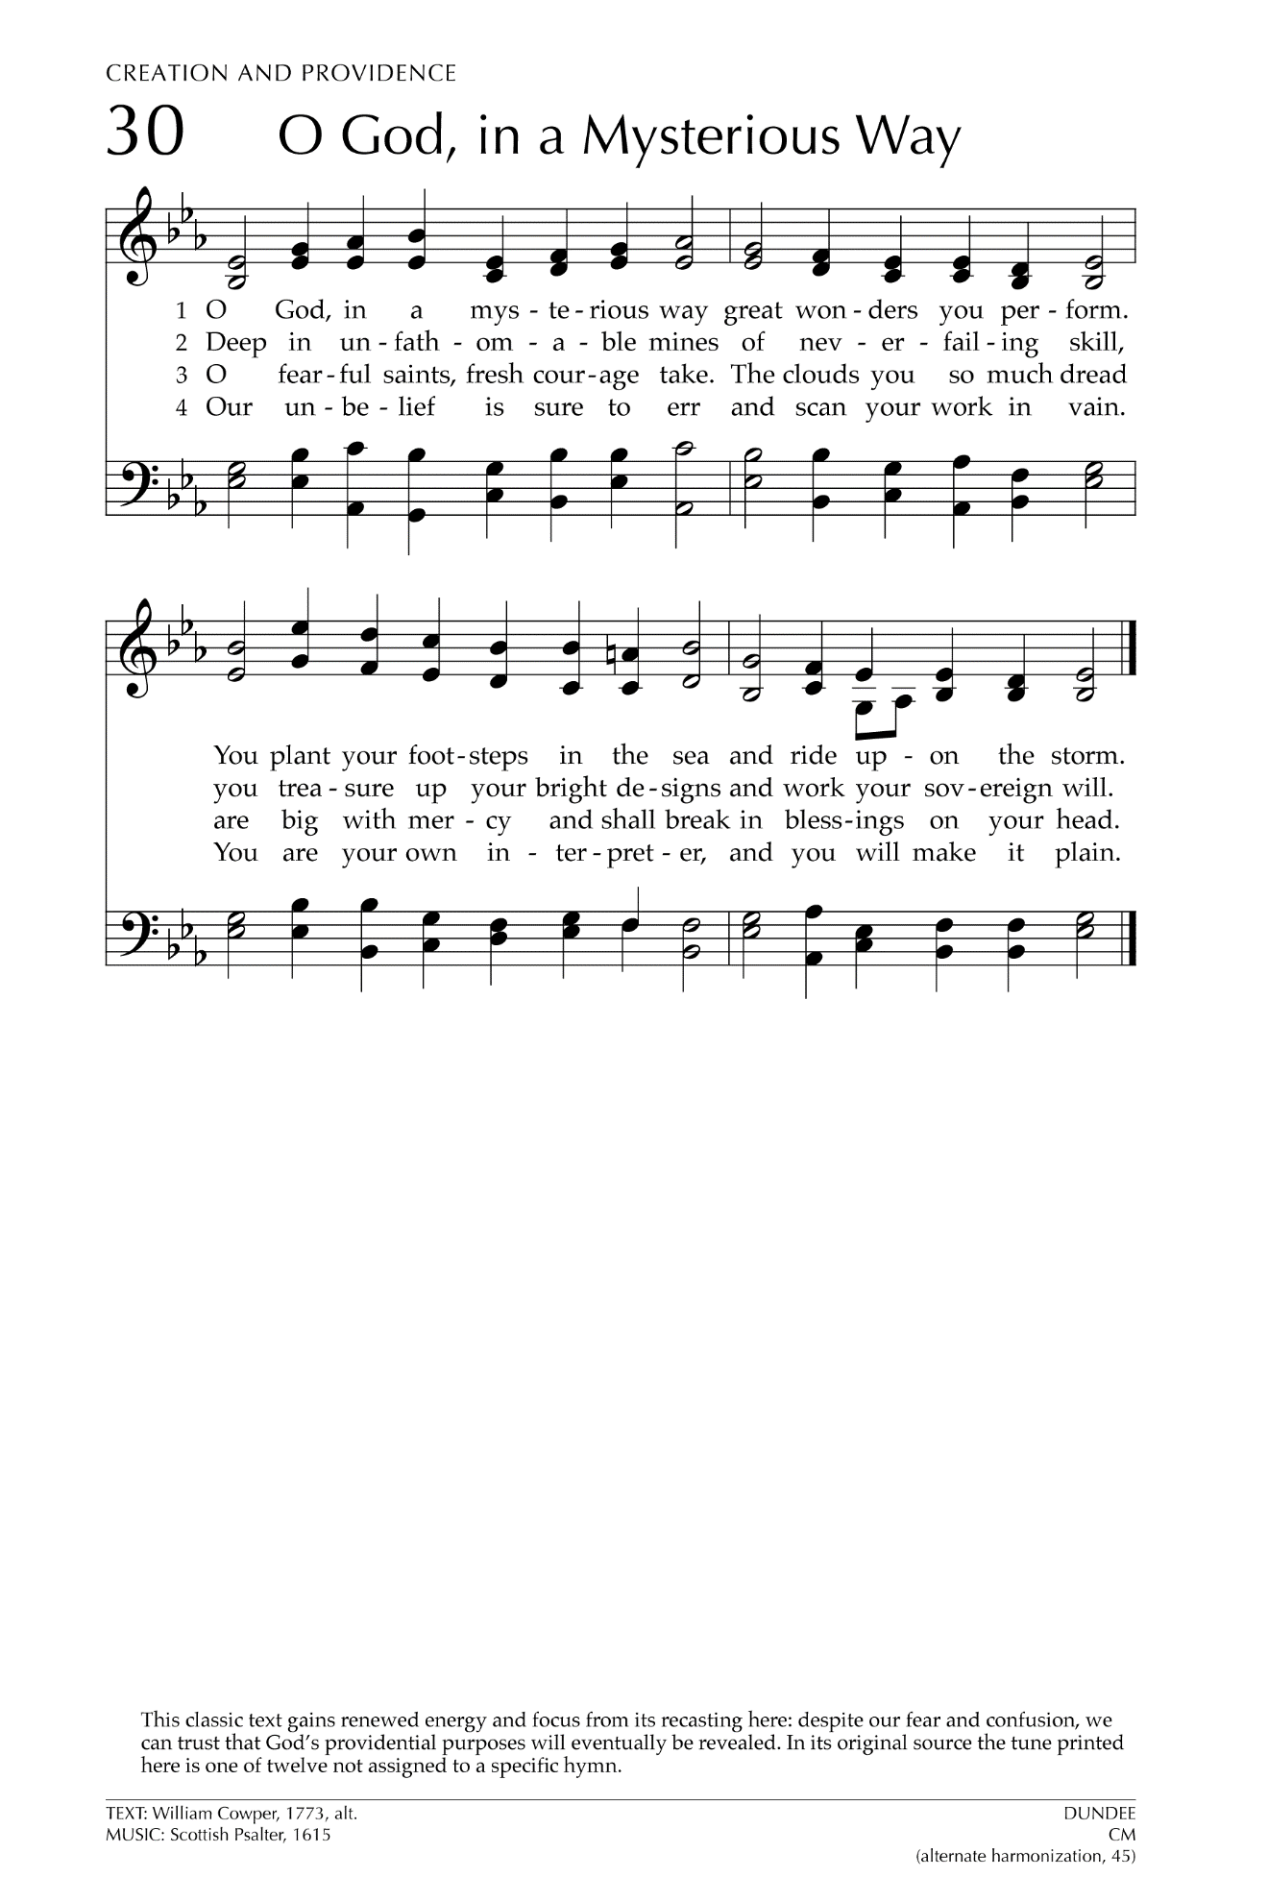
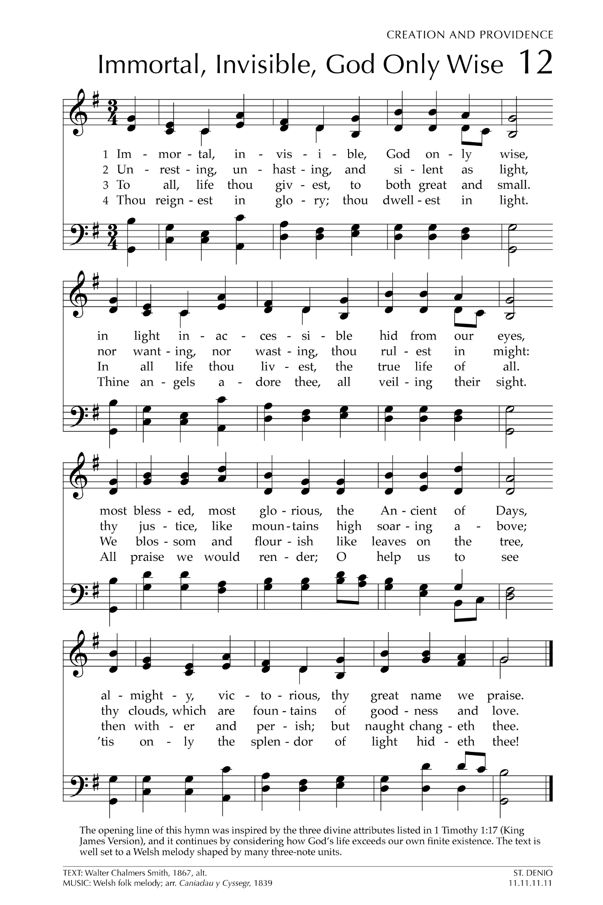

Let There Be Peace on Earth

Let there be peace on earth
And let it begin with me
Let there be peace on earth
The peace that was meant to be
With God as our Father
Christians all are we
Let us walk with each other
In perfect harmony.
Let peace begin with me
Let this be the moment now.
With every step I take
Let this be my solemn vow
To take each moment and live
Each moment in peace eternally
Let there be Peace on Earth
And let it begin with me!

