The Holy Way Presbyterian Church

Tucson, Arizona

November 7, 2021 9:30 a.m.
Trusting In God Brings Comfort...

Meditation: I have set the Lord always before me; Because He is at my right hand I shall not be moved. Therefore my heart is glad, and my glory rejoices.

Welcome to Worship Rev. Tina Salvaneschi
Opening Prayer
Release Children to Sunday School - Miss Kathy
Introit: Glorious Things of Thee are Spoken (Hymn #81, vs. 1)
Ryan Phillips, Choir Director

Hymn: For The Fruit of All Creation (Hymn #86) Ryan Phillips, Choir Director

Birthdays and Anniversaries Stephen Levine
If you want to participate in our tradition of celebrating your birthday or anniversary by giving money towards church building, renovation, improvement, sound systems, just waive your hand, or stand up and Pastor Tina will receive it in the plate!
Celebrations, Joys and Concerns Rev. Tina Salvaneschi
The People of the Congregation Share Joys and Concerns

...The Lord’s Prayer
People: Our Father, who art in heaven, hallowed be thy name. Thy kingdom come, thy will be done on earth as it is in heaven. Give us this day our daily bread, and forgive us our debts as we forgive our debtors. And lead us not into temptation, but deliver us from evil, for thine is the kingdom and the power and the glory forever. Amen

Anthem: At the Table of The Lord Chancel Choir
Tithes and Offering: Prayer Rev. Tina Salvaneschi
(Option: Place you index card with a private prayer for Pastor)
(Option: write on index card a word or two what giving to God means to you place index cards in plate)

Offertory Music: For the Beauty of The Earth Joyful Bells Come Christians, Join to Sing

Doxology: (Hymn #606) Ryan Phillips, Choir Director
Praise God, from whom all blessings flow;
praise God all creatures here below;
praise God above, ye heavenly host;
praise Father, Son, and Holy Ghost. Amen.

Scripture Reading: Lay Leader, Ali Clay
II Corinthians 5:1-7

5 For we know that if our earthly house, this tent, is destroyed, we have a building from God, a house not made with hands, eternal in the heavens. 2 For in this we groan, earnestly desiring to be clothed with our habitation which is from heaven, 3 if indeed, having been clothed, we shall not be found naked. 4 For we who are in this tent groan, being burdened, not because we want to be unclothed, but further clothed, that mortality may be swallowed up by life. 5 Now He who has prepared us for this very thing is God, who also has given us the Spirit as a guarantee.
6 So we are always confident, knowing that while we are at home in the body we are absent from the Lord. 7 For we walk by faith, not by sight.

Leader: This is the Word of the Lord.
People: Thanks be to God.

Message: “Assurance of Resurrection” Rev. Tina Salvaneschi

Communion Hymn: Bread of Heaven, On Thee We Feed (Hymn #496, vs. 1)
Ryan Phillips, Choir Director

Communion: Words of Institution Rev. Tina Salvaneschi
Servers will be passing trays through your rows, please take a piece of bread and hold it, until Pastor Tina leads us to take the body of Christ together. The same with the trays of individual cups.

Sending Hymn: Rejoice The Lord is King (Hymn #363)
Ryan Phillips, Choir Director

Benediction: 2 Corinthians 13:14 Rev. Tina Salvaneschi

Song: Let There Be Peace on Earth Ryan Phillips, Choir Director
Postlude: Dr. Astrid Chan

Stay Connected at The Holy Way
“Sermon Debrief Bible Study in person on Campus and Zoom” - Tuesday 10:00 a.m. -Vaccinated Only Please
It’s Both! Come and meet live in the Conference Room at 10:00 a.m. or join on Zoom and we will conference you in on the big screen!
This is a great way to get to Fellowship, wrestle with questions about Sunday’s sermon, ponder the meaning of God’s Word, and discover how Scriptures can transform our lives today. This is led by Pastor Tina and is interactive! Come join the live class if you are able!

“Thoughtful Thursdays” - Thursday 10:00 a.m. Zoom Only
This is a great way to stay connected (especially for our snowbirds, and folks that can’t make it to in-person services!). We share about our lives, spend time talking, share joys, prayer requests…and anything else that comes up. Oh yes, laughter seems to happen too. This is group led, with Pastor Tina and for women AND men!

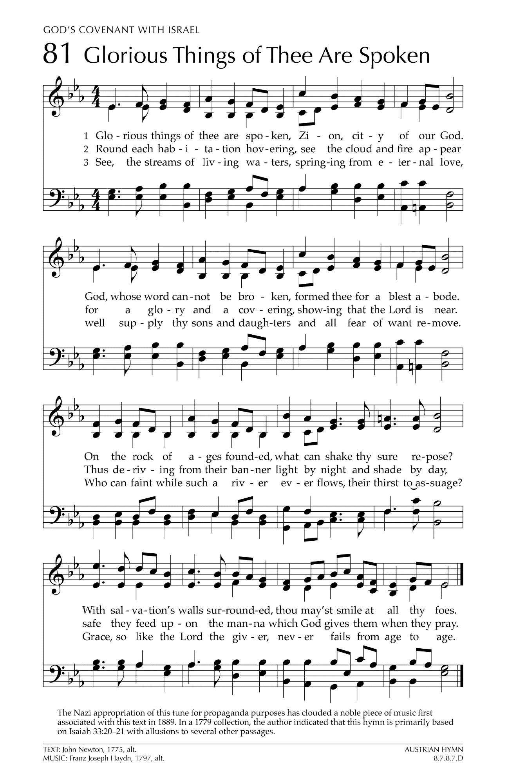
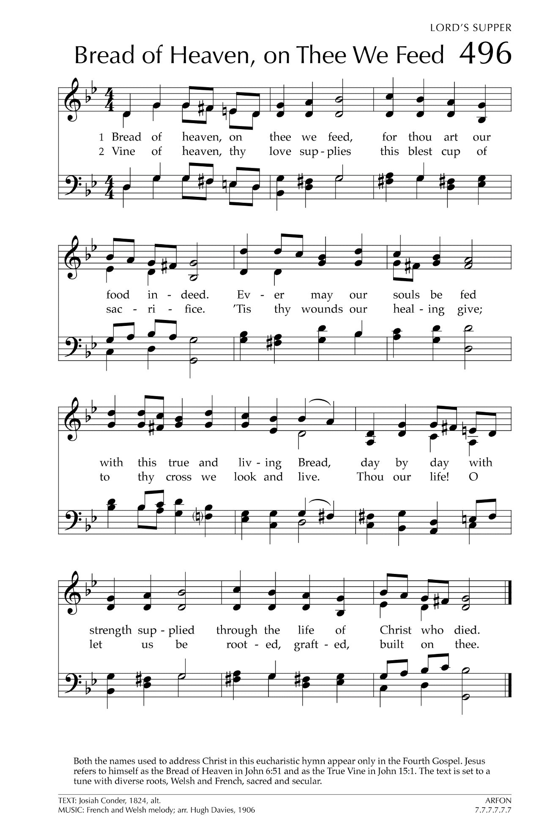
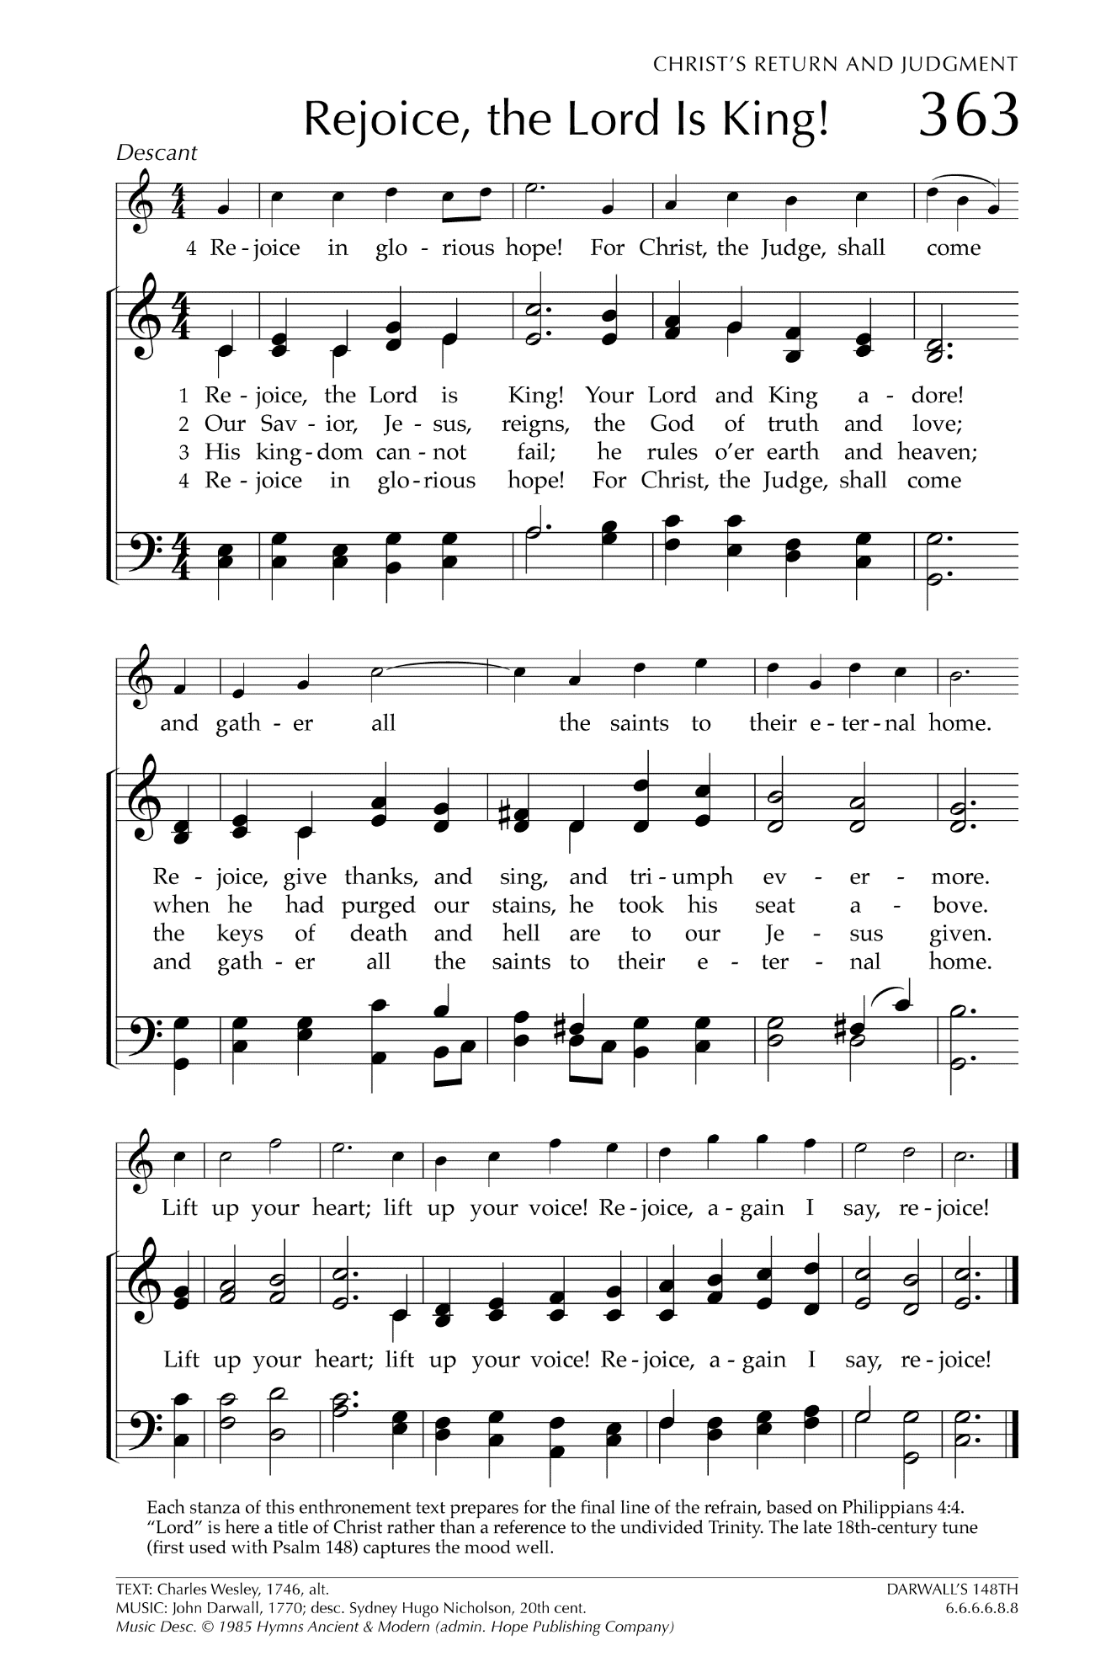

Let There Be Peace on Earth

Let there be peace on earth
And let it begin with me
Let there be peace on earth
The peace that was meant to be
With God as our Father
Christians all are we
Let us walk with each other
In perfect harmony.
Let peace begin with me
Let this be the moment now.
With every step I take
Let this be my solemn vow
To take each moment and live
Each moment in peace eternally
Let there be Peace on Earth
And let it begin with me!

