The Holy Way Presbyterian Church

Tucson, Arizona

December 12, 2021 9:30 a.m.
Third Sunday of Advent...

Meditation: The annunciation, Leonardi Da Vinci, Virgin Mary, Angel Gabriel, 1472-75 Florence, Italy.

Welcome to Worship Rev. Tina Salvaneschi
Opening Prayer
Release Children to Sunday School - Miss Kathy
Introit: Lift Up Your Heads You Mighty Gates (Hymn #93, v. 3)
Ryan Phillips, Choir Director

Hymn: Come Now, O Prince of Peace (Hymn #103) Ryan Phillips, Choir Director

Lighting of Advent Candle: Sheila Martin & Jan Martin
Zephaniah 3:14-20

Joy in God’s Faithfulness

14 Sing, O daughter of Zion!
Shout, O Israel!
Be glad and rejoice with all your heart,
O daughter of Jerusalem!
15 The Lord has taken away your judgments,
He has cast out your enemy.
The King of Israel, the Lord, is in your midst;
You shall see disaster no more.

16 In that day it shall be said to Jerusalem:
“Do not fear;
Zion, let not your hands be weak.
17 The Lord your God in your midst,
The Mighty One, will save;
He will rejoice over you with gladness,
He will quiet you with His love,
He will rejoice over you with singing.”

18 “I will gather those who sorrow over the appointed assembly,
Who are among you,
To whom its reproach is a burden.
19 Behold, at that time
I will deal with all who afflict you;
I will save the lame,
And gather those who were driven out;
I will appoint them for praise and fame
In every land where they were put to shame.

20 At that time I will bring you back,
Even at the time I gather you;
For I will give you [b]fame and praise
Among all the peoples of the earth,
When I return your captives before your eyes,”
Says the Lord.

People: Amen

Sheila Martin & Jan Martin light the candles.

Birthdays and Anniversaries Stephen Levine
If you want to participate in our tradition of celebrating your birthday or anniversary by giving money towards church building, renovation, improvement, sound systems, just waive your hand, or stand up and Pastor Tina will receive it in the plate!

Celebrations, Joys and Concerns Rev. Tina Salvaneschi
The People of the Congregation Share Joys and Concerns

...The Lord’s Prayer
People: Our Father, who art in heaven, hallowed be thy name. Thy kingdom come, thy will be done on earth as it is in heaven. Give us this day our daily bread, and forgive us our debts as we forgive our debtors. And lead us not into temptation, but deliver us from evil, for thine is the kingdom and the power and the glory forever. Amen

Anthem: Alleluia for Advent Chancel Choir
Allelu! Alleluia! Prepare for the Lord!
Allelu! Alleluia! Sing out in accord!
Hear the songs of the angels ring out through the night!
Allelu! He is coming, the Lord of Light! The Lord of Light!
Allelu! He is coming, the Lord of Light!
Allelu! Alleluia! Rise up, hear this call!
Allelu! Alleluia! Rejoice one and all!
For the child infant lowly will come from above!
Allelu! He will bring you God’s peace and love!
God’s peace and love!
Allelu! He will bring you God’s peace and love!
Allelu! Alleluia! Prepare for the King!
Allelu! Alleluia! Let voices now ring!
Hear the songs we are singing with joy and good cheer!
He shall come that holy night! Prepare for the Lord of Light!

Tithes and Offering: Prayer Rev. Tina Salvaneschi
(Option: Place you index card with a private prayer for Pastor)
(Option: write on index card a word or two what giving to God means to you place index cards in plate)

Offertory Music: Mary Did You Know Rosalie Baumrucker

Doxology: (Hymn #606) Ryan Phillips, Choir Director
Praise God, from whom all blessings flow;
praise God all creatures here below;
praise God above, ye heavenly host;
praise Father, Son, and Holy Ghost. Amen.

Scripture Reading: Lay Leader, Ruth Parsil

26 Now in the sixth month the angel Gabriel was sent by God to a city of Galilee named Nazareth, 27 to a virgin betrothed to a man whose name was Joseph, of the house of David. The virgin’s name was Mary. 28 And having come in, the angel said to her, “Rejoice, highly favored one, the Lord is with you; blessed are you among women!”

29 But when she saw him, she was troubled at his saying, and considered what manner of greeting this was. 30 Then the angel said to her, “Do not be afraid, Mary, for you have found favor with God. 31 And behold, you will conceive in your womb and bring forth a Son, and shall call His name Jesus. 32 He will be great, and will be called the Son of the Highest; and the Lord God will give Him the throne of His father David. 33 And He will reign over the house of Jacob forever, and of His kingdom there will be no end.”

34 Then Mary said to the angel, “How can this be, since I do not know a man?”

35 And the angel answered and said to her, “The Holy Spirit will come upon you, and the power of the Highest will overshadow you; therefore, also, that Holy One who is to be born will be called the Son of God. 36 Now indeed, Elizabeth your relative has also conceived a son in her old age; and this is now the sixth month for her who was called barren. 37 For with God nothing will be impossible.”

38 Then Mary said, “Behold the maidservant of the Lord! Let it be to me according to your word.” And the angel departed from her.

Leader: This is the Word of the Lord.
People: Thanks be to God.

Message: “The Faith of Mary” Rev. Tina Salvaneschi

Sending Hymn: O Lord, How Shall I Meet You (Hymn #104) Ryan Phillips, Choir Director

Benediction: 2 Corinthians 13:14 Rev. Tina Salvaneschi

Song: Let There Be Peace on Earth Ryan Phillips, Choir Director
Postlude: Dr. Astrid Chan

Stay Connected During the Week!

“Sermon Debrief Bible Study in person on Campus” - Tuesday 10:00 am! Vaccinated Only Please (no Zoom)
Come and meet live in the Sanctuary at 10:00 am.
This is a great way to get to Fellowship, wrestle with questions about Sunday’s sermon, ponder the meaning of God’s Word, and discover how Scriptures can transform our lives today. This is led by Pastor Tina and is interactive and often there are donuts! Come join the live class if you are able!

“Thoughtful Thursdays” - Thursdays 10:00 am Zoom Only
This is a great way to stay connected (especially for our snowbirds, and folks that can’t make it to in-person services!). We share about our lives, spend time talking, share joys, pray requests…and anything else that comes up. Oh yes, laughter seems to happen too. This is group led, with Pastor Tina and for women AND men!

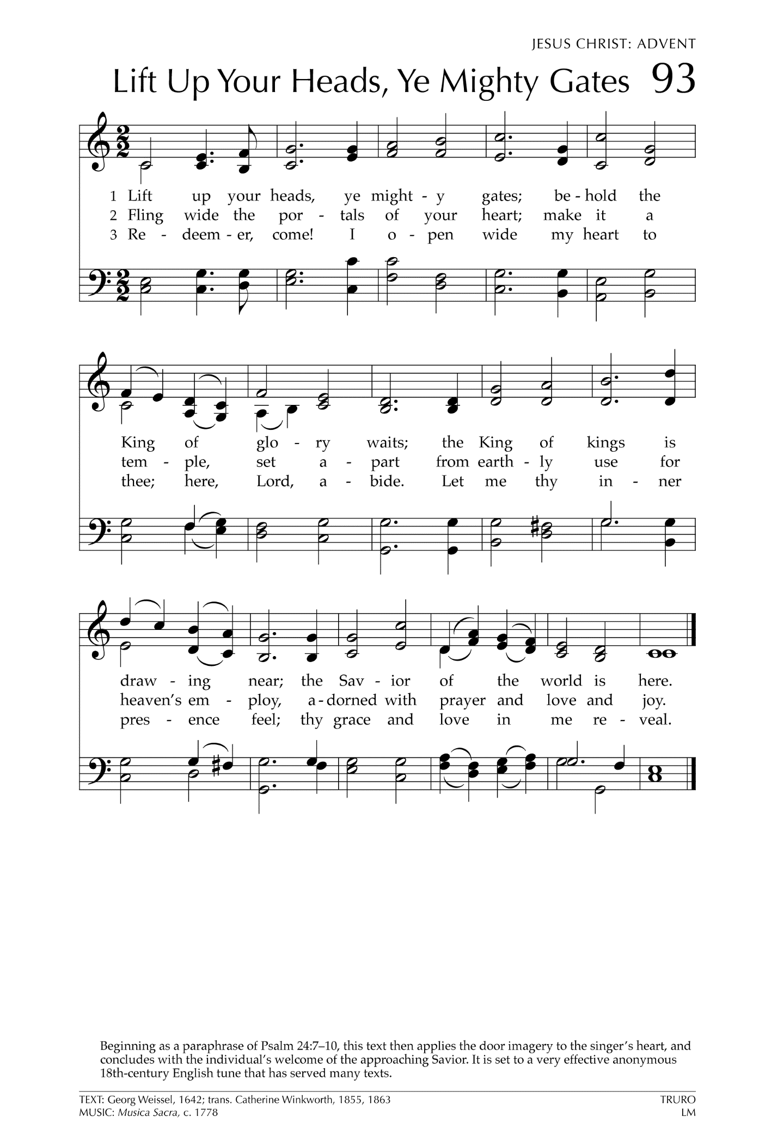
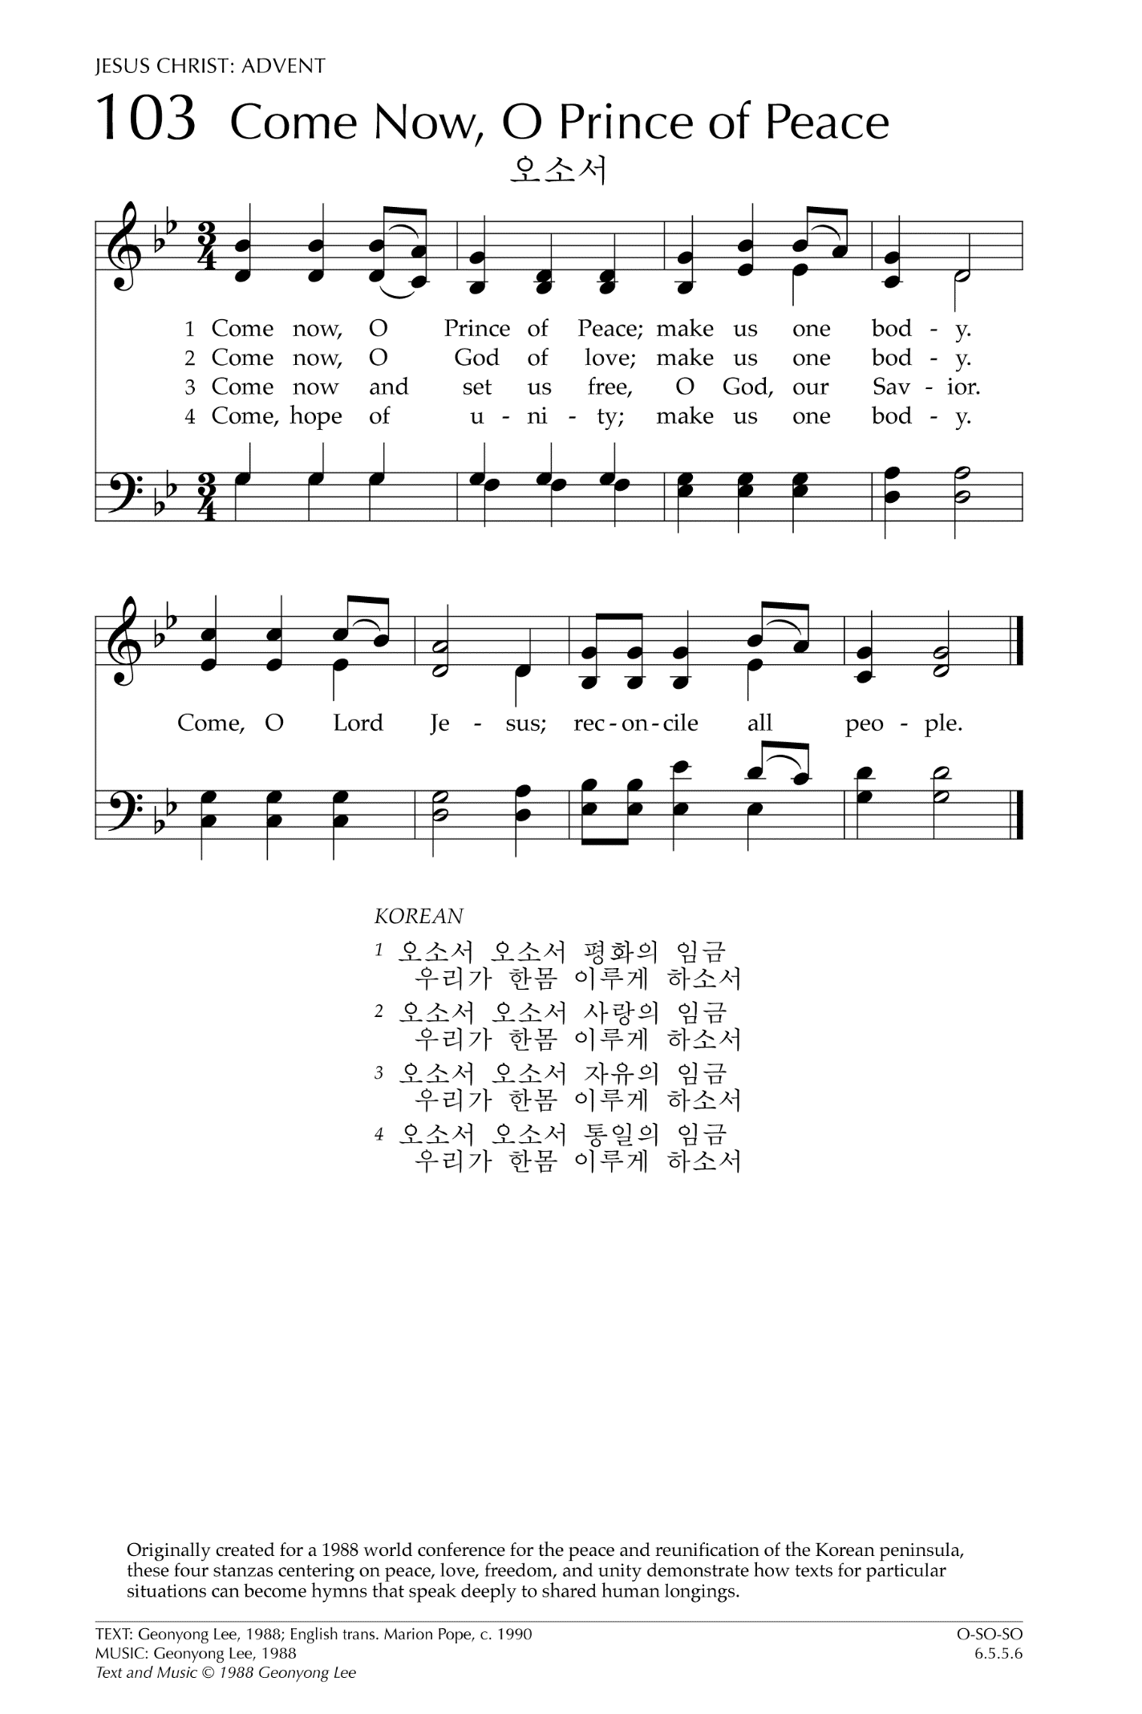
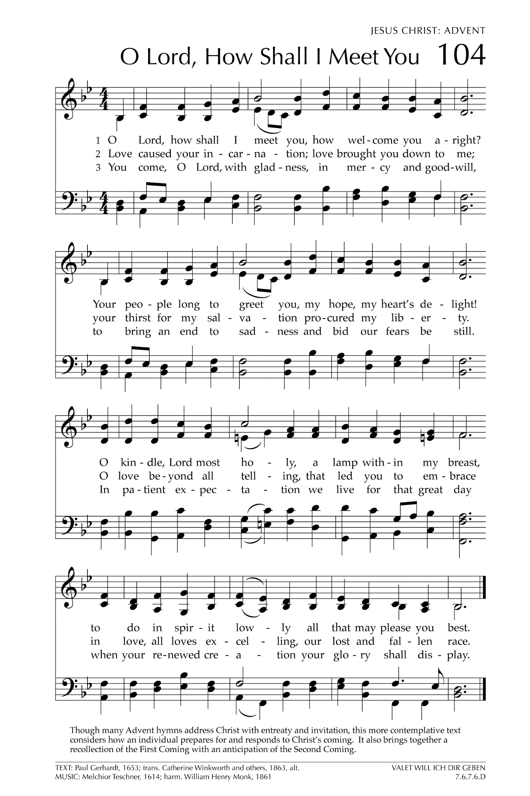

Let There Be Peace on Earth

Let there be peace on earth
And let it begin with me
Let there be peace on earth
The peace that was meant to be
With God as our Father
Christians all are we
Let us walk with each other
In perfect harmony.
Let peace begin with me
Let this be the moment now.
With every step I take
Let this be my solemn vow
To take each moment and live
Each moment in peace eternally
Let there be Peace on Earth
And let it begin with me!

