The Holy Way Presbyterian Church
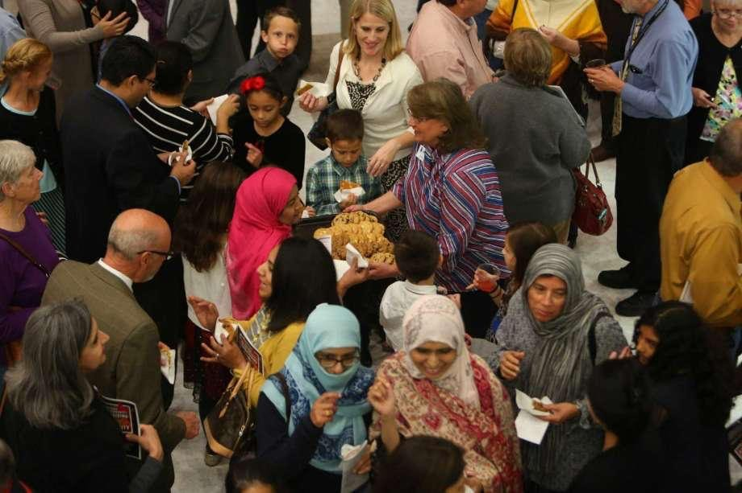

Tucson, Arizona

September 26, 2021 9:30 a.m.
Trusting In God Brings Comfort...

Words of Meditation - The Apostle Paul tells us that when someone in our community or family makes mistakes, the group should not gang up and come against that person, but should instead forgive, comfort and reaffirm its love for the person, let us learn to forgive as a community.

Welcome to Worship Rev. Tina Salvaneschi
Opening Prayer
Release Children to Sunday School - Miss Kathy
Introit: God, Who Stretched the Spangled Heavens (Hymn #24, V 3)
Ryan Phillips, Choir Director

Hymn: Deep in the Shadows of the Past (Hymn #50) Ryan Phillips, Choir Director

Call to Worship: Lay Leader, Ali Clay
Leader: Lord, give us a consistent kindness and compassion for others. Keep us always tender hearted even when the world delivers difficult blows and setbacks to us. Teach us once again about your redeeming grace in order that we may learn, however slowly and however tentatively, how to forgive others. Teach us how to live abundantly into the future as victorious and expectant people, greeting each new day with eagerness and excitement. God, remind us that we are among your forgiven and beloved community.

People: Lord, we present to you all people who have special need of your grace today. Keep them in your gracious care and let us be Your instrument to help make their burdens lighter. God, be with those who are at war and who are victims of war and my you grant us a peaceful world.

People: Amen

Birthdays and Anniversaries Alfonso Valenzuela
Celebrations, Joys and Concerns Rev. Tina Salvaneschi
The People of the Congregation Share Joys and Concerns

...The Lord’s Prayer
People: Our Father, who art in heaven, hallowed be thy name. Thy kingdom come, thy will be done on earth as it is in heaven. Give us this day our daily bread, and forgive us our debts as we forgive our debtors. And lead us not into temptation, but deliver us from evil, for thine is the kingdom and the power and the glory forever. Amen

Anthem: No Turning Back The Chancel Choir

Tithes and Offering: Prayer Rev. Tina Salvaneschi
(Option: Place you index card with a private prayer for Pastor)
(Option: write on index card a word or two what giving to God means to you place index cards in plate)

Offertory Music: How Great Is our God/How Great Thou Art
Ryan Phillips, Choir Director & Dr. Astrid Chan

Scripture Reading: Lay Leader, Ali Clay
2 Corinthians 2:3-11

3 And I wrote this very thing to you, lest, when I came, I should have sorrow over those from whom I ought to have joy, having confidence in you all that my joy is the joy of you all. 4 For out of much affliction and anguish of heart I wrote to you, with many tears, not that you should be grieved, but that you might know the love which I have so abundantly for you.

5 But if anyone has caused grief, he has not grieved me, but all of you to some extent—not to be too severe. 6 This punishment which was inflicted by the majority is sufficient for such a man, 7 so that, on the contrary, you ought rather to forgive and comfort him, lest perhaps such a one be swallowed up with too much sorrow. 8 Therefore I urge you to reaffirm your love to him. 9 For to this end I also wrote, that I might put you to the test, whether you are obedient in all things. 10 Now whom you forgive anything, I also forgive. For if indeed I have forgiven anything, I have forgiven that one for your sakes in the presence of Christ, 11 lest Satan should take advantage of us; for we are not ignorant of his devices.

Leader: This is the Word of the Lord. People: Thanks be to God.

Message: “Forgiveness in a Community” Rev. Tina Salvaneschi

Sending Hymn: Lord, Listen to your Children Praying (Hymn #469)
Ryan Phillips, Choir Director

Benediction: 2 Corinthians 13:14 Rev. Tina Salvaneschi

Song: Let There Be Peace On Earth Ryan Phillips, Choir Director

Postlude: Dr. Astrid Chan

Stay Connected at The Holy Way
“Sermon Debrief Bible Study in person on Campus and Zoom” - Tuesday 10:00 a.m.
It’s Both! Come and meet live in the Conference Room at 10:00 a.m. or join on Zoom and we will conference you in on the big screen!
This is a great way to get to Fellowship, wrestle with questions about Sunday’s sermon, ponder the meaning of God’s Word, and discover how Scriptures can transform our lives today. This is led by Pastor Tina and is interactive! Come join the live class if you are able!

“Thoughtful Thursdays” - Thursday 10:00 a.m. Zoom Only
This is a great way to stay connected (especially for our snowbirds, and folks that can’t make it to in-person services!). We share about our lives, spend time talking, share joys, prayer requests…and anything else that comes up. Oh yes, laughter seems to happen too. This is group led, with Pastor Tina and for women AND men!

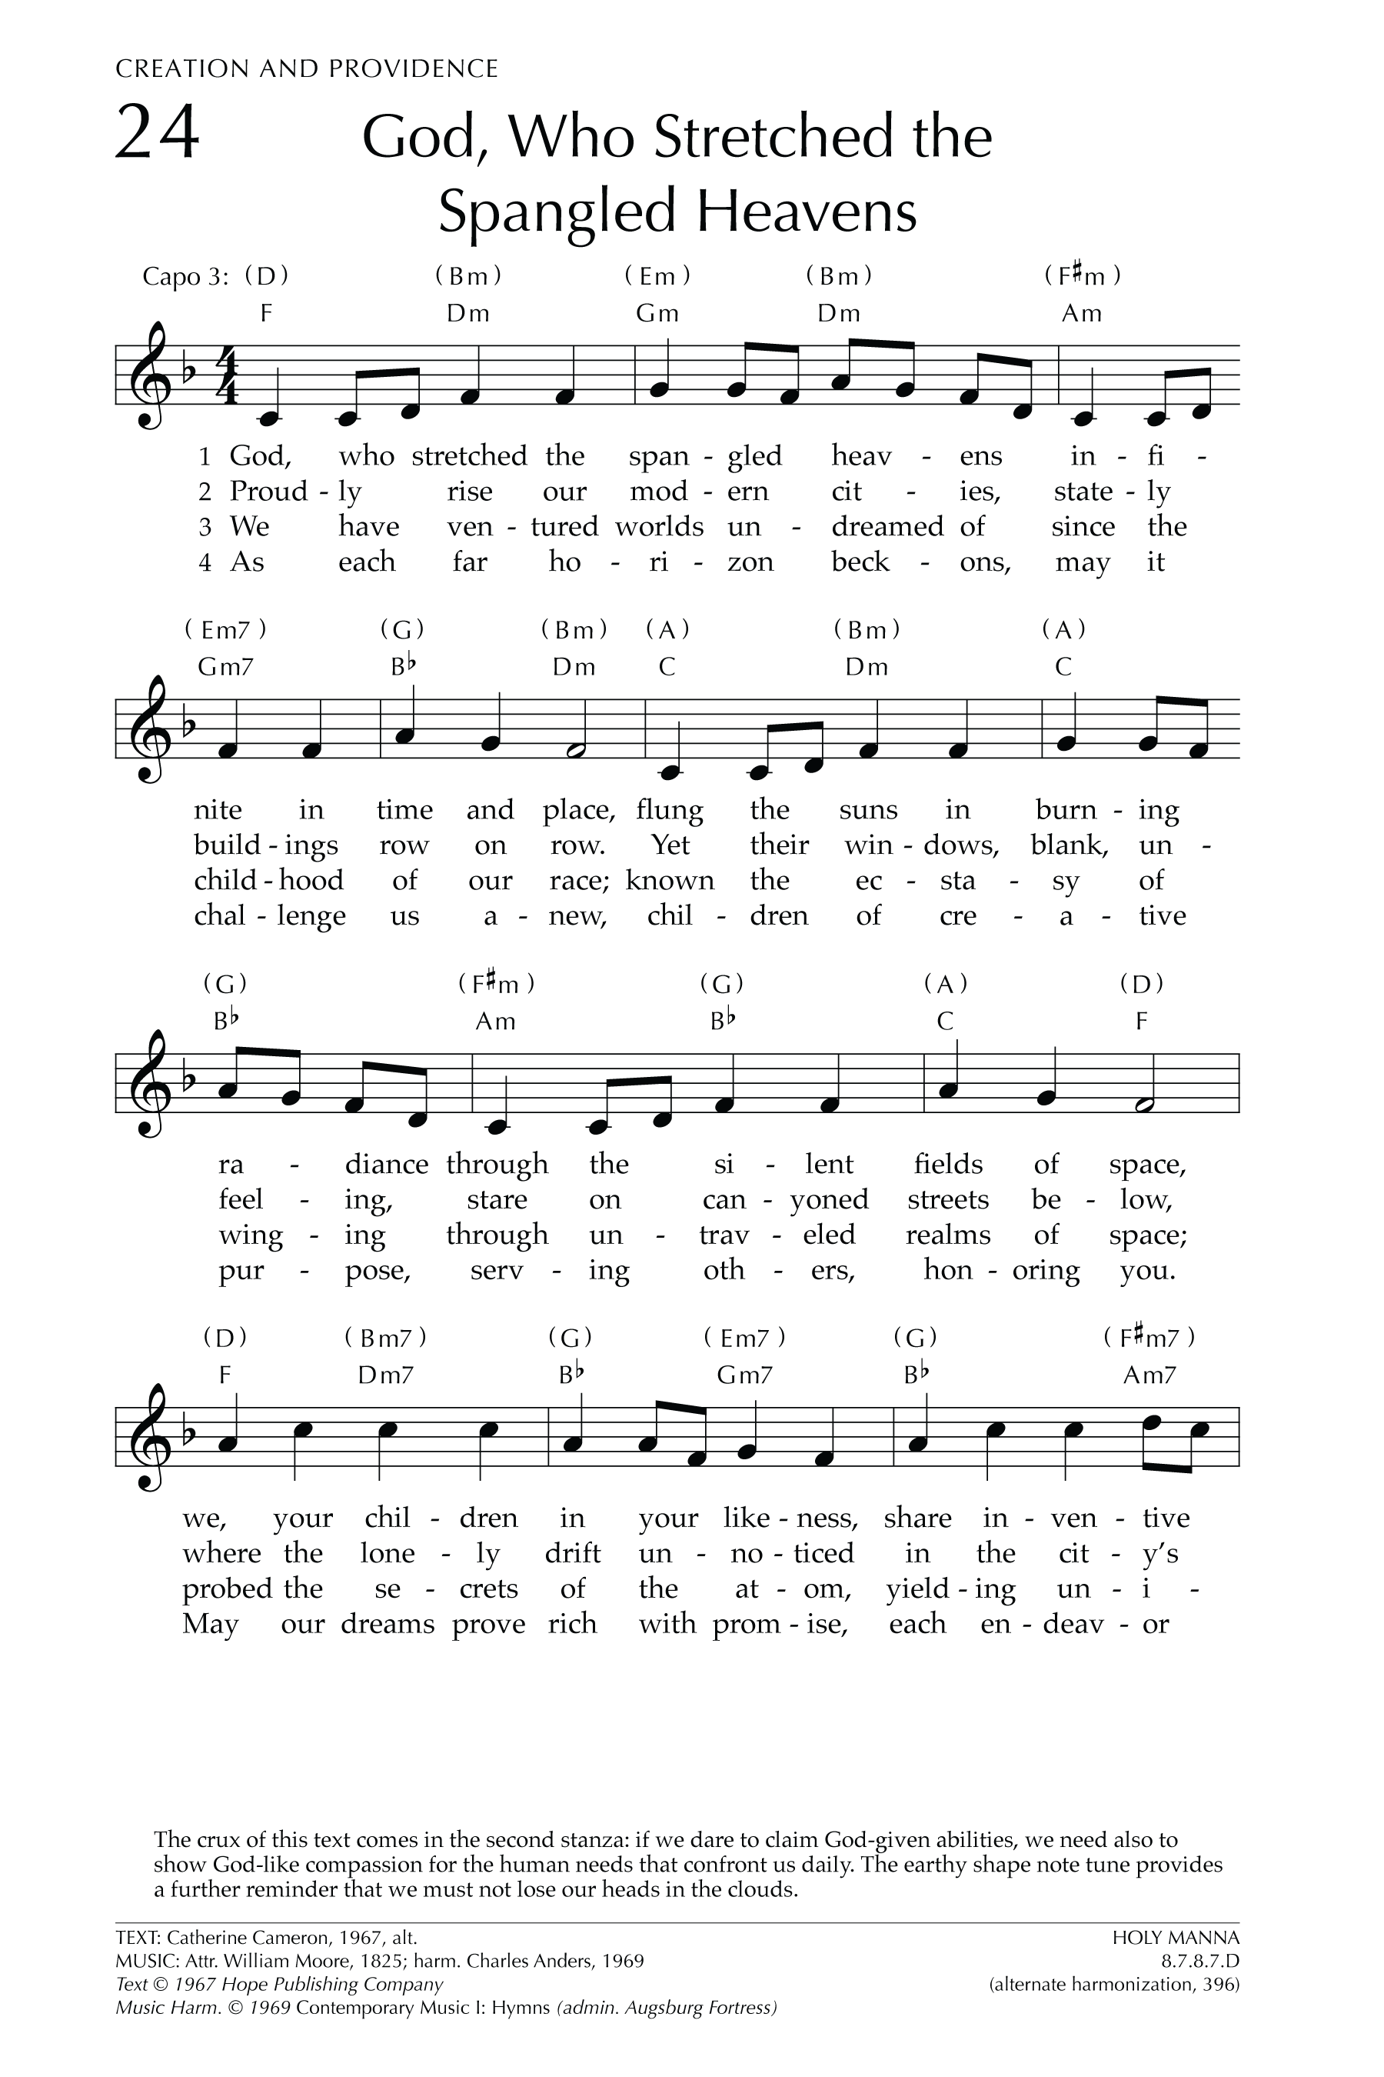
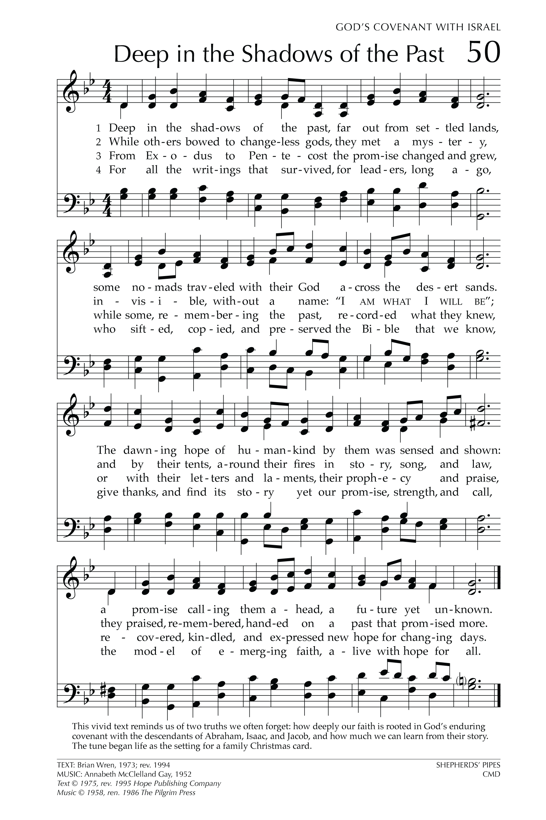
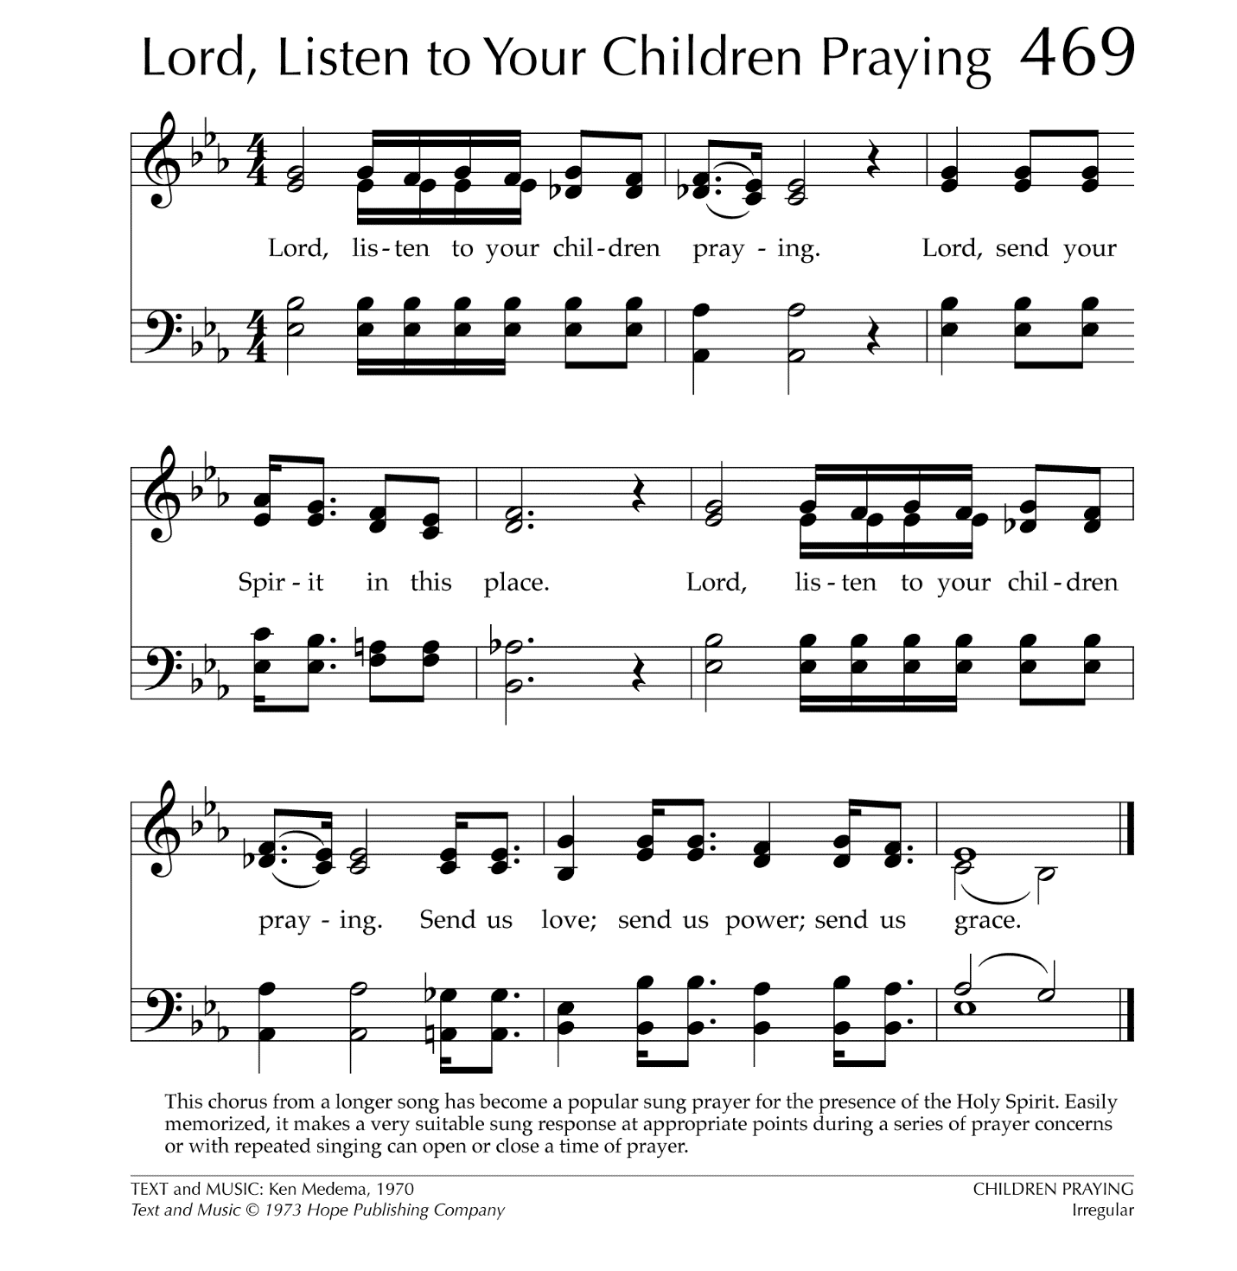

Let There Be Peace on Earth

Let there be peace on earth
And let it begin with me
Let there be peace on earth
The peace that was meant to be
With God as our Father
Christians all are we
Let us walk with each other
In perfect harmony.
Let peace begin with me
Let this be the moment now.
With every step I take
Let this be my solemn vow
To take each moment and live
Each moment in peace eternally
Let there be Peace on Earth
And let it begin with me!

