The Holy Way Presbyterian Church

Tucson, Arizona

January 23, 2022 9:30 a.m.
Finding Balanced Living Series...

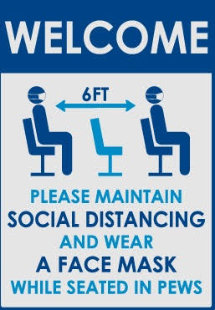

Welcome to Worship: Rev. Tina Salvaneschi
Opening Prayer
Children are Released to Sunday School

Announcements:

Special Congregation Meeting: Will be held during Worship Service on January 30th to elect new Elder to fill a recent vacancy.

Stay Up to Date: If you are not receiving e-mailed Newsletters or bi-monthly Pastors letters and would like to, please provide your information on a card provided in the baskets at the Sanctuary entrance.

Prayer Chain - If you have a prayer request during the week or weekend and would like our prayer team to be praying for you or someone you know, please contact Janie Saxton at (612) 387-7756.

Hymn: Lift High the Cross (Hymn 826, vs. 1, 2, 4) Congregation
Terry Saxton

Call To Worship: Bill Boals
When you're down and troubled
And you need some loving care
And nothing, nothing is going right
Close your eyes and think of me
And soon I will be there
To brighten up, even your darkest night

You just call out my name
And you know, wherever I am
I'll come running, to see you again.
Winter, spring, summer or fall
All you have to do is call
And I'll be there, You've got a friend

If the sky above you
Grows dark and full of clouds
And that old, north wind begins to blow
Keep your head together
And call my name out loud
Soon you'll hear me knocking at your door
You just call out my name
And you know, wherever I am
I'll come running, running, To see you again
Winter, spring, summer or fall
All you have to do is call
And I'll be there, yes, I will

Now, ain't it good to know that you've got a friend
When people can be so cold?
They'll hurt you, yes, and desert you
And take your soul if you let them
Oh, but don't you let them

You just call out my name
And you know, wherever I am
I'll come running, running, To see you again
Winter, spring, summer or fall
All you have to do is call
And I'll be there, yes, I will
You've got a friend
You've got a friend
Ain't it good to know you've got a friend

And the People said? Amen!

Birthdays and Anniversaries Ray Weathers
Sing Happy Birthday/Versary Terry Saxton

If you want to participate in our tradition of celebrating your birthday or anniversary by giving money towards church building, renovation, improvement, sound systems, just waive your hand, or stand up and Pastor Tina will receive it in the basket!

Celebrations, Joys and Concerns Rev. Tina Salvaneschi
The People of the Congregation Share Joys and Concerns

...The Lord’s Prayer
People: Our Father, who art in heaven, hallowed be thy name. Thy kingdom come, thy will be done on earth as it is in heaven. Give us this day our daily bread, and forgive us our debts as we forgive our debtors. And lead us not into temptation, but deliver us from evil, for thine is the kingdom and the power and the glory forever. Amen

Anthem: Quintet Special Music Rosalie Baumrucker, Lynn Wiger, Terry Saxton, Phil Hollis
Tithes and Offering: Prayer Rev. Tina Salvaneschi
(Option: Place you index card with a private prayer for Pastor)
(Option: write on index card a word or two what giving to God means to you place index cards in plate)

Offertory Music: Special Guest Woanching Lim

Doxology: (Hymn #606) Congregation
Praise God, from whom all blessings flow;
praise Him all creatures here below;
praise Him above, ye heavenly host;
praise Father, Son, and Holy Ghost. Amen.

Scripture Reading: Lay Leader Bill Boals
Exodus Chapter 18 verses

7 So Moses went out to meet his father-in-law, bowed down, and kissed him. And they asked each other about their well-being, and they went into the tent.

13 And so it was, on the next day, that Moses sat to judge the people; and the people stood before Moses from morning until evening. 14 So when Moses’ father-in-law saw all that he did for the people, he said, “What is this thing that you are doing for the people? Why do you alone sit, and all the people stand before you from morning until evening?”

17 So Moses’ father-in-law said to him, “The thing that you do is not good. 18 Both you and these people who are with you will surely wear yourselves out. For this thing is too much for you; you are not able to perform it by yourself. 19 Listen now to my voice; I will give you counsel, and God will be with you: Stand before God for the people, so that you may bring the difficulties to God. 20 And you shall teach them the statutes and the laws, and show them the way in which they must walk and the work they must do.

21 Moreover you shall select from all the people able men, such as fear God, men of truth, hating covetousness; and place such over them to be rulers of thousands, rulers of hundreds, rulers of fifties, and rulers of tens. 22 And let them judge the people at all times. Then it will be that every great matter they shall bring to you, but every small matter they themselves shall judge. So it will be easier for you, for they will bear the burden with you. 23 If you do this thing, and God so commands you, then you will be able to endure, and all this people will also go to their place in peace.”

24 So Moses heeded the voice of his father-in-law and did all that he had said.

Leader: This is the Word of the Lord.
People: Thanks be to God.

Message: “Don’t Do It Alone, Delegate” Rev. Tina Salvaneschi

Sending Hymn: What A Friend We Have in Jesus (Hymn 465) Congregation
Terry Saxton

Benediction: 2 Corinthians 13:14 Rev. Tina Salvaneschi

Song: Let There Be Peace on Earth Congregation
Postlude: Special Guest Woanching Lim

Stay Connected During the Week!

“Sermon Debrief Bible Study in person on Campus” - Tuesday 10:00 a.m.! Vaccinated Only Please (no Zoom)
Come and meet live in the Sanctuary at 10:00 a.m.
This is a great way to get to Fellowship, wrestle with questions about Sunday’s sermon, ponder the meaning of God’s Word, and discover how Scriptures can transform our lives today. This is led by Pastor Tina and is interactive and often there are donuts! Come join the live class if you are able!

“Thoughtful Thursdays” - Thursdays 10:00 a.m. Zoom Only
This is a great way to stay connected (especially for our snowbirds, and folks that can’t make it to in-person services!). We share about our lives, spend time talking, share joys, pray requests…and anything else that comes up. Oh yes, laughter seems to happen too. This is group lead, with Pastor Tina and for women AND men!

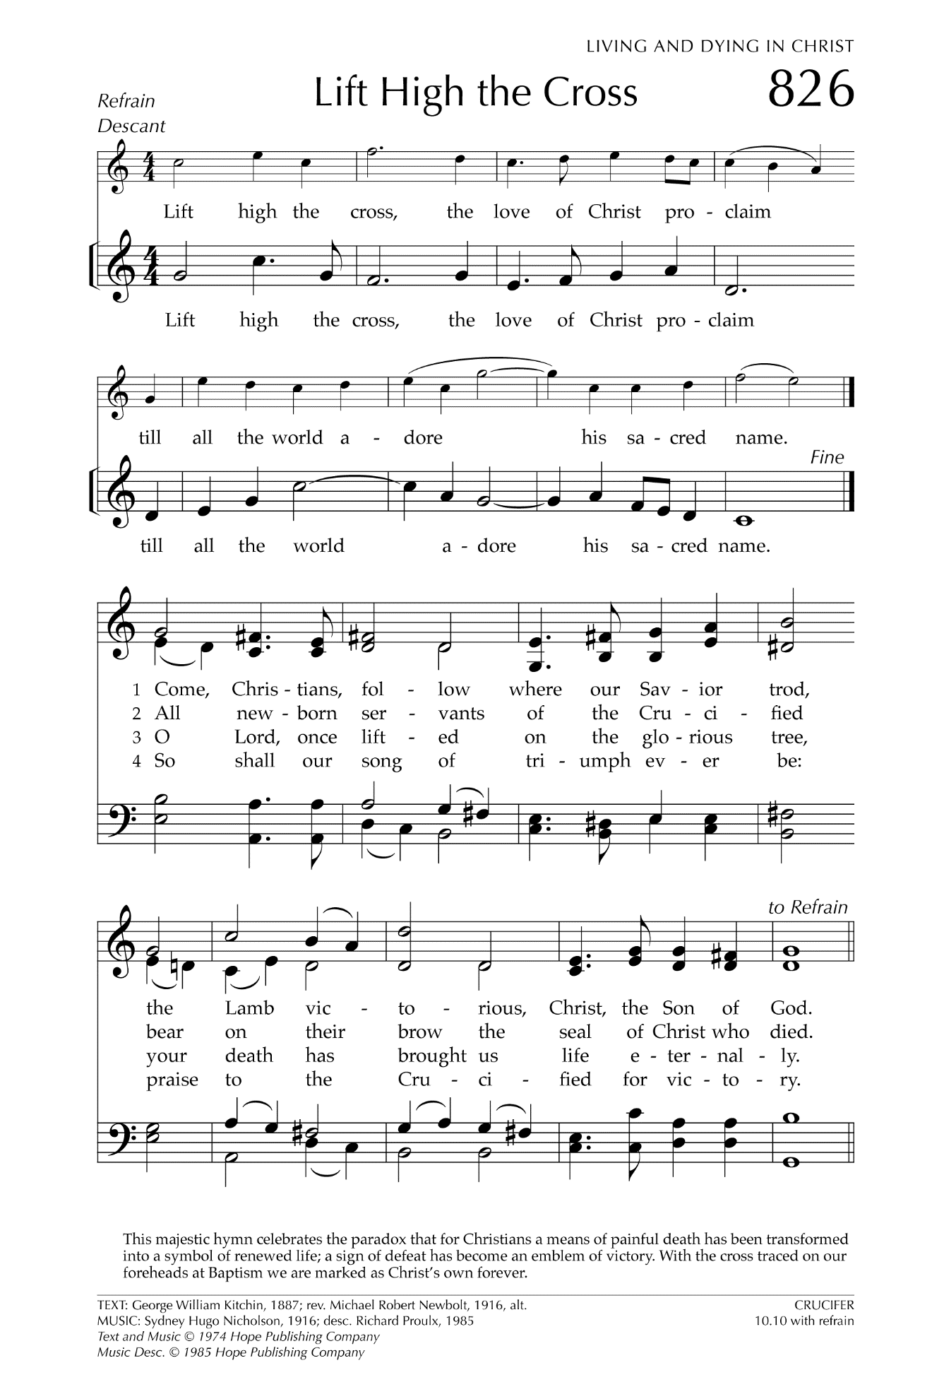
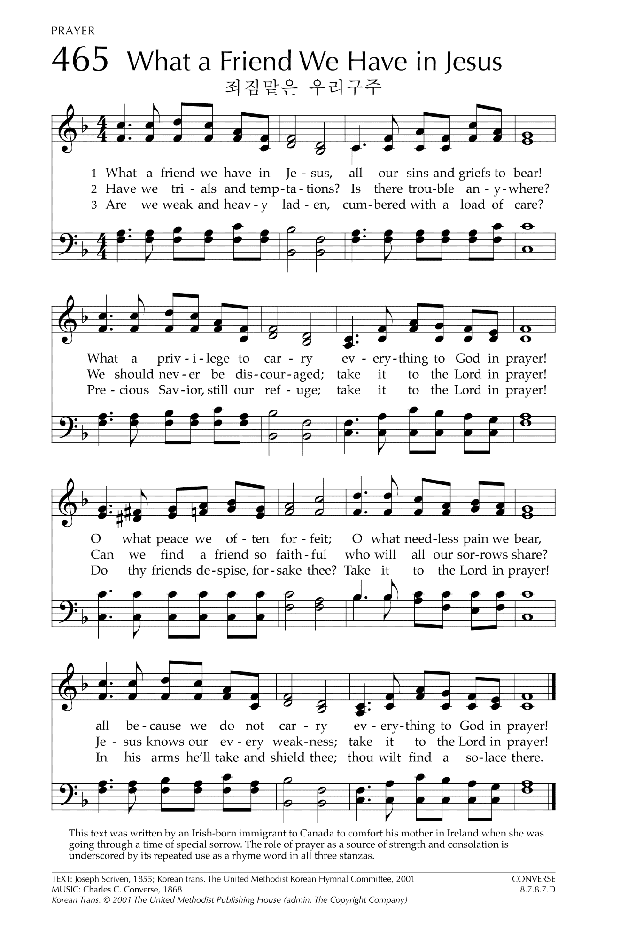

Let There Be Peace on Earth

Let there be peace on earth
And let it begin with me
Let there be peace on earth
The peace that was meant to be
With God as our Father
Christians all are we
Let us walk with each other
In perfect harmony.
Let peace begin with me
Let this be the moment now.
With every step I take
Let this be my solemn vow
To take each moment and live
Each moment in peace eternally
Let there be Peace on Earth
And let it begin with me!

