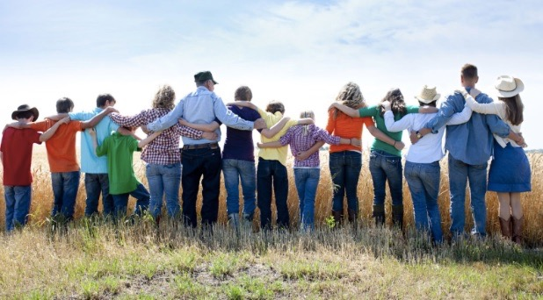
The Holy Way Presbyterian Church

Tucson, Arizona
July 25, 2021 9:30 a.m.

Living In Community...

Words of Meditation: Living in community means there is one Body of Christ, with one Spirit, who has been called in humility, gentleness and patience to share in each other’s burdens and be there for one another in love. That is how a Christian Community lives. The Apostle Paul says to live lives that are Holy and Blameless. Human nature + being a Christian = Holy. Living Holy lives and loving one another

Welcome to Worship Rev. Tina Salvaneschi
Opening Prayer

Introit: Eternal Father, Strong to Save (Hymn #8, V1)
Ryan Phillips, Director of Music

Hymn: For the Fruit of All Creation (Hymn #36, All)
Ryan Phillips, Director of Music

Call to Worship: Ali Clay, Lay Leader

Behold, how good and how pleasant it is For brethren to dwell together in unity! It is like the precious oil upon the head, Running down on the beard, The beard of Aaron, Running down on the edge of his garments. It is like the dew of Hermon, Descending upon the mountains of Zion; For there the Lord commanded the blessing—Life forevermore.

People: Amen

Birthday’s and Anniversaries Alfonso Valenzuela
Celebrations, Joys and Concerns Rev. Tina Salvaneschi

The Lord’s Prayer
Our Father, who art in heaven, hallowed be thy name. Thy kingdom come, thy will be done on earth as it is in heaven. Give us this day our daily bread, and forgive us our debts as we forgive our debtors. And lead us not into temptation, but deliver us from evil, for thine is the kingdom and the power and the glory forever. Amen
Anthem: I Glory In My Jesus Ryan Phillips, Director of Music

Invitation for Tithes and Offering: Rev. Tina Salvaneschi

Offertory Music: Woan Ching Lim, Pianist
(offering baskets available at all four exits as you leave)

Scripture Reading: Ali Clay, Lay Leader
Ephesians 4:1-6

1 I, therefore, the prisoner of the Lord, beseech you to walk worthy of the calling with which you were called, 2 with all lowliness and gentleness, with long suffering, bearing with one another in love, 3 endeavoring to keep the unity of the Spirit in the bond of peace. 4 There is one body and one Spirit, just as you were called in one hope of your calling; 5 one Lord, one faith, one baptism; 6 one God and Father of all, who is above all, and through all, and in you all.
Leader:
This is the Word of the Lord. People: Thanks be to God.
Message: Bearing One-Another In Love Rev. Tina Salvaneschi
Sending Hymn: Oh Lord, You Are MY God and King (Hymn #270, All) Ryan Phillips, Director of Music
Children: Children share prayers/art/lessons
Benediction: 2 Corinthians 13:14 Rev. Tina Salvaneschi
Song: Let There Be Peace on Earth Ryan Phillips, Director of Music
Postlude: Woan Ching Lim, Pianist

Stay Connected at The Holy Way

“Sermon Debrief Bible Study in person on Campus and Zoom” - Tuesday 10:00 a.m.
It’s Both! Come and meet live in the Conference Room at 10:00 a.m. or join on Zoom and we will conference you in on the big screen!
This is a great way to get to Fellowship, wrestle with questions about Sunday’s sermon, ponder the meaning of God’s Word, and discover how Scriptures can transform our lives today. This is led by Pastor Tina and is interactive! Come join the live class if you are able!

“Thoughtful Thursdays” - Thursday 10:00 a.m. Zoom
This is a great way to stay connected (especially for our snowbirds, and folks that can’t make it to in-person services!). We share about our lives, spend time talking, share joys, prayer requests…and anything else that comes up. Oh yes, laughter seems to happen too. This is group lead, with Pastor Tina and for women AND men!
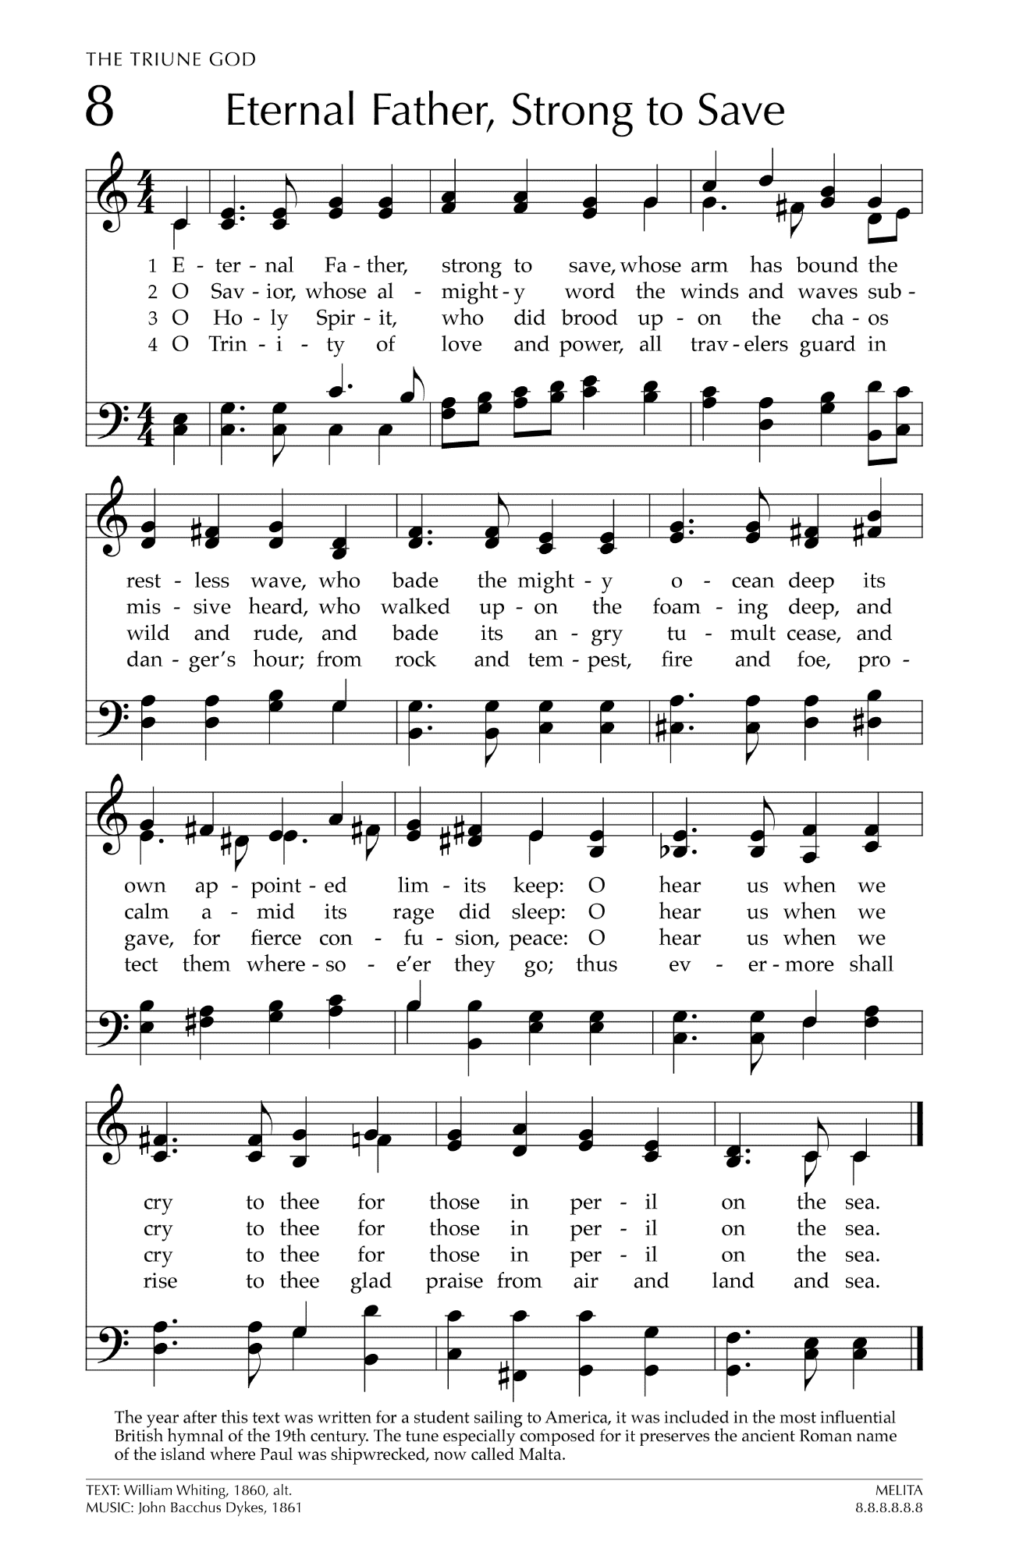
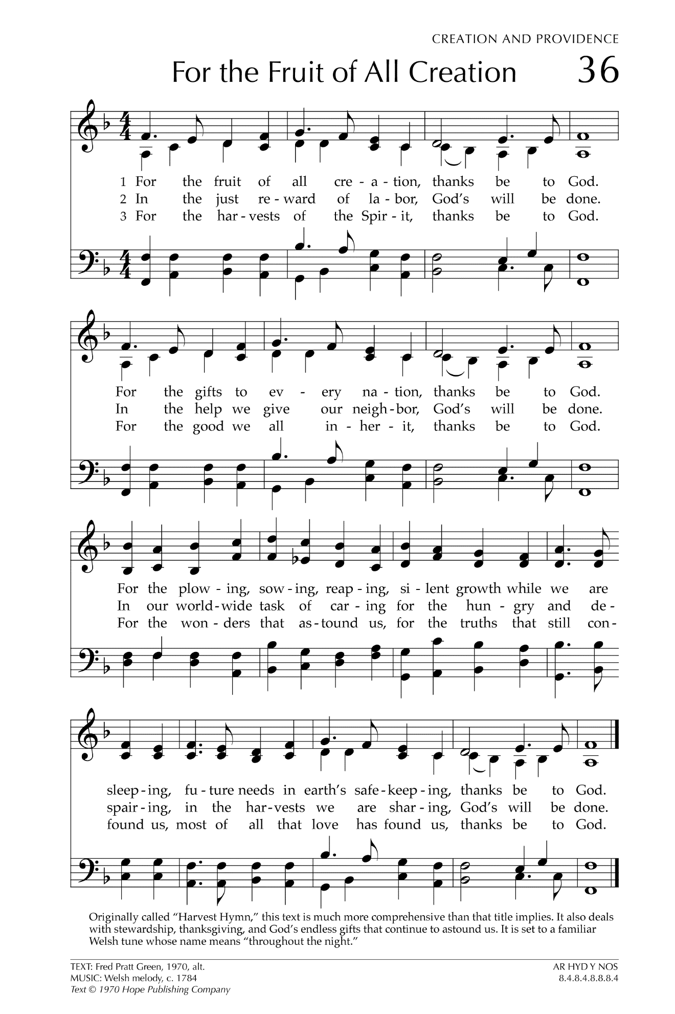
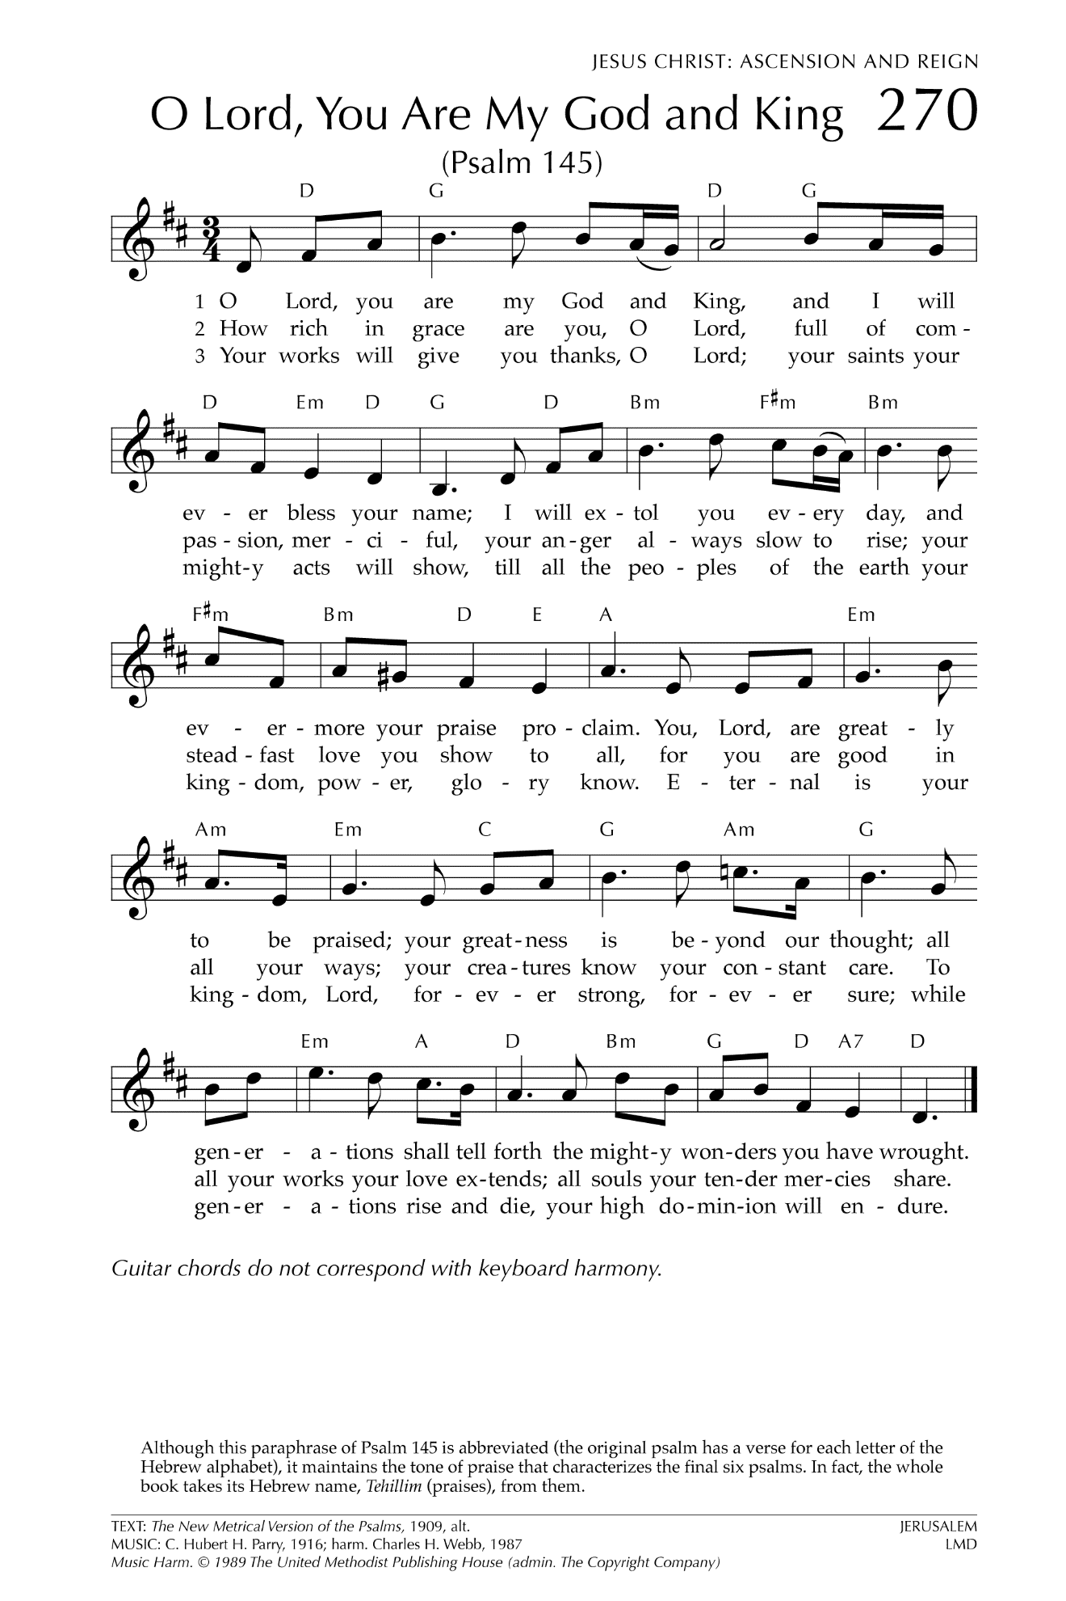

Let There Be Peace on Earth

Let there be peace on earth
And let it begin with me
Let there be peace on earth
The peace that was meant to be
With God as our Father
Christians all are we
Let us walk with each other
In perfect harmony.
Let peace begin with me
Let this be the moment now.
With every step I take
Let this be my solemn vow
To take each moment and live
Each moment in peace eternally
Let there be Peace on Earth
And let it begin with me!

