The Holy Way Presbyterian Church

Tucson, Arizona

November 14, 2021 9:30 a.m.
Trusting In God Brings Comfort...

Welcome to Worship Rev. Tina Salvaneschi
Opening Prayer
Release Children to Sunday School - Miss Kathy
Introit: Glorious Things of These Are Spoken (Hymn 81, Vs 2)
Ryan Phillips, Choir Director

Hymn: As the Wind Song (Hymn 292) Ryan Phillips, Choir Director

Call to Worship: Lay Leader, Don Kimball

Leader: What does the Lord require of you?

People: To do justice, and to love kindness,
and to walk humbly with our God.

Leader: What does God command of us?

People: To love God with all our heart,
and all our soul,
and all our mind,
and all our strength,
and to love our neighbor as ourselves.

Leader: God does not call us to ease or to comfort.

People: But to presence, and abundance,
and grace in our struggle.

Leader: Let us worship the God who believes in us,
and trusts in us, and abides with us.

People: Let us worship the God who will ask much of us,
but will be beside us every step of the way. Amen

Birthdays and Anniversaries
Celebrations, Joys and Concerns Rev. Tina Salvaneschi
The People of the Congregation Share Joys and Concerns

...The Lord’s Prayer
People: Our Father, who art in heaven, hallowed be thy name. Thy kingdom come, thy will be done on earth as it is in heaven. Give us this day our daily bread, and forgive us our debts as we forgive our debtors. And lead us not into temptation, but deliver us from evil, for thine is the kingdom and the power and the glory forever. Amen

Anthem: Rain Down Chancel Choir
Rain down, rain down, rain down your love on your people.
Rain down, rain down, rain down your love, God of life.
Faithful and true is the word of our God. All of God's works are so worthy of trust.
God's mercy falls on the just and the right; Full of God's love is the earth.
Rain down, rain down, rain down your love on your people.
Rain down, rain down, rain down your love, God of life.
We who revere and find hope in our God live in the kindness and joy of God's wing.
God will protect us from darkness and death; God will not leave us to starve.
Rain down, rain down, rain down your love on your people.
Rain down, rain down, rain down your love, God of life.
God of creation, we long for your truth; you are the water of life for our thirst.
Grant that your love and your peace touch our hearts, all of our hope lies in you.
Rain down, rain down, rain down your love on your people.
Rain down, rain down, rain down your love, God of life.

Tithes and Offering: Prayer Rev. Tina Salvaneschi
(Option: Place you index card with a private prayer for Pastor)
(Option: write on index card a word or two what giving to God means to you place index cards in plate)

Offertory Music: Dr. Astrid Chan

Scripture Reading: Lay Leader, Don Kimball
2 Corinthians 6:3-4.14-18

3 We put no stumbling block in anyone’s path, so that our ministry will not be discredited. 4 Rather, as servants of God we commend ourselves in every way: in great endurance; in troubles, hardships and distresses;

14 Do not be yoked together with unbelievers. For what do righteousness and wickedness have in common? Or what fellowship can light have with darkness? 15 What harmony is there between Christ and Belial? Or what does a believer have in common with an unbeliever? 16 What agreement is there between the temple of God and idols? For we are the temple of the living God.

As God has said: “I will live with them and walk among them, and I will be their God, and they will be my people.” 17 Therefore, “Come out from them and be separate, says the Lord. Touch no unclean thing, and I will receive you.”18 And, “I will be a Father to you, and you will be my sons and daughters, says the Lord Almighty.”

Leader: This is the Word of the Lord.

People: Thanks be to God.

Message: “God Yokes Us Together” Rev. Tina Salvaneschi

Sending Hymn: My Lord What a Morning (Hymn 352)
Ryan Phillips, Choir Director

Benediction: 2 Corinthians 13:14 Rev. Tina Salvaneschi

Song: Let There Be Peace on Earth Ryan Phillips, Choir Director
Postlude: Dr. Astrid Chan
Stay Connected at The Holy Way
“Sermon Debrief Bible Study in person on Campus and Zoom” - Tuesday 10:00 a.m. -Vaccinated Only Please
It’s Both! Come and meet live in the Conference Room at 10:00 a.m. or join on Zoom and we will conference you in on the big screen!
This is a great way to get to Fellowship, wrestle with questions about Sunday’s sermon, ponder the meaning of God’s Word, and discover how Scriptures can transform our lives today. This is led by Pastor Tina and is interactive! Come join the live class if you are able!

“Thoughtful Thursdays” - Thursday 10:00 a.m. Zoom Only
This is a great way to stay connected (especially for our snowbirds, and folks that can’t make it to in-person services!). We share about our lives, spend time talking, share joys, prayer requests…and anything else that comes up. Oh yes, laughter seems to happen too. This is group led, with Pastor Tina and for women AND men!

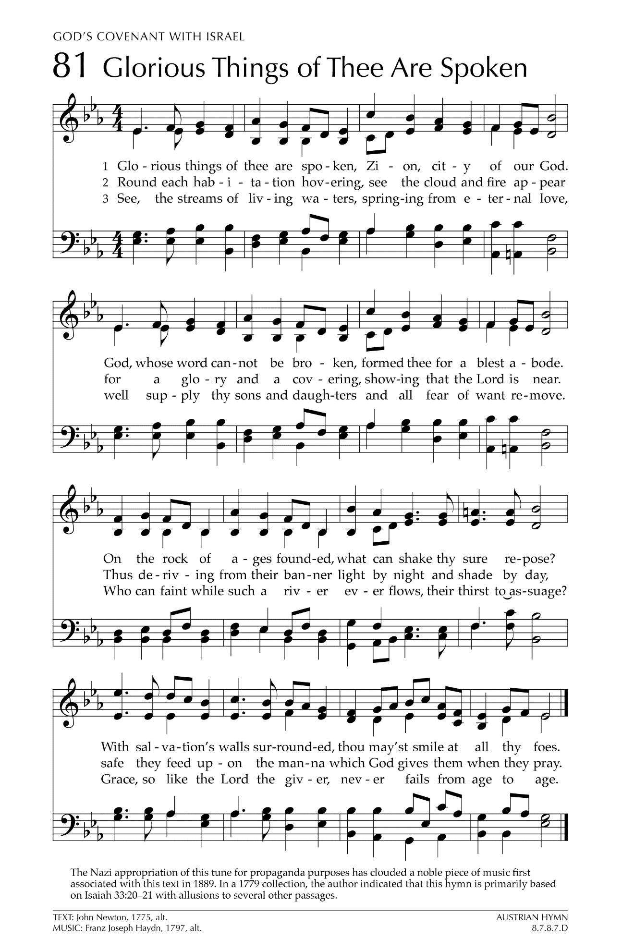
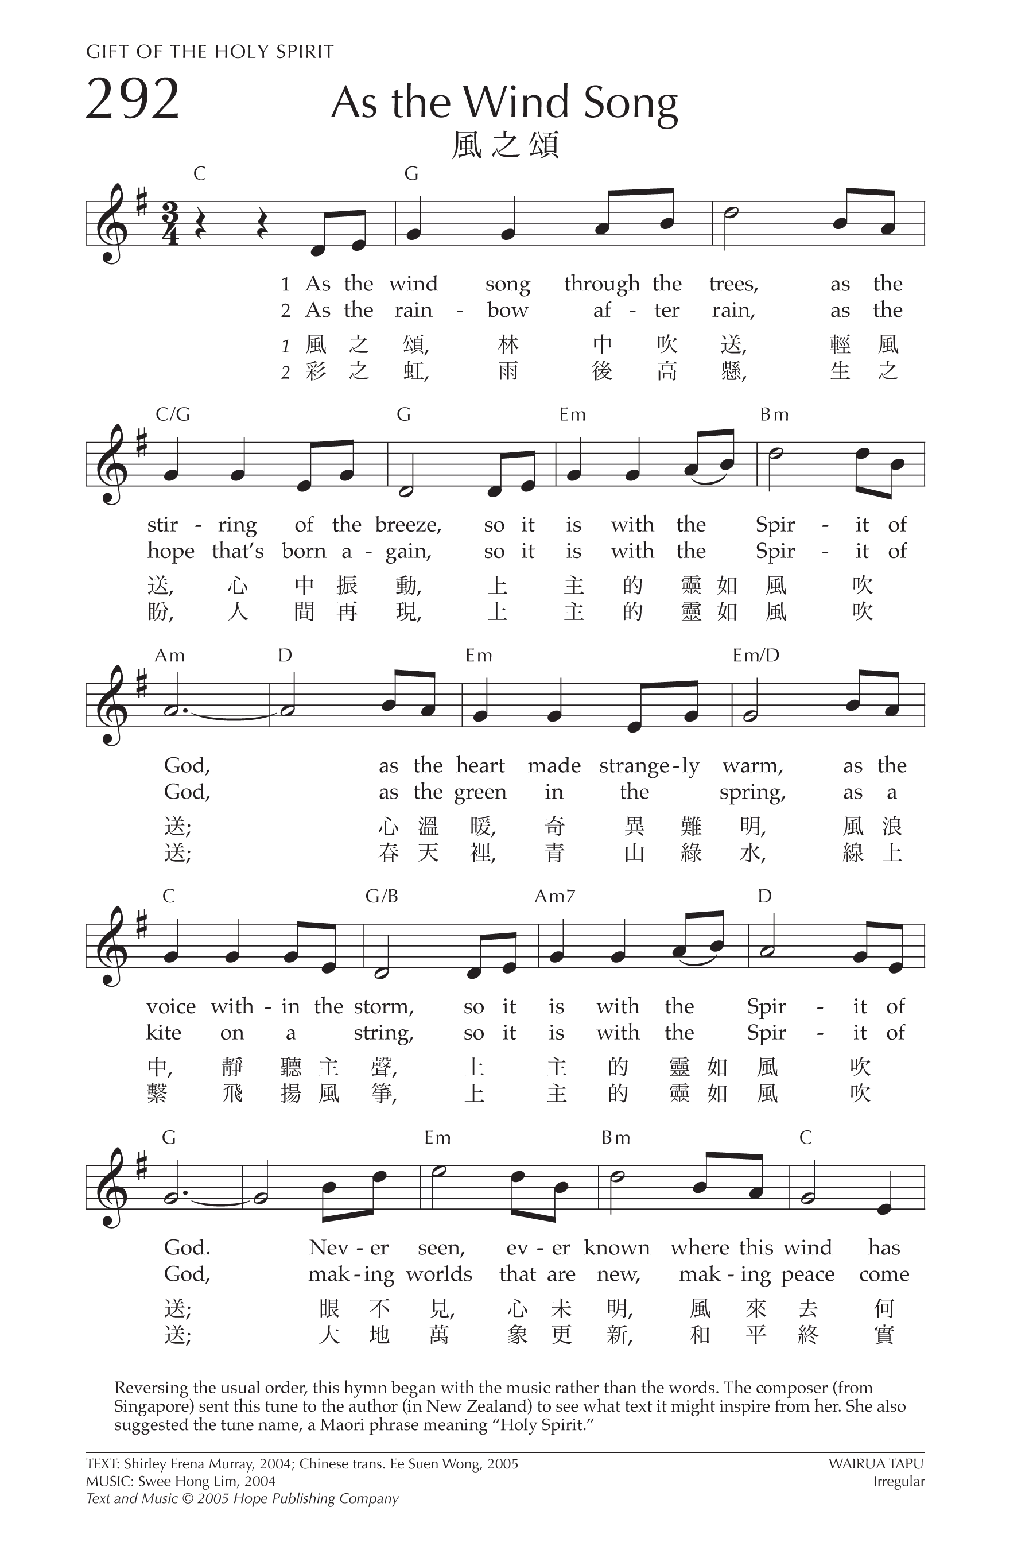
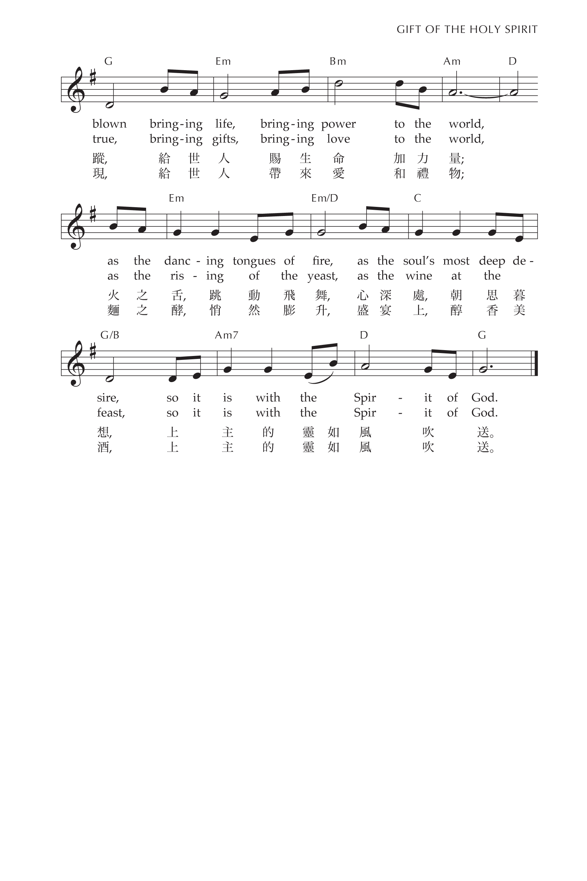
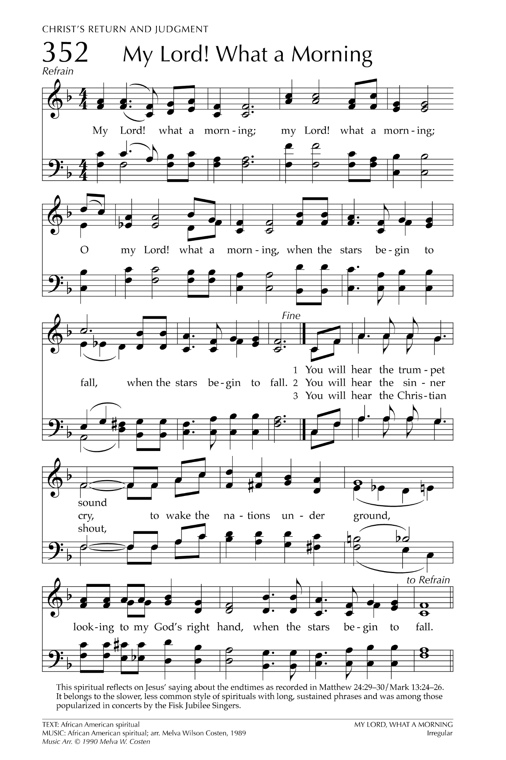

Let There Be Peace on Earth

Let there be peace on earth
And let it begin with me
Let there be peace on earth
The peace that was meant to be
With God as our Father
Christians all are we
Let us walk with each other
In perfect harmony.
Let peace begin with me
Let this be the moment now.
With every step I take
Let this be my solemn vow
To take each moment and live
Each moment in peace eternally
Let there be Peace on Earth
And let it begin with me!

