The Holy Way Presbyterian Church

Tucson, Arizona

September 12, 2021 9:30 a.m.
Living In Community...

Words of Meditation - The Writer of Ephesians encourages us in the epistle how to live out the Christian life. Yet the book begins with the promises and blessings of this kind of life; we are Adopted into a family, Redeemed by Christ and will receive an inheritance.

Welcome to Worship Rev. Tina Salvaneschi
Opening Prayer
Release Children to Sunday School - Miss Kathy
Introit: God, Who Stretched the Spangled Heavens (Hymn #24, V 1)
Ryan Phillips, Choir Director

Hymn: Take Up Your Cross, the Savior Said (Hymn #718) Ryan Phillips, Choir Director

Call to Worship: Lay Leader, Cindy Johnston

People: Merciful God,
We come before You with praise and thanksgiving!
Through Jesus Christ,
You have lavished on us every spiritual blessing
we could possibly imagine!

Leader: Before the world was created,
You already knew us and loved us.
You adopted us as your own children,
and redeemed us through the blood of Christ.
Even more, you have made us your heirs,
and given us your own Spirit as a sign and guarantee.
How we praise you!

People: Open our hearts and minds to Your presence among us here.
May our worship this morning bring You honor and glory,
for You alone are worthy of our praise.

People: Amen

Birthdays and Anniversaries Alfonso Valenzuela
Celebrations, Joys and Concerns Rev. Tina Salvaneschi
The People of the Congregation Share Joys and Concerns

...The Lord’s Prayer
People: Our Father, who art in heaven, hallowed be thy name. Thy kingdom come, thy will be done on earth as it is in heaven. Give us this day our daily bread, and forgive us our debts as we forgive our debtors. And lead us not into temptation, but deliver us from evil, for thine is the kingdom and the power and the glory forever. Amen

Anthem: Canticle of Hope Chancel Choir
Tithes and Offering: Prayer Rev. Tina Salvaneschi
(option: Place you index card with a private prayer for Pastor)
(option: write on index card a word or two what giving to God means to you place index cards in plate)

Offertory Music: I will Give Thanks Gail Schumacher
Dr. Astrid Chan
Scripture Reading: Lay Leader, Cindy Johnston
Ephesians 4:3-9
3 Blessed be the God and Father of our Lord Jesus Christ, who has blessed us with every spiritual blessing in the heavenly places in Christ, 4 just as He chose us in Him before the foundation of the world, that we should be holy and without blame before Him in love, 5 having predestined us to adoption as sons by Jesus Christ to Himself, according to the good pleasure of His will, 6 to the praise of the glory of His grace, by which He made us accepted in the Beloved
7 In Him we have redemption through His blood (His life), the forgiveness of sins, according to the riches of His grace 8 which He made to abound toward us in all wisdom and prudence, 9 having made known to us the mystery of His will, according to His good pleasure which He purposed in Himself.

Ephesians 2:8-10
8 For by grace you have been saved through faith, and that not of yourselves; it is the gift of God, 9 not of works, lest anyone should boast. 10 For we are His workmanship, created in Christ Jesus for good works, which God prepared beforehand that we should walk in them.

Leader: This is the Word of the Lord. People: Thanks be to God.

Message: “Living The Christian Life” Rev. Tina Salvaneschi

Sending Hymn: Lord, Speak to Me, That I May Speak (Hymn #722, 1,2,3,5)
Ryan Phillips, Choir Director

Benediction: 2 Corinthians 13:14 Rev. Tina Salvaneschi

Song: Let There Be Peace on Earth Ryan Phillips, Choir Director
Postlude: Dr. Astrid Chan

Stay Connected at The Holy Way
“Sermon Debrief Bible Study in person on Campus and Zoom” - Tuesday 10:00 a.m.
It’s Both! Come and meet live in the Conference Room at 10:00 a.m. or join on Zoom and we will conference you in on the big screen!
This is a great way to get to Fellowship, wrestle with questions about Sunday’s sermon, ponder the meaning of God’s Word, and discover how Scriptures can transform our lives today. This is led by Pastor Tina and is interactive! Come join the live class if you are able!

“Thoughtful Thursdays” - Thursday 10:00 a.m. Zoom Only
This is a great way to stay connected (especially for our snowbirds, and folks that can’t make it to in-person services!). We share about our lives, spend time talking, share joys, prayer requests…and anything else that comes up. Oh yes, laughter seems to happen too. This is group led, with Pastor Tina and for women AND men!

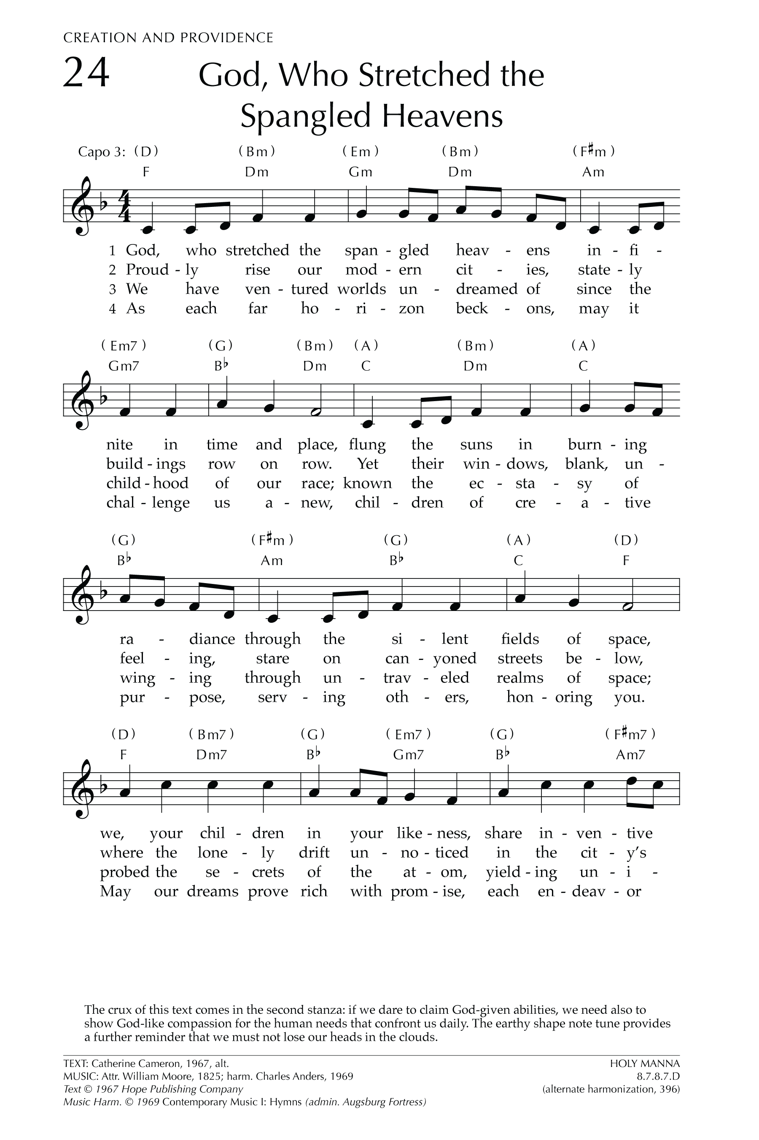
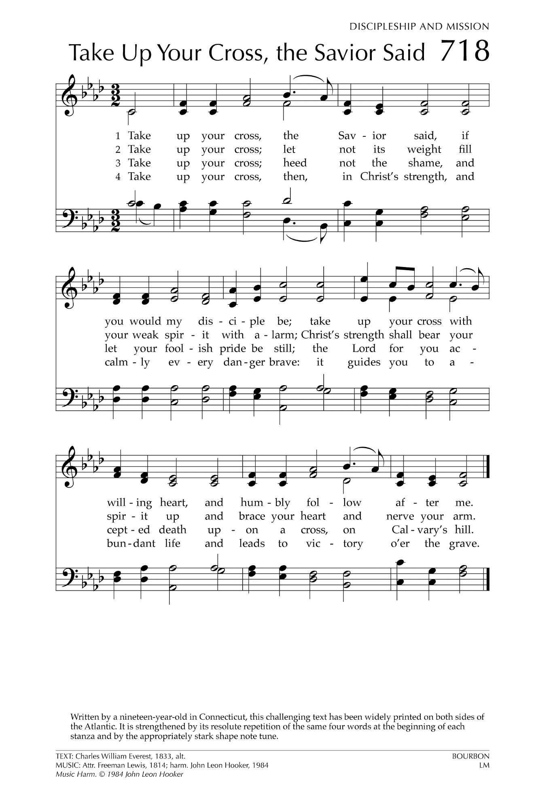
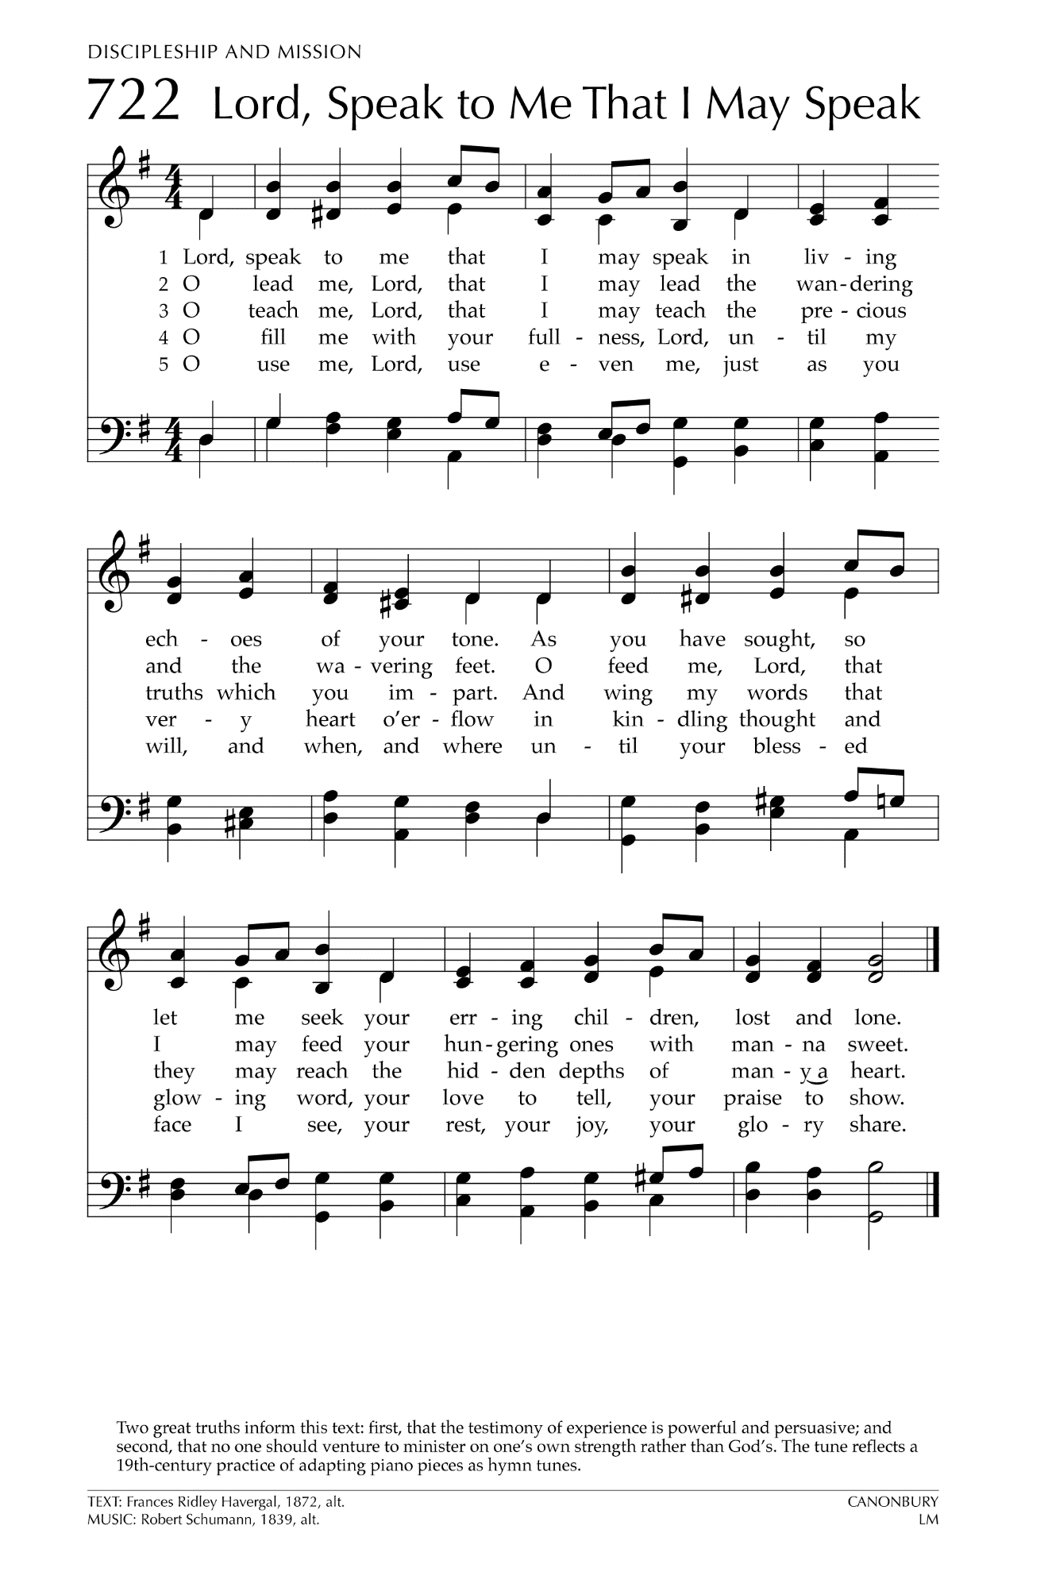

Let There Be Peace on Earth

Let there be peace on earth
And let it begin with me
Let there be peace on earth
The peace that was meant to be
With God as our Father
Christians all are we
Let us walk with each other
In perfect harmony.
Let peace begin with me
Let this be the moment now.
With every step I take
Let this be my solemn vow
To take each moment and live
Each moment in peace eternally
Let there be Peace on Earth
And let it begin with me!

