The Holy Way Presbyterian Church
Tucson, Arizona

January 16, 2022 9:30 a.m.
Finding Balanced Living Series...

Welcome to Worship: Rev. Tina Salvaneschi
Opening Prayer
Children are Released to Sunday School

Announcements:
Prayer Chain - If you have a prayer request during the week or weekend and would like our prayer team to be praying for you or someone you know, please contact Janie Saxton at (612) 387-7756.

Deacons - Our nine Deacons have now been given their own flock, which is a small group of people attending the Holy Way. Your Deacon will be contacting you in the near future to say hello, and be certain you are receiving correspondence, ask if you need prayer, a pastors visit, or just want to chat.

Hymn: Be Thou My Vision (Hymn #450, Vs. 1, 2, 4) Congregation
Rosalie Baumrucker

Call To Worship: Terry Saxton

Tell it from the mountains and to the sea,
the greatness of God's grace.
God is doing wonderful things,
comforting those who grieve,
giving us days in His mercy,
and filling our hearts and the hearts of our children.
He is providing help in trouble and new beginnings,
bringing reconciliation where there was brokenness
causing healing in our bodies and our souls,
sending songs of joy to awaken life.

Tell it out, people of God,
the greatness of God and His grace.

Congregation of Jesus Christ, in whom are you trusting?
Our help is in the name of the Lord who made heaven and earth.
Grace, mercy, and peace to you in the name of the Father, the Son, and the Holy Spirit.

People: Amen!

Birthdays and Anniversaries Stephen Levine
If you want to participate in our tradition of celebrating your birthday or anniversary by giving money towards church building, renovations, improvements, or sound systems, just waive your hand, or stand up and Pastor Tina will receive it in the basket!

Celebrations, Joys and Concerns Rev. Tina Salvaneschi
The People of the Congregation Share Joys and Concerns

...The Lord’s Prayer
People: Our Father, who art in heaven, hallowed be thy name. Thy kingdom come, thy will be done on earth as it is in heaven. Give us this day our daily bread, and forgive us our debts as we forgive our debtors. And lead us not into temptation, but deliver us from evil, for thine is the kingdom and the power and the glory forever. Amen

Anthem: Surely The Presence Of The Lord Is In This Place
(In Memory of Marv Knittel) Rosalie Baumrucker
Tithes and Offering: Prayer Rev. Tina Salvaneschi
(Option: Place you index card with a private prayer for Pastor)
(Option: write on index card a word or two what giving to God means to you place index cards in plate)

Offertory Music: Dr. Astrid Chan

Doxology: (Hymn #606) Congregation
Praise God, from whom all blessings flow;
praise Him all creatures here below;
praise Him above, ye heavenly host;
praise Father, Son, and Holy Ghost. Amen.

Scripture Reading: Lay Leader Terry Saxton
Reading from Psalm 55

1 Give ear to my prayer, O God,
And do not hide Yourself from my supplication.
2 Attend to me, and hear me;
I am restless in my complaint, and moan noisily,
3 Because of the voice of the enemy,
Because of the oppression of the wicked;
For they bring down trouble upon me,
And in wrath they hate me.

4 My heart is severely pained within me,
And the terrors of death have fallen upon me.
5 Fearfulness and trembling have come upon me,
And horror has overwhelmed me.

12 For it is not an enemy who reproaches me;
Then I could bear it.
Nor is it one who hates me who has exalted himself against me;
Then I could hide from him.
13 But it was you, a man my equal,
My companion and my acquaintance.
14 We took sweet counsel together,
And walked to the house of God in the throng.

16 As for me, I will call upon God,
And the Lord shall save me.
17 Evening and morning and at noon
I will pray, and cry aloud,
And He shall hear my voice.
18 He has redeemed my soul in peace from the battle that was against me,
For there were many against me.
19 God will hear, and afflict them,
Even He who abides from of old. Selah
Because they do not change,
Therefore they do not fear God.

22 Cast your burden on the Lord,
And He shall sustain you;
He shall never permit the righteous to be moved.

Leader: This is the Word of the Lord.
People: Thanks be to God.

Message: “Shedding Your Emotional Baggage” Rev. Tina Salvaneschi

Sending Hymn: Majesty Congregation
Rosalie Baumrucker

Benediction: 2 Corinthians 13:14 Rev. Tina Salvaneschi

Song: Let There Be Peace on Earth Congregation
Postlude: Dr. Astrid Chan

Stay Connected During the Week!

“Sermon Debrief Bible Study in person on Campus” - Tuesday 10:00 a.m.! Vaccinated Only Please (no Zoom)
Come and meet live in the Sanctuary at 10:00 a.m.
This is a great way to get to Fellowship, wrestle with questions about Sunday’s sermon, ponder the meaning of God’s Word, and discover how Scriptures can transform our lives today. This is led by Pastor Tina and is interactive and often there are donuts! Come join the live class if you are able!

“Thoughtful Thursdays” - Thursdays 10:00 a.m. Zoom Only
This is a great way to stay connected (especially for our snowbirds, and folks that can’t make it to in-person services!). We share about our lives, spend time talking, share joys, pray requests…and anything else that comes up. Oh yes, laughter seems to happen too. This is group lead, with Pastor Tina and for women AND men!

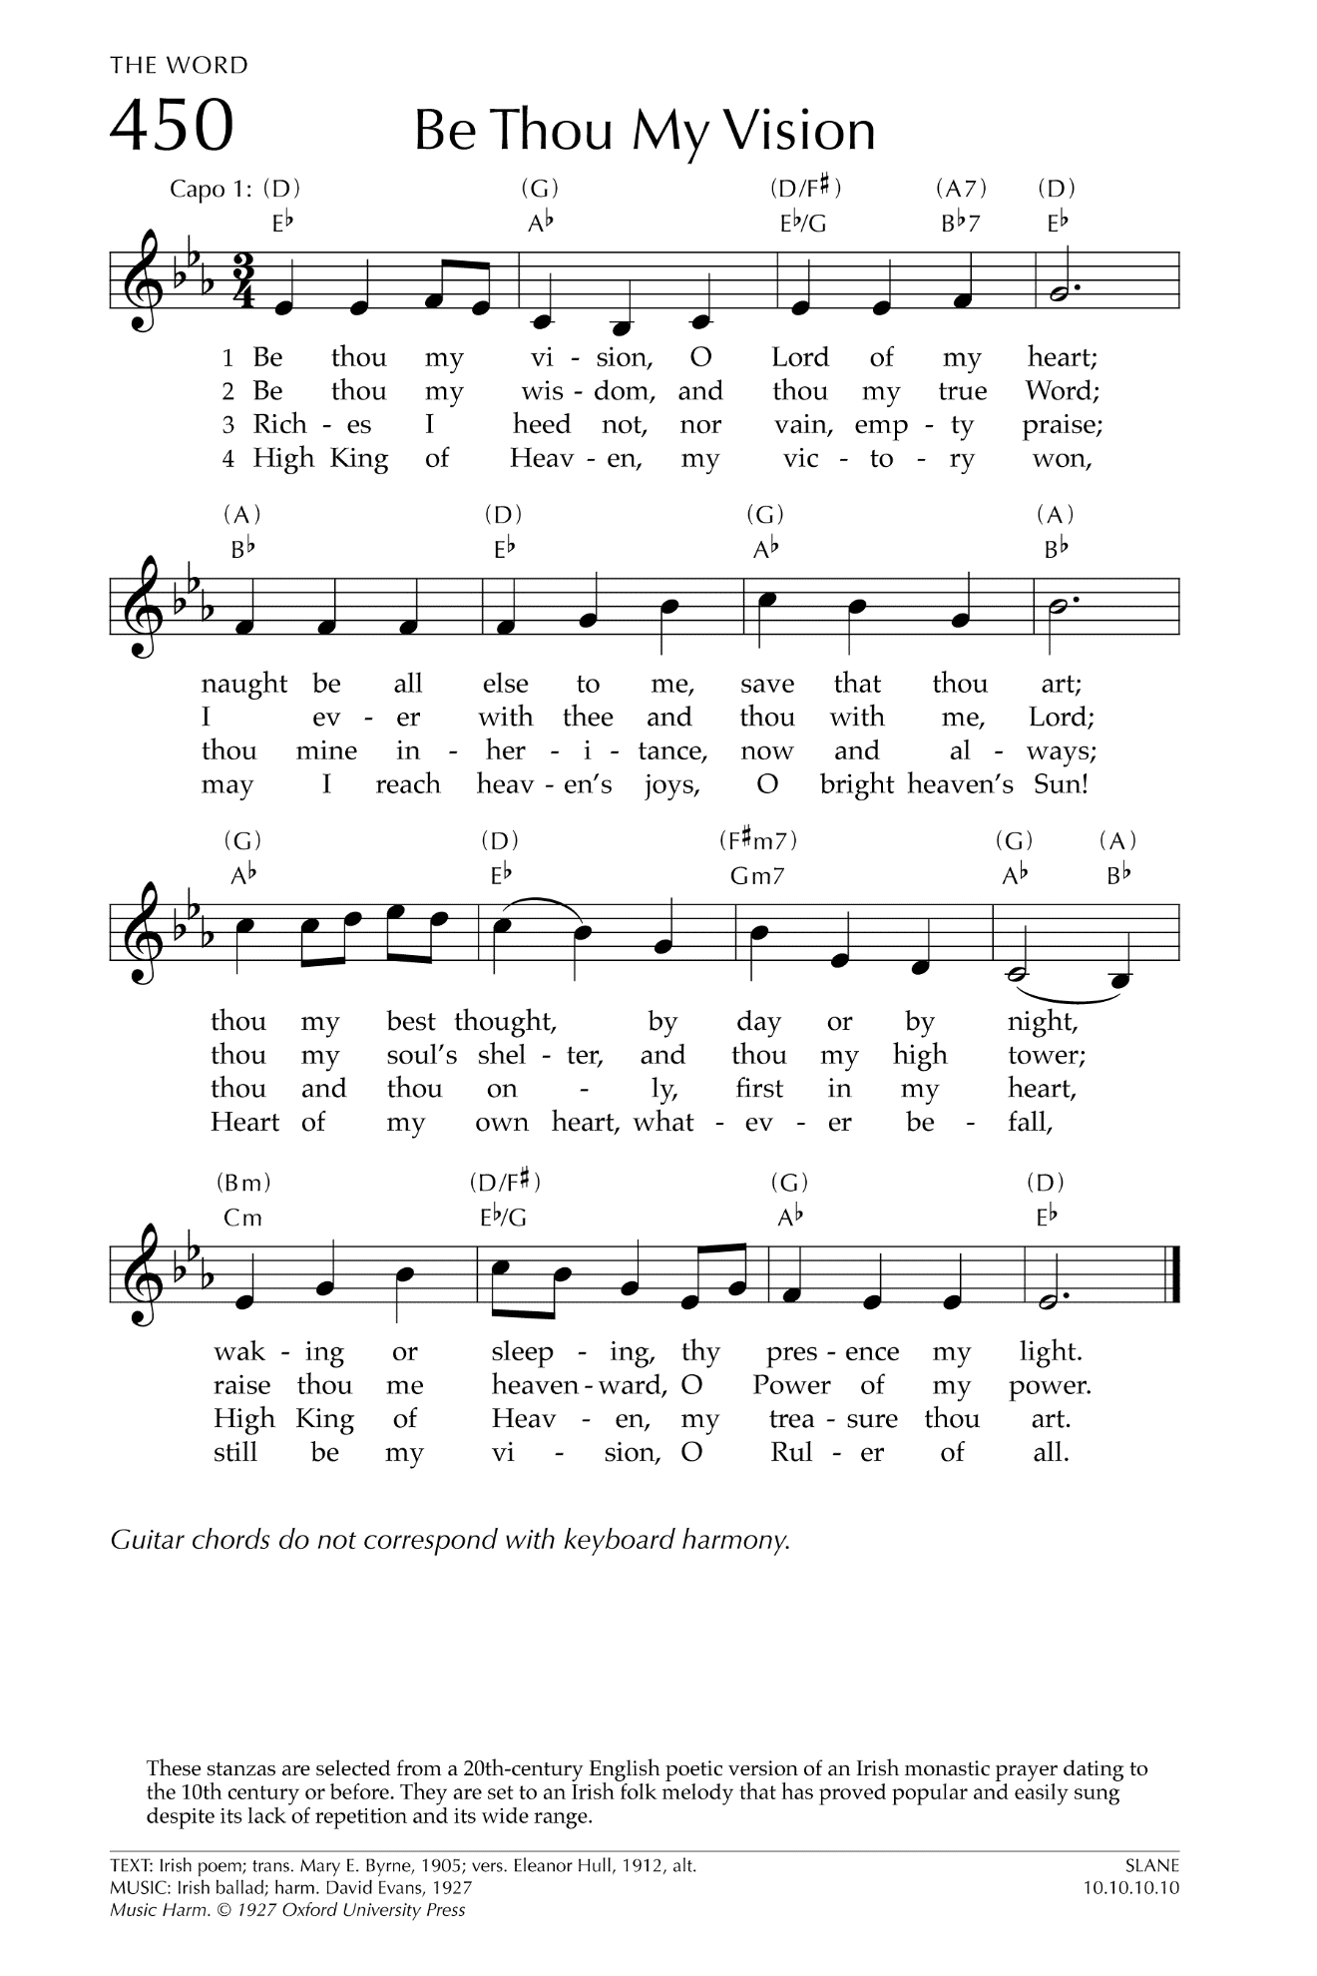

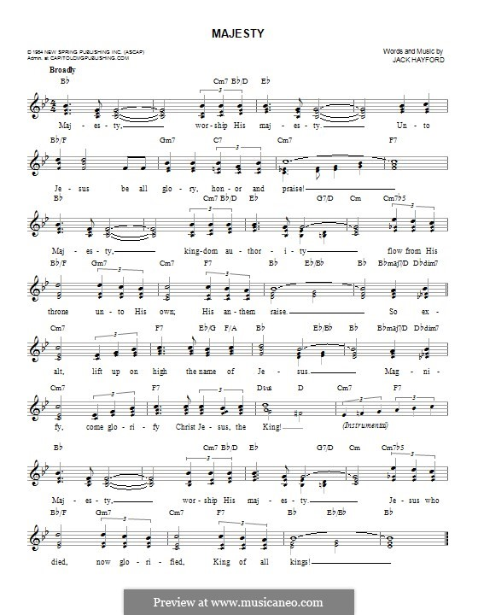

Let There Be Peace on Earth

Let there be peace on earth
And let it begin with me
Let there be peace on earth
The peace that was meant to be
With God as our Father
Christians all are we
Let us walk with each other
In perfect harmony.
Let peace begin with me
Let this be the moment now.
With every step I take
Let this be my solemn vow
To take each moment and live
Each moment in peace eternally
Let there be Peace on Earth
And let it begin with me!

