The Holy Way Presbyterian Church
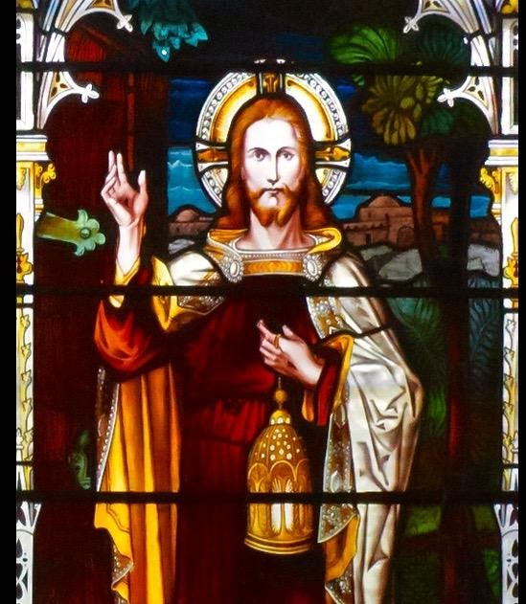
Tucson, Arizona

January 2, 2022 9:30 a.m.
Second Sunday After Christmas…

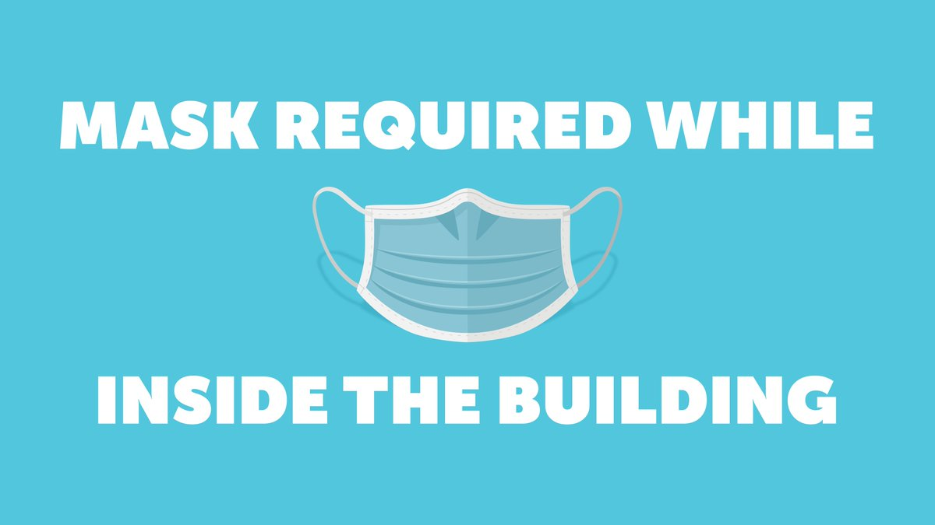
Welcome to Worship Karl Allen
Opening Prayer
Release Children to Sunday School Miss. Ruth Parsil
Special: The First Song I Sing Rosalie & Al Baumrucker
Call To Worship: Lay Leader Barbara Armbruster
Psalm 147:12-20

12 Praise the Lord, O Jerusalem!
Praise your God, O Zion!
13 For He has strengthened the bars of your gates;
He has blessed your children within you.
14 He makes peace in your borders,
And fills you with the finest wheat.

15 He sends out His command to the earth;
His word runs very swiftly.
16 He gives snow like wool;
He scatters the frost like ashes;
17 He casts out His hail like morsels;
Who can stand before His cold?
18 He sends out His word and melts them;
He causes His wind to blow, and the waters flow.

19 He declares His word to Jacob,
His statutes and His judgments to Israel.
20 He has not dealt thus with any nation;
And as for His judgments, they have not known them.

People: Amen

Hymn: When Israel Was in Egypt's Land (Hymn # 52)
Congregation
Rosalie Baumrucker

Birthdays and Anniversaries Ray Weathers
If you want to participate in our tradition of celebrating your birthday or anniversary by giving money towards church building, renovation, improvement, sound systems, just waive your hand, or stand up and we will receive it in the plate!

Celebrations, Joys and Concerns Cindy Johnston
The People of the Congregation Share Joys and Concerns
Ray Weathers will bring the microphone to you.

The Lord’s Prayer Cindy Johnston
People: Our Father, who art in heaven, hallowed be thy name. Thy kingdom come, thy will be done on earth as it is in heaven. Give us this day our daily bread, and forgive us our debts as we forgive our debtors. And lead us not into temptation, but deliver us from evil, for thine is the kingdom and the power and the glory forever. Amen

Anthem: Spirit Song Rosalie Baumrucker
Tithes and Offering: Prayer Karl Allen
(Option: Place your index card with a private prayer for Pastor)
(Option: write on index card a word or two what giving to God means to you-place index cards in plate)

Offertory Music: Special Music Judy Montrose

Doxology: (Hymn #606) Congregation
Rosalie Baumrucker
Praise God, from whom all blessings flow;
praise Him all creatures here below;
praise God above, ye heavenly host;
praise Father, Son, and Holy Ghost. Amen.

Scripture Reading: Lay Leader Barbara Armbruster
Gospel John 1:1-9, 14-18
1 In the beginning was the Word, and the Word was with God, and the Word was God. 2 He was in the beginning with God. 3 All things were made through Him, and without Him nothing was made that was made. 4 In Him was life, and the life was the light of men. 5 And the light shines in the darkness, and the darkness did not comprehend it.
6 There was a man sent from God, whose name was John. 7 This man came for a witness, to bear witness of the Light, that all through him might believe. 8 He was not that Light, but was sent to bear witness of that Light. 9 That was the true Light which gives light to every man coming into the world.
14 And the Word became flesh and dwelt among us, and we beheld His glory, the glory as of the only begotten of the Father, full of grace and truth.
15 John bore witness of Him and cried out, saying, “This was He of whom I said, ‘He who comes after me is preferred before me, for He was before me.’ ”

16 And of His fullness we have all received, and grace for grace. 17 For the law was given through Moses, but grace and truth came through Jesus Christ. 18 No one has seen God at any time. The only begotten Son, who is in the bosom of the Father, He has declared Him.

Leader: This is the Word of the Lord.
People: Thanks be to God.

Message: “The Gift” Karl Allen

Sending Hymn: Jesus, Lover of My Soul (Hymn #440)
Congregation
Rosalie Baumrucker

Benediction: Karl Allen
Song: Let There Be Peace on Earth Congregation
Postlude: Dr. Astrid Chan

Sermon Debrief and Thoughtful Thursdays will be closed for the Holiday this week!
We will resume our gatherings on Tuesday January 11th!

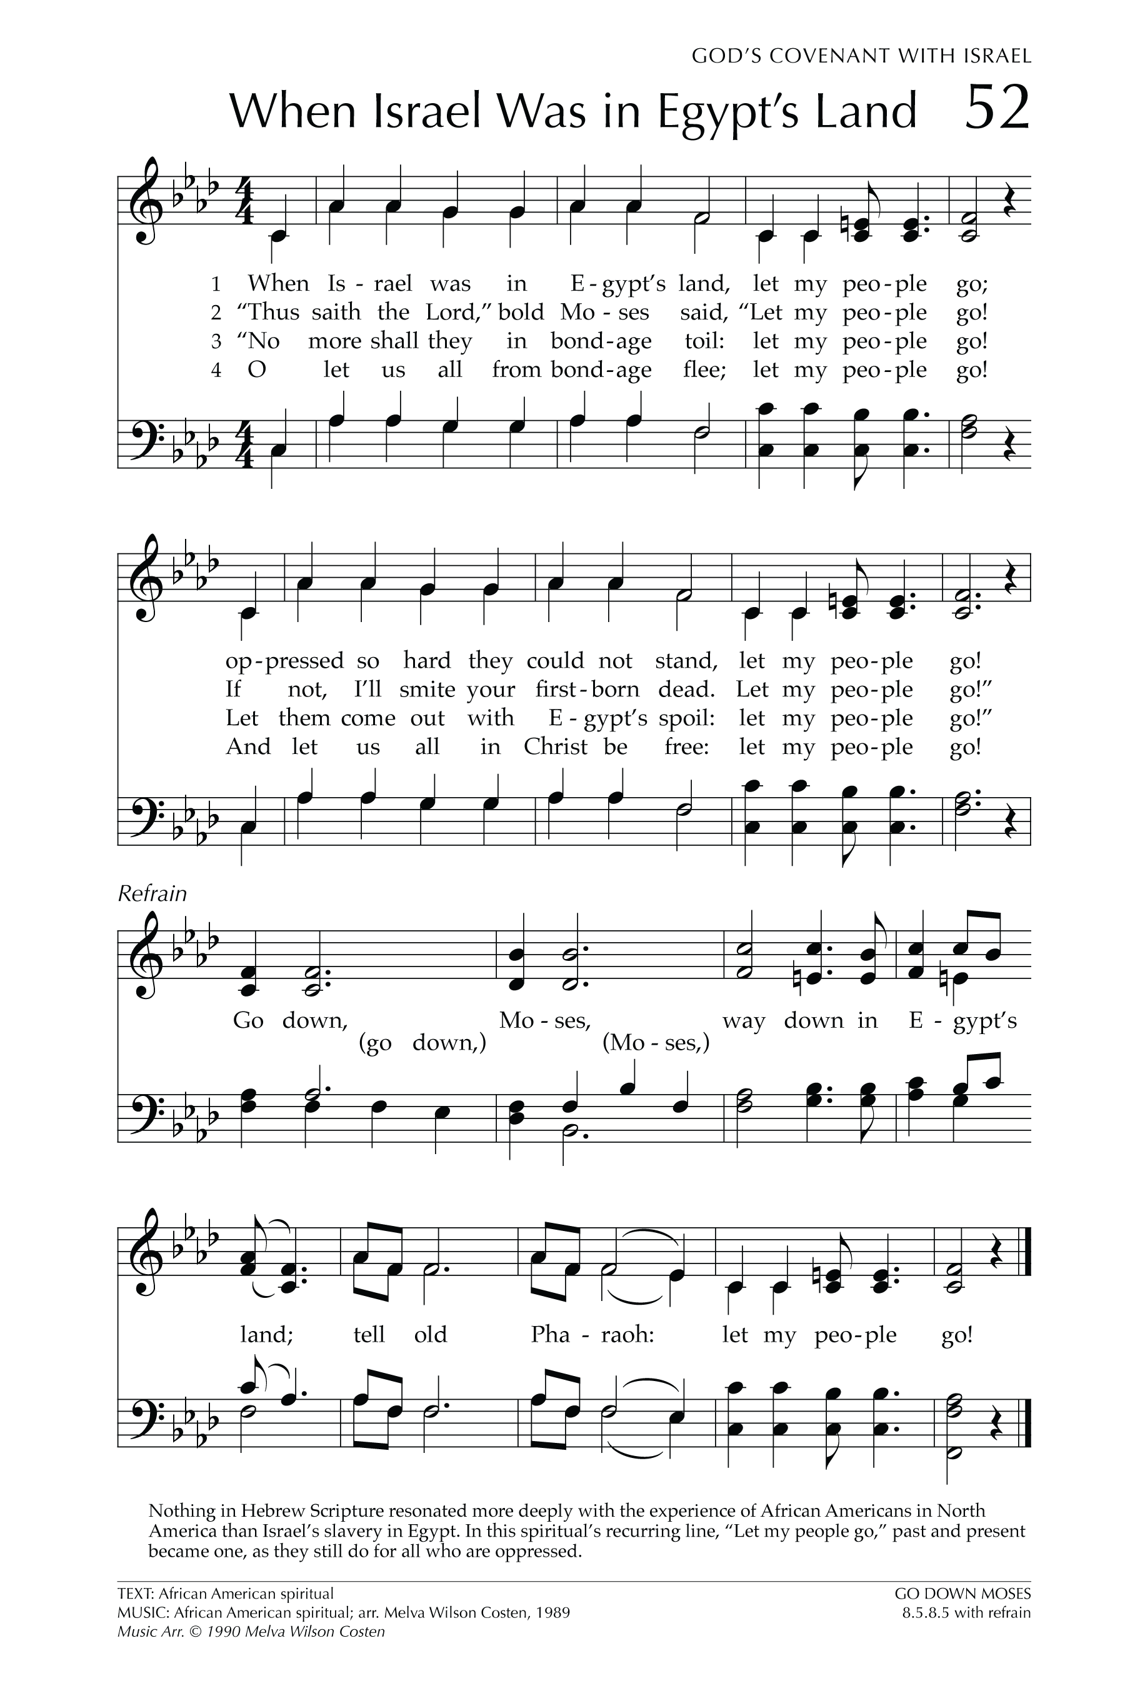
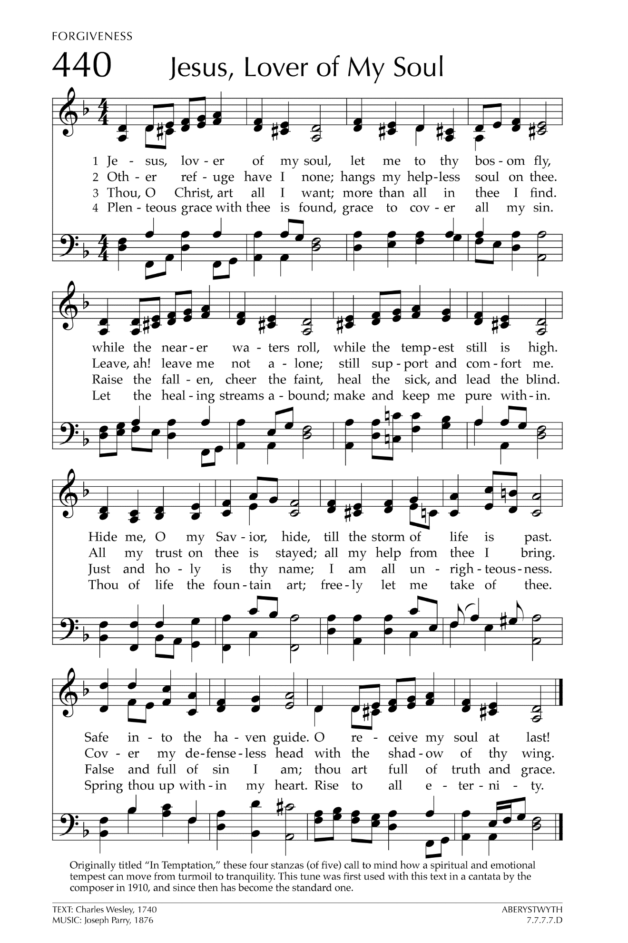

Let There Be Peace on Earth

Let there be peace on earth
And let it begin with me
Let there be peace on earth
The peace that was meant to be
With God as our Father
Christians all are we
Let us walk with each other
In perfect harmony.
Let peace begin with me
Let this be the moment now.
With every step I take
Let this be my solemn vow
To take each moment and live
Each moment in peace eternally
Let there be Peace on Earth
And let it begin with me!

